**Driven by Hyperfocus: ADHD Task and Behavior Management Website**

**A Capstone Project**

**Presented to the**

**Information Technology and Information Systems Department**

**Adamson University**

**In Partial Fulfillment of the Requirement for the**

**Bachelor’s Degree in Information Technology**

**By**

ANTONI, GABRIEL LOUIZZE S.

ATIENZA, ALFRED II M.

BALDONASA, GIANNE LEXTER S.

MANAOIS, DIOMER L.

Mrs. Charlene Vergara-Gonzales

Technical Adviser

December 2024

**EXECUTIVE SUMMARY**

**Title:** **Driven by Hyperfocus: ADHD Task and Behavior Management Website**

**Developers: Antoni Gabriel Louizze S.**

**Atienza Alfred II M.**

**Baldonasa Gianne Lexter S.**

**Manaois Diomer L.**

**Class Adviser:** **Ms. Ma. Carmela M. Racelis**

**Technical Adviser:** **Ms. Charlene I. Vergara**-**Gonzales**

**Copyright Year:** **December, 2024**

**Summary:**

Driven by Hyperfocus is an online platform designed to support individuals with ADHD, enhancing emotional intelligence and daily progress. Developed for the ADHD Society of the Philippines, the platform is accessible on both desktop and mobile devices. Its key features include a task management system, behavior tracker, sleep tracker, and a progress tracker which will contain data analytics of each user, by analyzing user interactions and survey data, the platform provides recommended activities to help users manage routines, improve behaviors, and track progress effectively. Additionally, the collected data can be used by health professionals to assist in diagnosing users and prescribing appropriate medication.

The proposed system effectively addresses the challenges faced by individuals with ADHD and healthcare professionals, as evidenced by the overwhelmingly positive feedback from target users. The system was developed and tested using the ISO 25010 quality model, adopting a mixed-methods approach that integrated quantitative and qualitative analysis with Agile methodology (Scrum). Surveys were conducted among individuals with ADHD, healthcare professionals, IT specialists, and board members of the beneficiary organization to ensure a comprehensive evaluation and a user-centered development process. The evaluation confirmed its "Excellent" overall rating, particularly excelling in functionality and performance. The system aligns with their needs, solving significant issues such as the lack of personalized and accessible platforms for ADHD support. With a mean score of 4.52 and 90% of respondents strongly agreeing, users confirmed that the system's features comprehensively cover their tasks and objectives, validating its necessity and impact. Comparisons with current solutions show its superiority in usability, functionality, and user-friendliness, as illustrated in the evaluation data (Figures 3 and 24). These innovations provide a practical, flexible, and engaging platform for managing ADHD.

Lastly, the developers hereby recommend to the future developers of the system to expand the tools capabilities and update the standardized survey form on the website as well as increase the utilization of other website’s functions.

**TABLE OF CONTENTS**

|  |  |  |  |  |
| --- | --- | --- | --- | --- |
|  | | |  | **Pages** |
| **TITLE PAGE** | | |  | i |
| **APPROVAL SHEET** | | |  | ii |
| **EXECUTIVE SUMMARY** | | |  | iii |
| **TABLE OF CONTENTS** | | |  | vi |
| **Overview** | | |  | 1 |
| **Categories and Subject Descriptors** | | |  | 1 |
| **General Terms** | | |  | 1 |
| **Keywords** | | |  | 1 |
| **Chapter** | | |  |  |
| **1** | **THE PROBLEM AND ITS BACKGROUND** | | | 1 |
|  | Project Context | | | 1 |
|  |  | Introduction | | 1 |
|  |  | Background of the Study | | 1 |
|  | Purpose and Description | | | 2 |
|  | Objectives of the Study | | | 2 |
|  | Scope and Limitation | | | 2 |
|  | Definition of Terms | | | 3 |
| **2** | **REVIEW OF RELATED LITERATURE/SYSTEMS**  **AND STUDIES** | | | 3 |
|  | Local Literature | | | 3 |
|  | Foreign Literature | | | 4 |
|  | Local Studies | | | 5 |
|  | Foreign Studies | | | 5 |
| **3** | **METHODOLOGY, RESULTS AND DISCUSSION** | | | 8 |
|  | Requirements Analysis | | | 8 |
|  | Requirements Documentation | | | 33 |
|  | Technical Background | | | 33 |
|  | Development and Testing | | | 34 |
|  | Description of the Prototype | | | 34 |
|  | Implementation Plan | | | 39 |
|  | Implementation Results | | | 39 |
|  |  | | |  |
| **4** | **SUMMARY, CONCLUSION AND RECOMMENDATIONS** | | | 39 |
|  | Summary | | | 39 |
|  | Conclusion | | | 40 |
|  | Recommendation | | | 40 |
| **ACKNOWLEDGEMENT** | | | | 40 |
| **REFERENCES** | | | | 41 |
| **APPENDICES** | | | |  |
|  | **A** | Certificate of Implementation | |  |
|  | **B** | Certificate of Authentic Authorship | |  |
|  | **C** | Presentation of Findings | |  |
|  | **D** | Evaluation Tool/Test Documents | |  |
|  | **E** | Certificate of Initial and Final Testing | |  |
|  | **F** | Letter of Approval of the Beneficiary | |  |
|  | **G** | Gantt Chart of Developmental Schedule | |  |
|  | **H** | User’s Guide | |  |

# Driven by Hyperfocus: ADHD Task and Behavior Management Website

|  |  |
| --- | --- |
| Gabriel Louizze S. Antoni  Adamson University  [gabriel.louizze.antoni061@adamson.edu.ph](mailto:gabriel.louizze.antoni061@adamson.edu.ph) | Alfred M. Atienza II  Adamson University  [alfred.atienza.ii@adamson.edu.ph](mailto:alfred.atienza.ii@adamson.edu.ph) |
| Gianne Lexter S. Baldonasa  Adamson University  [gianne.lexter.baldonasa@adamson.edu.ph](mailto:gianne.lexter.baldonasa@adamson.edu.ph) | Diomer L. Manaois  Adamson University  [diomer.manaois@adamson.edu.ph](mailto:diomer.manaois@adamson.edu.ph) |

Charlene Vergara-Gonzales

Adamson University

[charlene.vergara@adamson.edu.ph](mailto:charlene.vergara@adamson.edu.ph)

## OVERVIEW

This project aimed to develop a dynamic website that assists individuals with ADHD in managing daily tasks and enhancing their emotional intelligence. Furthermore, user interactions on the website were examined in order to track general progress and provide customized suggestions for enhancing emotional intelligence. The ultimate objective was to offer essential support and guidance to people with ADHD so they're able to successfully manage their daily schedules and habits.

### Categories and Subject Descriptors

Information Systems>Information Systems Applications>

### General Terms

Management, Performance, Design, Analytics, Feedback, Accessibility

### Keywords

ADHD, Dynamic, Task Manager, Behavior Tracker, Sleep Tracker, Progress Tracker

## THE PROBLEM AND ITS BACKGROUND

This chapter presents Attention-Deficit/Hyperactivity condition (ADHD), a neurodevelopmental condition with several manifestations that affect individuals of all ages. Based on recent search trends, the prevalence of ADHD in the Philippines is highlighted, underscoring its importance. In addition to highlighting the importance of recognizing ADHD in the country as a whole, the chapter presents the ADHD Society of the Philippines as a major supporter. The discussion then turns to the significance of having a dynamic website designed specifically for people with ADHD, pointing out the lack of research and potential consequences if this kind of platform is not developed. The project proposal is presented, including its goals to develop an accessible and encouraging website for people with ADHD.

### Project Context

#### Introduction

A neurodevelopmental disorder affecting people of all ages is called Attention-Deficit/Hyperactivity Disorder, or ADHD. Primarily inattentive, mainly hyperactive-impulsive, and combination presentation are the three primary ways the condition manifests. People struggle to pay attention, sit still, or listen and follow directions. However, for people with ADHD, these kinds of behaviors are so frequent and severe that they interfere with their ability to function. Barkley indicated that ADHD involves significant problems with sustained attention, persistence toward goals, resisting distractions along the way, inhibiting excessive task-irrelevant activity (hyperactivity), and inhibiting actions, words, thoughts, and emotions that are either socially inappropriate for the situation or inconsistent with one’s longer- term goals and general welfare [1].

Hyperfocus is most often mentioned in the context of autism, schizophrenia, and attention deficit hyperactivity disorder, but research into its effect on cognitive and neural functioning is limited. Luo, Wiebman, Halperin, and Li (2019) indicated that this disorder affects approximately 8%–12% of children worldwide [2]. Akel and Ashinoff added that 'Hyperfocus' is a phenomenon that reflects one's complete absorption in a task, to a point where a person appears to completely ignore or 'tune out' everything else [3]. Apor, Alonto, and Jamora assessed that the most searched neurological diseases in the Philippines over the past year were ADHD, Migraine, and Dysmnesia [4]. This may reflect the prevalence of these diseases in the country but this may also be highly influenced by social media trends on the Internet such as awareness campaigns and videos.

The platform that will be presented is the first working website in the Philippines that is devoted to providing support to people who are struggling with issues associated with ADHD, especially those that involve the intricacies of daily work schedules and behavior control. What it focuses on most is helping people in need by covering a wide range of difficulties with work schedules and behavioral problems that people with ADHD often meet. Focusing on these complex areas, the platform hopes to become a

trusted and invaluable tool that can help people with ADHD in the Philippines become more resilient and empowered.

#### Background of the Study

In the Philippines, acknowledging ADHD is essential to promoting understanding, lowering stigma, and offering the required support. By acknowledging their condition, people with ADHD may make sure they get the help, education, and community they need. With the mission of raising awareness of Attention Deficit and Hyperactivity Disorder and fostering a caring, compassionate, and supportive environment for kids, teens, and adults with the disorder in the home, school, and workplace, the ADHD Society of the Philippines is an all- volunteer, non-government, non-profit organization made up of parents, children/adults with ADHD, special education teachers, doctors, therapists, school administrators, guidance counselors, and corporate organizations [5].

For those with ADHD, developing a dynamic website is essential to offering helpful assistance in overcoming obstacles at work. The user experience is improved with an easy-to-use interface, a minimalistic visual style, and customizable features. Yo & Dennie [2018] stated that a website-based task board application can provide detailed information about the status of tasks and projects that are running or finished to the account executive and the account executive can provide information to the client in a short time because the report can be viewed through the application taskboard [6]. Efficient time management is facilitated by features such as task management tools, time-tracking, and reminders. In addition to that, music also influences particular changes in the brain particularly the reduction of anxiety, improvement of stress management, and increase of focus.

An accommodating platform that helps people with ADHD manage work routines more effectively is created with a responsive design, which guarantees accessibility across devices. Asherson, Merwood, and Sedwick [2018] stated that although the participants reported several disabling impairments in daily life, they also described positive aspects of ADHD (i.e. high levels of energy and drive, creativity, hyper-focus, agreeableness, empathy, and a willingness to assist others) [8]. There's a chance that people with ADHD won't be able to continue to access resources and information that are specifically designed if research on creating dynamic websites for them isn't done. This could result in more annoyance, less output, and difficulties establishing and adhering to work schedules. In the absence of minimalistic platforms, a less inclusive digital environment might continue, which would be detrimental to the success and well-being of people with ADHD in the workplace.

### Purpose and Description

This project aims to implement a dynamic website design specifically catering to supporting individuals with ADHD. Accessible on both desktops and smartphones, the platform displays users' analyzed data and progress daily, with the primary goal of enhancing their emotional intelligence. The website features an interface with a task management system and self-report tracker, allowing users to monitor and gradually improve their behaviors over time. It provides recommended activities based on analyzed survey data, personalized to each user's needs and progress. Additionally, a sleep tracker and progress tracker are integrated to help users monitor their sleep patterns and enhance productivity through engaging in beneficial activities. Kim adds that all of the user experiences accounts—including psychological and detrimental to the success and

behavioral changes—provide invaluable insights into developing the next generation of health information technology devices that seamlessly integrate into daily human lives [9]. Data collected from user interactions within the website is analyzed to track overall progress and provide personalized suggestions for enhancing emotional intelligence, offering valuable support and assistance to individuals with ADHD in managing their daily routines and behaviors effectively.

### Objectives of the Study

#### General Objective

To develop a dynamic website design aimed at supporting individuals with ADHD, the platform will be designed to be accessible on both desktops and smartphones. This inclusive approach ensures that users can easily access their analyzed data and track progress on a daily basis, ultimately enhancing their emotional intelligence. The website will have a user-interface with interactive elements tailored to the unique needs of individuals with ADHD, providing them with a seamless and engaging experience as they navigate the platform.

#### Specific Objectives

* + - 1. *To design*
         * a website for the users to be pleased with and easily navigate throughout the platform.

#### To create

* + - * + a task management system that aids in breaking down tasks and prioritizing important activities for individuals with ADHD.
        + dynamic website accessible for both websites and smartphones.

#### To provide

* + - * + a self-report tracker for users allowing them to monitor and gradually improve their behaviors over time, with recommendation to seek professional help
        + analyzed survey data to generate personalized recommendations
        + sleep tracker and progress tracker, empowering users to monitor their sleep patterns and boost progress
        + support users on their journey towards self- improvement and achieving their goals.
        + to test and evaluate the system using ISO 25010.

### 1.4 Scope and Limitation

1. The proposed website is intended for individuals with ADHD and was implemented for the benefit of organizations and institutions focused on supporting such individuals. The platform's primary users are individuals diagnosed with ADHD; the platform features an interface accessible on both desktop and mobile devices. Key functions and features include a task management system, a self-report tracker, a sleep tracker, and a progress tracker. Data analysis provides personalized suggestions for improving emotional intelligence, aiding users in managing daily routines and behaviors effectively. The proposed website does not provide medical diagnosis or treatment for ADHD. It does not address underlying medical conditions or provide emergency assistance. Additionally, while the platform aims to enhance emotional

### intelligence, it does not provide counseling or therapy services. The platform focuses on providing support and tools for managing daily routines and behaviors, rather than addressing broader mental health issues. The platform is not responsible for any adverse effects or consequences resulting from the use of the recommended activities or features. Additionally, the platform does not guarantee improvement in emotional intelligence or behavioral changes, as individual results may vary.

### Definition of Terms

The following terms are defined for easier understanding of the study. while the platform aims to enhance emotional intelligence, it does not provide counseling or therapy services. The platform focuses on providing support and tools for managing daily routines and behaviors, rather than addressing broader mental health issues. The platform is not responsible for any adverse effects or consequences resulting from the use of the recommended activities or features. Additionally, the platform does not guarantee improvement in emotional intelligence or behavioral changes, as individual results may vary.

**ACM (Association for Computing Machinery).** A professional association with criteria for copyright notices and document distribution that is included in the copyright notice.

**Accessibility.** The design ensures simple access and navigation on desktop and mobile platforms while promoting inclusion for those with ADHD.

**ADHD (Attention-Deficit/Hyperactivity Disorder).** An illness that affects neurodevelopment and can lead to impulsive behavior and very high levels of hyperactivity.

**ADHD Society of the Philippines.** A nonprofit group in the Philippines that supports and raises awareness of people with ADHD.

**Behavior-Tracking Platform.** An instrument built right into the website to track and gradually enhance actions, encouraging personal development and well-informed choices.

**Cognitive Behavioral Techniques (CBT).** A therapeutic approach often used to treat ADHD, focusing on changing negative patterns of thinking and behavior to improve emotional regulation, decision-making, and overall mental well-being.

**Counseling or Therapy Services.** The platform encourages users to seek appropriate assistance from professional mental health support services that are not offered by it.

**Data Analysis.** Looking at how users engage with the website to gain understanding, monitor development, and offer tailored advice on how to become more emotionally intelligent.

**Digital Copies.** Digitized copies of the document may be reproduced, provided that the copyright notice is followed**.**

**Dynamic Website.** A user-responsive, dynamic website that changes and responds to users in real time, meeting their demands and improving the user experience as a whole.

**Emotional Intelligence.** The capacity to navigate, comprehend, and control one's own emotions in addition to successfully influencing and navigating those of others.

**Emergency Assistance.** Help that is not offered by the platform in an emergency. Users are advised to get in touch with the proper emergency services.

**Hyperfocus.** A phenomenon that is frequently linked to ADHD and is defined by a person's total focus on a task is discussed in the context of study limitations.

**Inclusive Design.** The website's design promotes equitable participation and a positive user experience by making sure people with a range of skills, including those with ADHD, can access and use it.

**Internet Trends.** Patterns in online behavior, which have an impact on search trends and the prevalence of specific neurological conditions, as the paper discusses.

**Interactive Elements.** A dynamic and responsive user experience is enhanced by features on the website that promote user involvement.

**Medical Diagnosis or Treatment.** Not offered by the site are expert medical services for the diagnosis and treatment of medical disorders.

**Personalized Suggestions.** The platform makes recommendations that are specifically tailored to each user based on their requirements, preferences, and progress, making the experience more personalized.

**Progress Tracker.** A feature included into the website that aids users in seeing their chores to improve productivity and time management in general.

**Recommended Activities.** Recommendations made by the platform based on survey data analysis that are customized to each user's needs and level of development in order to improve emotional intelligence.

**Responsive Design.** A design strategy that guarantees inclusion by making the website usable and accessible on a variety of devices.

**Sleep Tracker.** A function built into the website that tracks users' sleep habits in an effort to raise awareness and possibly enhance general wellbeing.

## 2. REVIEW OF RELATED LITERATURE AND STUDY/SYSTEMS

This section covers existing knowledge and systems related to attention-deficit/hyperactivity disorder (ADHD) in great detail. This thorough analysis includes research and writings that shed light on the causes, symptoms, and treatments associated with ADHD from both international and domestic viewpoints.

International studies and literature offer a global viewpoint by presenting a range of methodologies and research findings from scholars across the globe. However, local research and literature address regional and cultural quirks to offer context-specific knowledge of ADHD in the Philippines. Furthermore, the section explores previous research projects and associated systems, analyzing the advancement of knowledge and technological advancements in the area.

### Local Literature

#### 2.1.1 IMPLEMENTING RULES AND REGULATIONS OF REPUBLIC ACT NO. 10173, KNOWN AS THE “DATA PRIVACY ACT OF 2012” This policy will be implemented in the website to maintain integrity and confidentiality with its users, by making sure that data from the users will not be used or accessed by someone else.

#### About ADHD Society of the Philippines (2000)

The AD/HD Society of the Philippines noted that our mission is to empower these individuals and their families, fostering a robust network of stakeholders to advocate for their needs. We strive to be an accessible, compassionate, and responsive organization, promoting the well-being of persons with ADHD through various programs, projects, and activities [5].

This organization is the beneficiary of this study and will be given access to the website to help in aiding people with ADHD.

#### 2.1.3 Play these Filipino lullabies when you need an express ticket to dreamland (2021)

Yuvallos revealed that for many of us, sleep has been difficult to come by as of late. This suggests that music can be used to calm and make people sleepy. [7].

The reason why music is so appealing on ADHD websites is that it helps with both mood regulation and attention enhancement. Music provides a rhythmic anchor for people dealing with ADHD-related difficulties, which facilitates prolonged interaction with online information. These platforms use music to provide users with a supportive environment in which they can manage their condition more easily and comfortably, in addition to providing information.

#### 2.1.4 Chess and Mathematics Performance of College Players: An Exploratory Analysis (2019)

Subia, Amaranto, Amaranto, Bustamante, and Damaso observed that a respondent who performed better in higher chess competition also performed better or obtained higher GWA in Mathematics. Furthermore, the respondents believed that a chess player can be a good mathematician especially if they start playing early in life and if chess was a part of the school curriculum since playing chess continuously has helped them in developing and improving their problem solving and critical thinking skills [11].

This study suggests by utilizing interactive platforms people with ADHD will be able to be more entertained and also enhance strategic thinking. The website will suggest activities like chess that will make users try it in their daily life. Through cognitively stimulating tasks, users can learn skills that are not only fun to use, but also helpful in managing symptoms of ADHD. The website aims to offer a dynamic and engaging experience that assists users in their journey towards self-improvement and successful ADHD management through interactive features and personalized recommendations.

*2.1.5 Prevalence and Correlates of Depression, Anxiety, and Distress Among Filipinos from Low- Income Communities in the Philippines (2018)*

Lorraine Evangelista, JosefinaTuazon, Marysol Cacciata, Erwin William Leyva, Mary Abigail Hernandez, and Jo Leah Flores reported that more than one billion people worldwide are affected by mental health disorders, making up 16% of the world’s population. However, psychological morbidity has been understudied and disparately estimated among Filipinos living in low-income communities in the Philippines [12].

This literature will contribute more information about ADHD and will help individuals with this disorder to gain more knowledge and info. In addition, it gives awareness of what ADHD is and if they are already encountering the disorder itself.

### 2.2 Foreign Literature

#### ADHD and Executive Functioning (2014)

Barkley indicated that ADHD involves significant problems with sustained attention, persistence toward goals, resisting distractions along the way, inhibiting excessive task- irrelevant activity (hyperactivity), and inhibiting actions, words, thoughts, and emotions that are either socially inappropriate for the situation or inconsistent with one’s longer-term goals and general welfare. Since the late 1970s, clinical researchers who were studying ADHD asserted that the disorder likely involved a serious problem with self-regulation [1].

This information from the literature will help the website in developing features that will target the problems related to self- regulation in ADHD specifically; Task management

#### The Self Report Method (2007)

Paulhus & Vazire stated that although alternative methods have an equally long history, self-reports remain the most popular choice. Their popularity appears to be based on a number of persuasive advantages: These include easy interpretability, richness of information, motivation to report, causal force, and sheer practicality [13].

This study aims to not only facilitate easy interpretation of the data but also enhance users' motivation to consistently report their experiences. Users are more likely to engage in self-reporting when they know it allows them to track their progress. The website can leverage these advantages to optimize its effectiveness in supporting individuals with ADHD who face challenges in managing tasks and behavior. This approach will also be implemented in the sleep tracker, enabling users to visualize their sleep data, including the duration of their sleep and the sleep debt they owe in case they have a day where they are missing a few hours of sleep.

#### ADHD: The Facts (2004)

Selikowitz stated that ADHD is one of the most common conditions in childhood, affecting as many as 5% of school-aged children. It affects about three times as many boys as girls and occurs in all ethnic groups. It seems that the predominance of boys in the overall number is due to their overrepresentation in the hyperactive-impulsive group. In the inattentive group, there are as many affected girls as boys [14].

The collected data will inform the design choices for the website. Given that ADHD is more prevalent in men, it makes sense to tailor the design to suit this gender. However, the website will still feature an interface that can be appreciated by individuals of all genders. Additionally, the data also indicates that ADHD can start at a young age.

#### 2.2.4. Qualitative Vs Quantitative Research Methods & Data Analysis (2023)

According to Mcleod, quantitative research involves the process of objectively collecting and analyzing numerical data to describe, predict, or control variables of interest. The goals of quantitative research are to test causal relationships between variables, make predictions, and generalize results to wider populations [15]. Through the use of numerical techniques for data gathering and analysis, researchers can find trends, evaluate causal linkages, and make predictions that are essential for comprehending the dynamics of mental health. By using this method, policies and interventions that are specifically designed to meet the needs of

these communities can be created, eventually leading to better mental health outcomes.

*2.2.5. Why Is Quantitative Research Important? (2021)*

Williams stated the speed and efficiency of the quantitative method are attractive to many researchers. Data computing equipment makes it possible to process and analyze data quickly, even with large sample sizes. Surveys, polls, statistical analysis software and weather thermometers are all examples of instruments used to collect and measure quantitative data [16].

The effectiveness of quantitative approaches in data processing and analysis speeds up the advancement of research. Large datasets may be processed quickly with the use of sophisticated computer techniques, enabling the creation of knowledge quickly. Tools such as statistical software and questionnaires facilitate data collecting, making it possible to obtain reliable quantitative data quickly. This faster rate of research advances science and improves disciplinary decision-making, highlighting the value of quantitative methods in solving difficult problems.

### 2.3 Local Study/Systems

#### Online Gaming Addiction among BSIT Students of Leyte Normal University Philippines Its and its Implications towards Academic Performance (2017)

Verecio determined that this study anchored on Flow State Theory which occurs when an individual faced with a task that has clear goals that require specific responses. For the duration of the competition, the player has concrete goals, allowing attention to be focused entirely on the game during the period of play [17]. This information is similar or another term for hyperfocus, whereas, if you’re totally in deep focus on what you’re doing you immerse into a state where you lose awareness of your surroundings and continuously do it until you are satisfied or reach your goal.

#### Burden of Neurological Diseases in the Philippines as Revealed by Web Searches: An Infodemiological Study (2022)

Jamora emphasized that this study assessed the interest of Internet users in the Philippines on neurological diseases. The most searched neurological diseases in the Philippines over the past year were ADHD, migraine, and AD. This may reflect the prevalence of these diseases in the country but this may also be highly influenced by social media trends on the Internet such as awareness campaigns and videos [4].

Regarding the literature, this project or website will have a huge impact on social media trends, to be aware of what is the disorder all about, and especially to those individuals with the ADHD to aid them what to do and how to improve their behavior.

#### Association Between Allergic Diseases and Attention-Deficit/Hyperactivity Disorder (ADHD) Symptoms in Children Aged 6–12 Years Using the Filipino Version of the Vanderbilt ADHD Parent Rating Scale (2021)

Andaya and Madulara concluded that over the last decades, the hypothesis that an allergic response could lead to the all about, and development of attention-deficit/hyperactivity disorder (ADHD) was raised and clinical studies investigated the coexistence of both. These studies had shown that allergic diseases and neurobehavioral disorders were concurrent and could be associated with genetic factors, neuroimmunity and microbial dysbiosis [18].

This study suggests that while certain allergies may contribute to the development of ADHD, its origins are not predominantly linked to just allergies; instead, it is primarily associated with complex interplay of genetic, neurological, and environmental factors, which also includes behavior.

#### Prevalence of Behavioral Symptoms Leading to Attention Deficit Hyperactivity Disorder (ADHD) Among Grade I Learners (2017)

Zabala Jr. & Manabat observed that every child is a unique individual. The way children act or behave in a particular situation may differ from one another. The study identified the prevalence of ADHD symptoms among Grade I learners as observed by their teachers. Descriptive method was utilized. Questionnaire, interview guide, and observation were the instruments used in 17 respondents. It revealed that the academic performance level of identified learners to have ADHD symptoms varies. Learners have low academic performance level while others have average academic performance level [19].

This study aimed to understand the diversity in children's behavior by investigating the generality of ADHD symptoms among Grade 1 learners. The websites might provide resources, strategies, or tools for effective task and behavior management tailored to people with ADHD symptoms.

#### Emotional Intelligence and Academic Achievement (2017)

Lorie Anne Socorro R. Moreno pointed out that the ability of self-control of emotions is an important matter. A high emotional intelligence helps maintain a state of harmony in oneself and be more confident in dealing with the challenges of living and learning in educational institutions. High emotional intelligence can contribute to pupils’ learning process [20].

This study will support the implementation of a new feature on the website - a 'self-tracker/behavior tracker.' This tool aims to monitor user progress, providing them with visualizations of their data. Users can track their behavior and identify areas for improvement. The tracker will incorporate survey questions, based on decision-making scenarios, to generate potential emotional states.

#### 2.3.6. AM FOR ADHD: An Exploration in the Lives of and its Effects in Children with ADHD (2015)

Castro stated that Children with ADHD are easily distracted by extraneous stimuli, have problems organizing activities, and lack inhibitory control (Gawrilow, Gollwitzer & Oetinnger, 2011). Prominent theories on ADHD suggest that ADHD symptoms arise from deficits in executive functions because these deficits reliably [21].

This study proves that the person with ADHD can be easily distracted and struggle to do their tasks, so the website provides recommended solutions to improve their behavior and solutions regarding the lack of focus. It will also help them in managing their tasks and, allowing them to be more focused because the website will provide an organized task management system.

### 2.4 Foreign Study/Systems

#### 2.4.1. AM FOR ADHD: An Exploration in the Lives of and its Effects in Children with ADHD (2015)

Couture and Sharma stated that ADHD is a neurological disorder that affects children, but symptoms may persist into adulthood. Individuals suffering from this disorder exhibit hyperactivity,

impulsivity, and problems in social interaction and academic performance. Medications used to treat ADHD such as methylphenidate, amphetamine, and atomoxetine indicate a dopamine/norepinephrine deficit as the neurochemical basis of ADHD, but the etiology is more complex. Moreover, these agents have poor adverse effect profiles and a multitude of drug interactions. Because these drugs are also dispensed to adults who may have concomitant conditions or medications, a pharmacist needs to be aware of these adverse events and drug interactions [22].

This study emphasizes that while medical treatments exist for addressing ADHD symptoms, they often show limited effectiveness with reported poor effects. The website's concept revolves around providing assistance without relying on medications, aligning with the project's mission to enhance the Task and Behavior Management of individuals with ADHD. Besides the medications mentioned in this study, the project will provide other alternatives that can be beneficial to the users in improving their lack of focus and social problems.

#### 2.4.2. INCREASING ON-TASK PERFORMANCE FOR STUDENTS WITH ADHD (2018)

Knox collected baseline data on off-task behavior during the first week of the study. After implementing the CHAMPS (Classroom and Hallway Assessment and Management Plans) PBIS (Positive Behavioral Interventions and Supports) approach over the next six weeks, the researcher observed a reduction of off-task behavior in all subjects, ranging from 58% to 100%. The data indicated that the use of CHAMPS PBIS behavior intervention effectively decreased off-task behavior in students with ADHD. Gelber, Jaffery, Stein, and Cymbala (2015) stated that school-wide positive behavior intervention support (SW- PBIS) would effectively reduce problem behaviors and simultaneously increase prosocial behaviors in general education and alternative settings [23].

This study supports the task management system of the project, whereas, the task managing system affects the individuals with ADHD to be active and improves their goals and productivity behavior. By offering a clear visualization of progress data, the system aims to motivate users to strive for better results. Users are likely to be interested in self-improvement, driven by the visual representation of their performance and quality.

#### 2.4.3. Increasing On Task Behavior in Students with Attention Deficit Hyperactivity Disorder Using a PBIS Approach (2018)

This study supports the task management system of the project, whereas, the task managing system affects the individuals with ADHD to be active and improves their goals and productivity behavior. By offering a clear visualization of progress data, the system aims to motivate users to strive for better results. Users are likely to be interested in self-improvement, driven by the visual representation of their performance and quality. This study supports the task management system of the project, whereas, the task managing system affects the individuals with ADHD to be active and improves their goals and productivity behavior. By offering a clear visualization of progress data, the system aims to motivate users to strive for better results. Users are likely to be interested in self-improvement, driven by the visual representation of their performance and quality.

#### 2.4.4. Working Memory and Organizational Skills Problems in ADHD (2017)

Kofler, M. J., Sarver, D. E., Harmon, S. L., Moltisanti, A., Aduen,

P. A., Soto, E. F., & Ferretti, N. Children with ADHD exhibit multi-setting, broad-based organizational impairment. These impaired organizational skills are attributable in part to performance deficits secondary to working memory dysfunction, both directly and indirectly via working memory's role in regulating attention. Impaired working memory in ADHD renders it extraordinarily difficult for these children to consistently anticipate, plan, enact, and maintain goal-directed actions [24]. Comprehending this study may be crucial in customizing therapies or support tactics intended to enhance organizational skills in ADHD individuals. On the website, some questions are not answerable by auto-generated answers. There will be an option if the user would like to speak to a professional regarding his or her concern.

#### 2.4.5. Attention-Deficit/Hyperactivity Disorder (ADHD) Behavior Explained by Dysfunctioning Reinforcement (2002)

Johansen, E. B., Aase, H., Sagvolden, T., & Meyer, A. ADHD symptoms may to a large extent be caused by a dysfunctioning dopamine system. A dysfunctioning meso-limbo- cortical dopamine branch will produce altered reinforcement and extinction processes that, on a behavioral level, give rise to deficient sustained attention, hyperactivity, increased behavioral variability, and impulsiveness [25].

It offers a neurobiological explanation of ADHD by implying that the disorder may be primarily caused by a dopaminergic dysfunction. To make the most of this data, it is about investigating how the study's suggested abnormalities of the dopamine system relate to or affect the particular features of ADHD.

#### 2.4.6. Co-Development of ADHD and Externalizing Behavior from Childhood to Adulthood.

1. Kuja-Halkola, Lichtenstein, D'Onofrio, and Larsson concluded that the effects were due to both new genetic and environmental factors emerging up to young adulthood. Clinicians and researchers need to consider complex etiologic and developmental models for the comorbidity between ADHD and externalizing behaviors [26].
2. Using a thorough strategy that takes into consideration the effects of both the environment and heredity on the co-occurrence of various diseases. In addition to helping to a deeper understanding of the developmental trajectory and potential intervention points for people with externalizing behaviors and ADHD, an understanding of the intricate interactions between these characteristics may inspire more focused examinations and interventions.

#### 2.4.7. Co-Development of ADHD and Externalizing Behavior from Childhood to Adulthood. (2022)

Redshaw & McCormack concluded that a tendency to live in the moment was consistent across the nine participants in this study and aligns with quantitative research showing differences in the processing of temporal information in ADHD [27]. Examining these positive aspects and how they affect people's experiences, perceptions of themselves, and day-to-day functioning will aid in this study's understanding of the strengths and potentially lead to a more thorough understanding of ADHD, which could then inform interventions, support plans, or instructional strategies that make the most of the positive aspects of the disorder.

#### 2.4.8. Divided Attention Skills in College Students with ADHD: Is it Advantageous to Have ADHD? (2001)

Linterman and Weyandt stated that ADHD is not a disorder but rather a set of behaviors that can be adaptive, to assess attention in individuals with ADHD, clinicians and researchers have relied primarily on behavior rating scales and, more recently, norm-based computerized clinic-based measures of attention, such as the Continuous Performance Test (CPT) [28].

Since ADHD is viewed as a collection of behaviors, physicians employ a variety of tests to evaluate attention. One popular tool is the CPT, albeit there are variations in the test parameters between versions. The relevant resources and tools to improve the website's usability for users of all ages will be developed with the aid of this study.

#### 2.4.9. Teaching Strategies for Students with ADHD: Findings from the Field (2016)

Astramovich and Hamilton stated that children with ADHD often experience academic challenges and interpersonal difficulties which may impact their educational success. Using a case study approach, the authors explored the experiences of a 00child with attention deficit hyperactivity disorder (ADHD) in a fifth-grade school setting [29].

In this study, the unique interpersonal and intellectual difficulties faced by people with ADHD in the context of their choice are examined. To improve educational outcomes for those with ADHD, look into therapies or support systems that tackle these issues. Its methodology can act as a guide for comprehending the complex experiences of an ADHD child in a classroom, offering perspectives that could direct tactics for enhancing the educational experience for ADHD participants in your research.

#### 2.4.10. Teaching Strategies for Students with ADHD: Findings from the Field (2010)

Salpekar and Weiss stated that an estimated 25–50% of children and adolescents with attentiondeficit hyperactivity disorder (ADHD) experience problems with sleep. Salpekar and Weiss (2010) added that properly assessing and treating sleep problems will help improve the health, well-being and possibly the behavioural outcome of children with ADHD [30].

To reduce stress and improve family quality of life, the study emphasized how important it is to treat sleep issues. The results underscore the importance of diagnosing and treating sleep disturbances, which may be more common in kids with ADHD. Understanding and enhancing the general wellness of ADHD patients may be facilitated by these findings, which are pertinent to the study's focus on ADHD or sleep-related problems.

#### 2.4.11. The Positive Aspects of Attention Deficit Hyperactivity Disorder: A Qualitative Investigation of Successful Adults with ADHD (2019)

Asherson, Merwood and Sedwick stated that although the participants reported a number disabling impairments in daily life, they also described positive aspects of ADHD (i.e. high levels of energy and drive, creativity, hyper-focus, agreeableness, empathy and a willingness to assist others) [31].

Examine how recognizing and utilizing these advantageous qualities could lead to a more thorough comprehension of ADHD.

The implications for developing support networks or interventions that capitalize on the positive aspects of ADHD features in addition to addressing problems. Acknowledging and utilizing these positive qualities may offer a more comprehensive and empowering method of working with ADHD suffer.

#### 2.4.12. A Qualitative Analysis of User Experiences with a Self-Tracker for Activity, Sleep, and Diet (2014)

Kim stated that all of the user experience accounts— including psychological and behavioral changes—will provide invaluable insights into developing the next generation of health information technology devices that will seamlessly integrate into daily human lives [9].

Patient-generated data has the potential to completely transform healthcare by speeding up scientific research and enhancing patient outcomes. Individuals can obtain personalized treatment programs that are suited to their specific needs through the constant tracking and sharing of health indicators, which improves efficacy and lowers side effects.

#### A Taskboard System Based on Website (2018)

Yo & Dennie stated that this form of collecting data through observation and questionnaires were distributed in the scope of the company. The test results of these applications concluded that with the application task board-based website Efficiency was increased by electronic data processing, which made it possible to update tasks quickly even when personnel were not in the office. According to their research, these kinds of applications help boost worker productivity. This emphasizes the possible advantages of technology-driven solutions for project management and data collection in a business context [6].

#### 2.4.14. Advantages and Limitations of Web-Based Surveys: Evidence from a Child Mental Health Survey (2009)

Goodman & Heiervang concluded that Web-based surveys may be performed faster and at lower cost than more traditional approaches with personal interviews. Selective participation seems a particular threat to point estimates of psychopathology, while patterns of associations are more robust [32].

The effectiveness and affordability of web-based surveys in comparison to in-person interviews may influence the choice of data collection approach. Additionally, anticipating and addressing problems linked to the representativeness of the sample will be made easier by being aware of potential concerns, such as selective participation.

#### 2.4.15. Do Agile Methods Work for Large Software Projects? (2018)

Jørgensen concluded that large projects are inherently risky, and our data suggests that the failure risk is reduced rather than increased with the use of agile methods instead of non-agile methods. Agile development techniques may be better equipped to handle the high requirement volatility of many major projects because they adopt a process where change is a more integrated aspect [33]. The fact that it is less likely that needs will stay constant as software projects get larger is one argument in favor of their adoption. Over the course of the project, it is expected that the demands will change, and changes in the external environment will also probably result in modifications to the requirements.

## METHODOLOGY, RESULTS AND DISCUSSION

### Requirements Analysis

#### 3.1.1. Software Development Life Cycle

The Software Development Life Cycle (SDLC) is an organized method for developing software that directs the process from ideation to implementation and upkeep. By outlining stages and tasks, the SDLC guarantees the effectiveness and caliber of software applications.

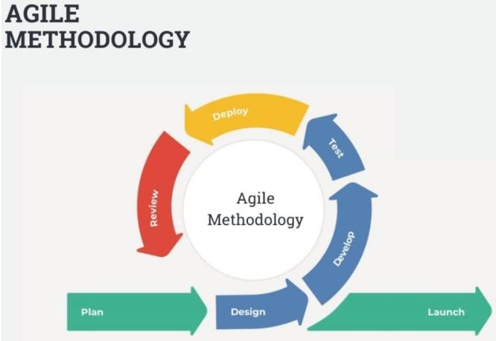For this study, the researchers have chosen to employ Agile methodology. Using this can react swiftly to changes in requirements and stakeholder needs because of this methodology's flexible and iterative structure, which permits constant feedback and adaptation throughout the development process. According to Garbajosa, Wang and Aguiar, Agile practices have been widely used in software industries to develop systems on time and within budget with improved software quality and customer satisfaction [31].

**Figure 1. Agile Methodology [34]**

Agile technique is flexible and iterative, which fits the project's objectives and requirements perfectly. For this study, the researchers will use it. Agile development processes enable ongoing feedback loops, which make it possible to constantly solicit feedback from stakeholders and make sure the platform efficiently satisfies their demands. Agile promotes the active participation of stakeholders, such as end users and healthcare providers, to guarantee that their feedback influences the development process. The Agile model is shown in Figure 1.

#### I. Plan

#### In this phase, the researchers arranged and group the system's specific objectives. From there, they determined the issue, the best course of action, and the tools required to launch the entire process, including the planning of the system's features.

#### II. Design

#### In this phase, after planning the specific goals, the researchers started designing and implementing various features of the system like registration, task manager, behavioral tracker and many more. Collaborating with the beneficiary, as the researchers constructed the system, the beneficiary's views and opinions were crucial to effectively meeting their needs.

#### III. Development

#### In this phase, following a plan agreement with the beneficiary, the researchers developed the system. The development was carried out in phases, with each session aiming to enhance the system's current design.

#### IV. Testing

#### In the initial testing phase, the researchers evaluated the current system's overall functionality and find any possible mishaps on the website’s current state. For the final testing phase, the researchers continued to assess the system's functionality comprehensively, ensuring that all aspects of the website are functioning smoothly.

#### V. Deploy

#### In this phase, the researchers assessed the general functionality of the system and its transition from development to a live environment to improve website performance and user experience. Hosting the site on Hostinger was a smart choice because it is reliable and strong. The research team made sure the program met all system requirements and fixed any problems, with Hostinger's support being very helpful.

#### VI. Review

#### In this phase, the researchers examined the program to ensure that it satisfies the system's requirements and that all problems have been fixed.

#### VII. Launch

#### In this phase, the system has now been released to the users and is ready for use; tasks at this stage could include user training,

#### 3.1.2 Conceptual Diagram

The Conceptual Diagram conveys abstract information by outlining the process in terms and phrases, explaining the key ideas, outlining the pertinent system variables, and showing the relationships between the variables.

Figure 2 shows the users, data inputs, development process, and output components of the "Driven by Hyperfocus: ADHD Task and Behavior Management Website" project, as well as how they interact with each other.

##### *INPUT*

This block contains 4 sections which are the first set of information and materials needed to start the development process. The target users (adults with ADHD) are identified, together with the data to be gathered (task, behavior, sleep habits, progress, and survey responses), and the development tools (Notepad++ or Visual Studio Code).

##### *PROCESS*

The processes involved in creating the "Driven by Hyperfocus: ADHD Task and Behavior Management Website" are described in the process section. These include creating a website that is especially made to help people with ADHD manage their tasks and behaviors. There are several steps in the process, including planning, analyzing, designing, developing, testing, deploying, and maintaining.

##### *OUTPUT*

##### The expected outcomes or deliverables of the development process are outlined in the output section. This covers the website's screen output, which includes the task manager, behavior tracker, recommendations section, sleep tracker, and progress tracker in addition to the user interface.

##### BENEFITS

##### This block only presents a list of all the benefits that each partner and user will receive because of utilizing the system.

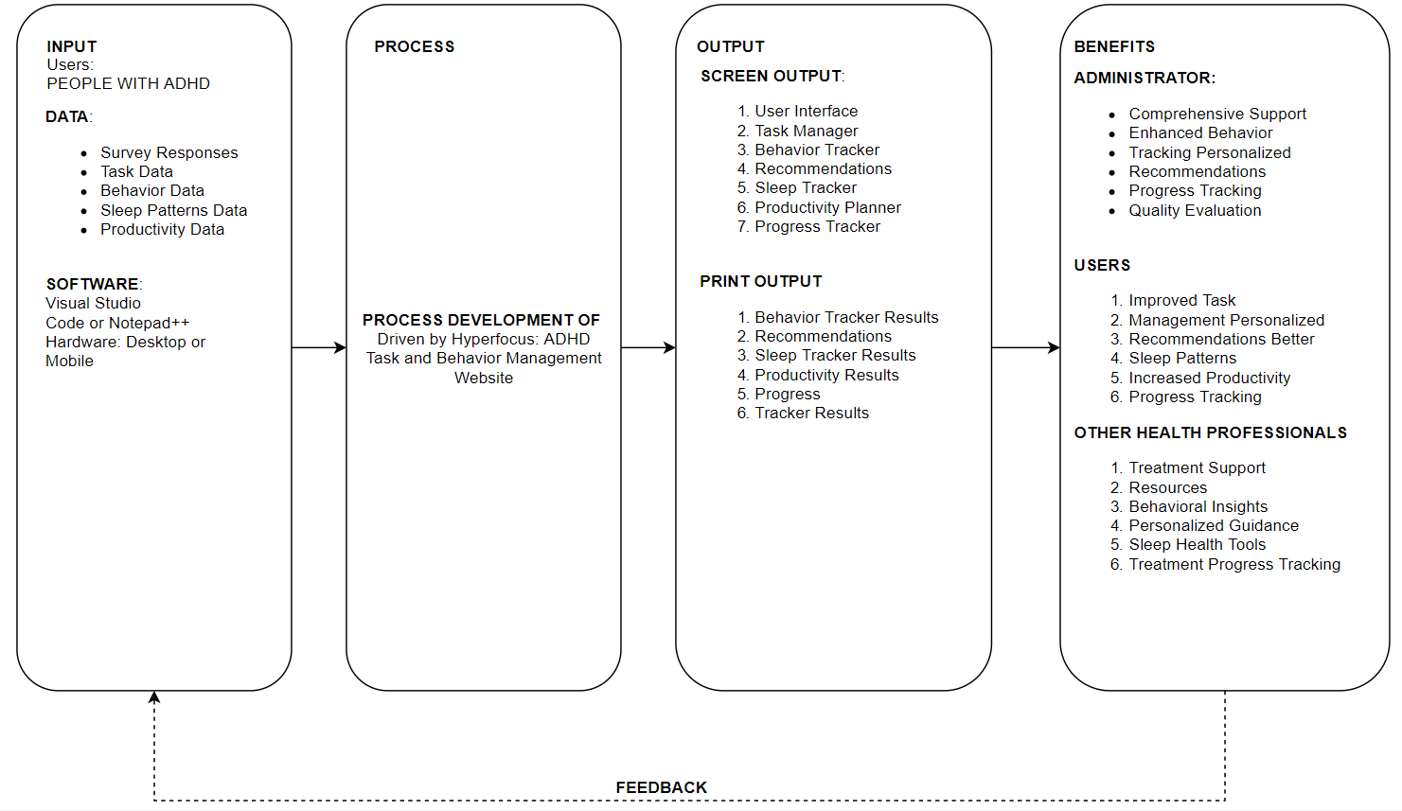

**Figure 2. Conceptual Diagram**

#### Flow of Existing System

*3.1.3.1. Flowchart of the Existing System*

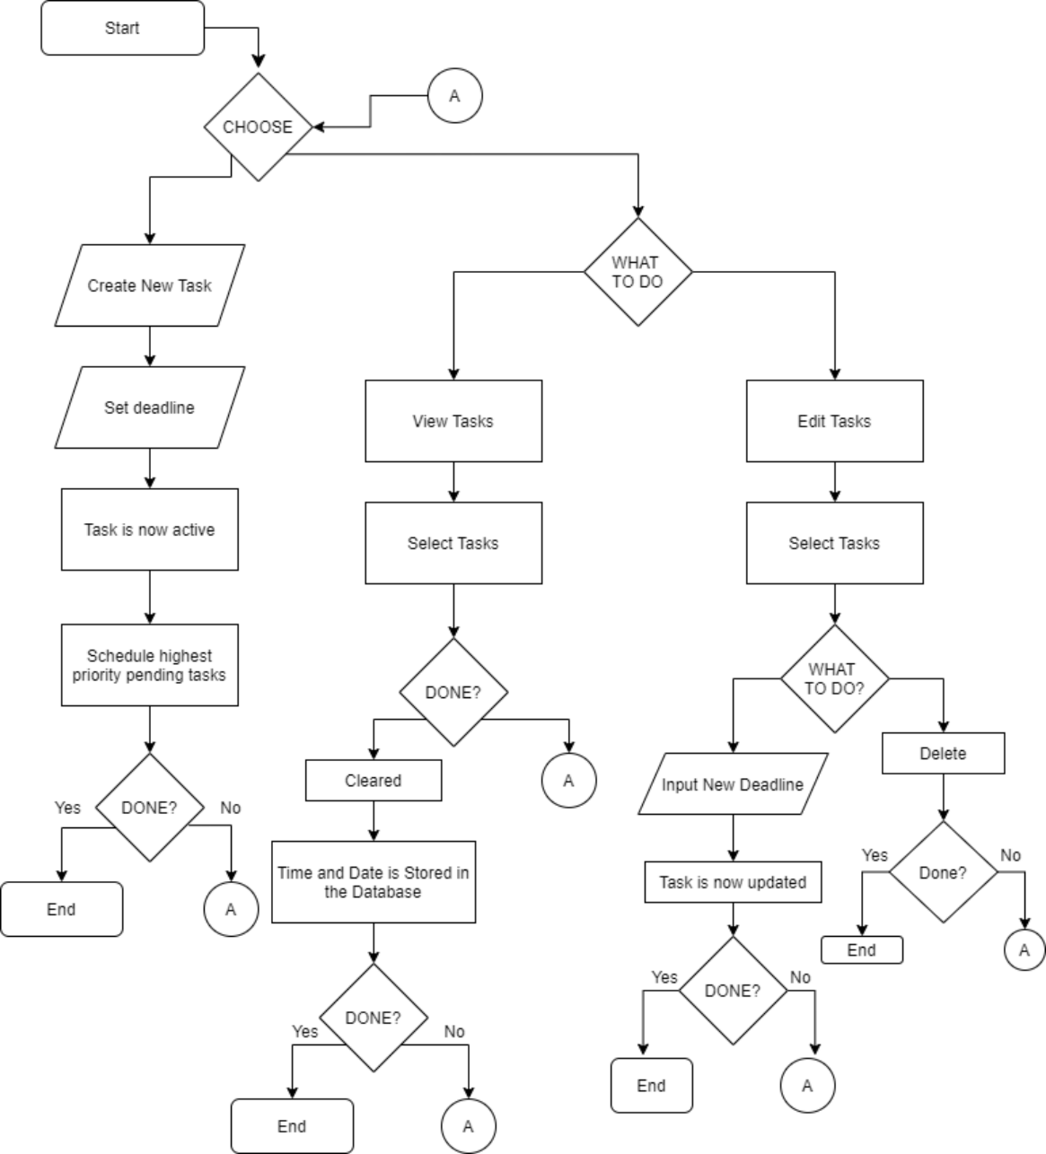

**Figure 3. Flowchart of the Existing System (Task Manager) [35]**

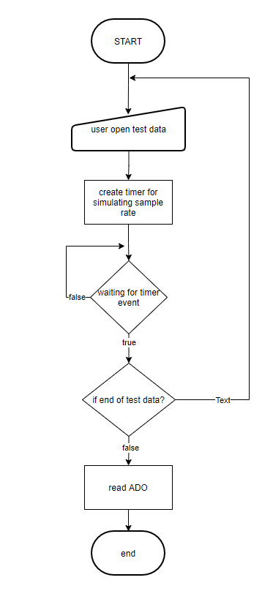

##### Figure 4. System Flowchart of the Existing System (Behavior Tracker) [36]

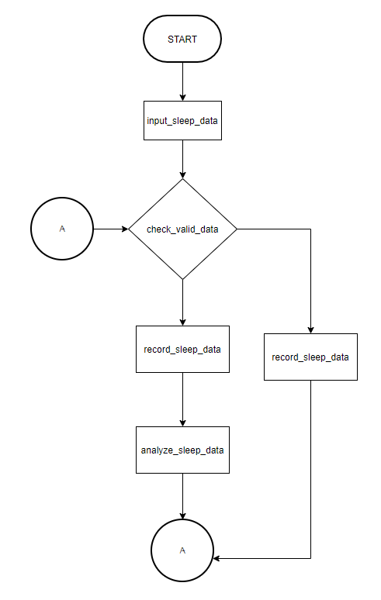

##### Figure 5. System Flowchart of the Existing System (Sleep Tracker) [37]

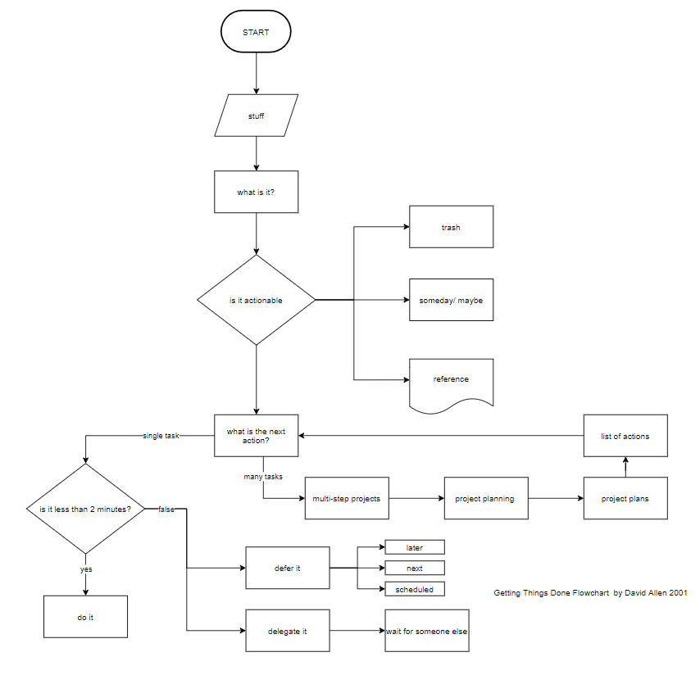

##### Figure 6. System Flowchart of the Existing System (Productivity Planner) [38]

#### Data Flow Diagram of the Existing System

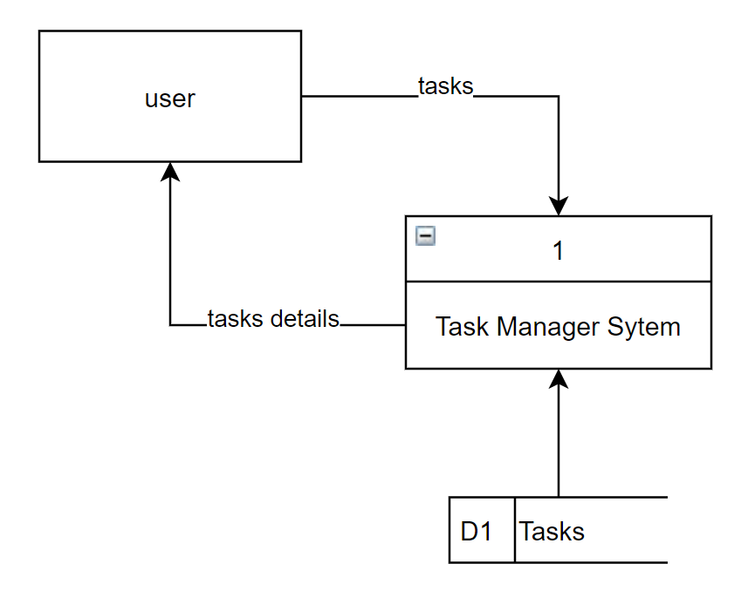

##### Figure 7. Data Flow of the Existing System (Task Manager) [35]

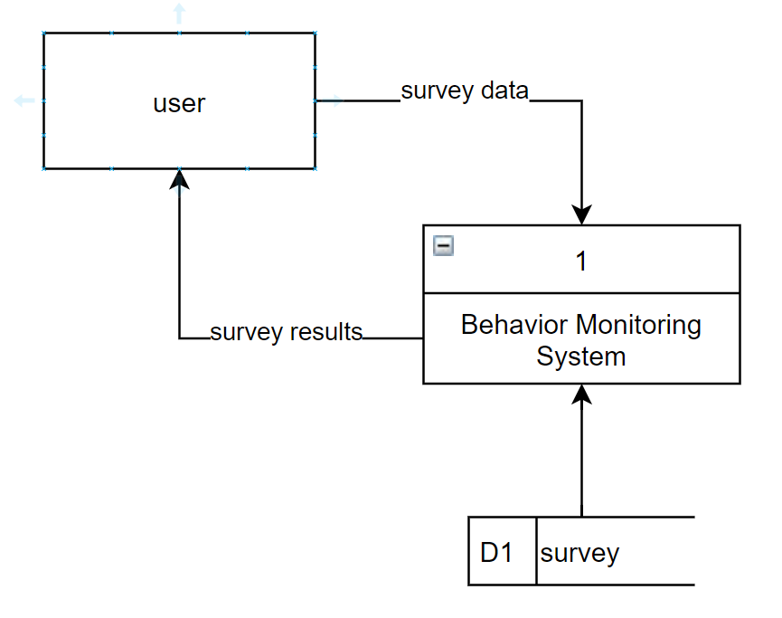

##### Figure 8. Data Flow Diagram of the Existing System (Behavior Tracker) [36]

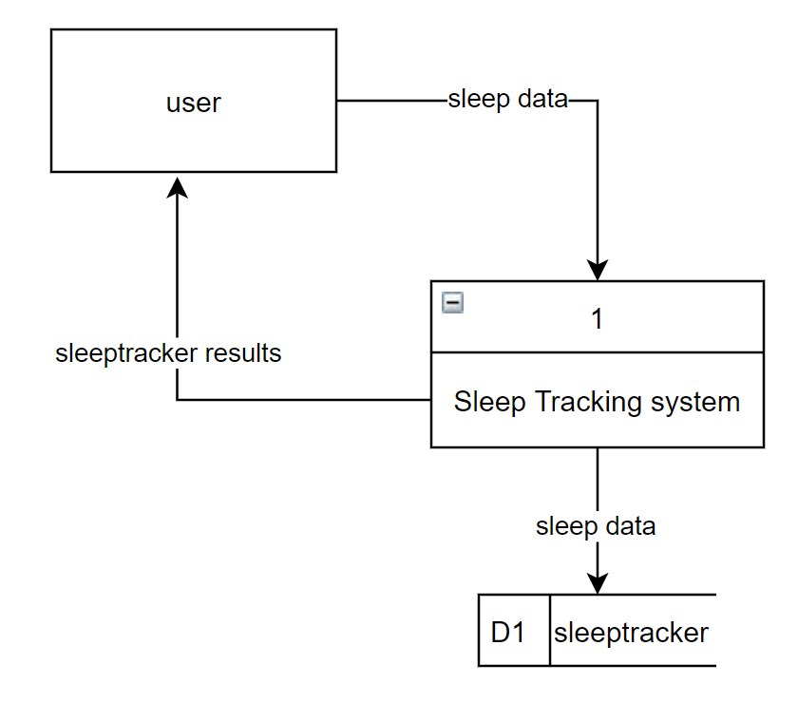

##### Figure 9. Data Flow Diagram of the Existing System (Sleep Tracker) [37]

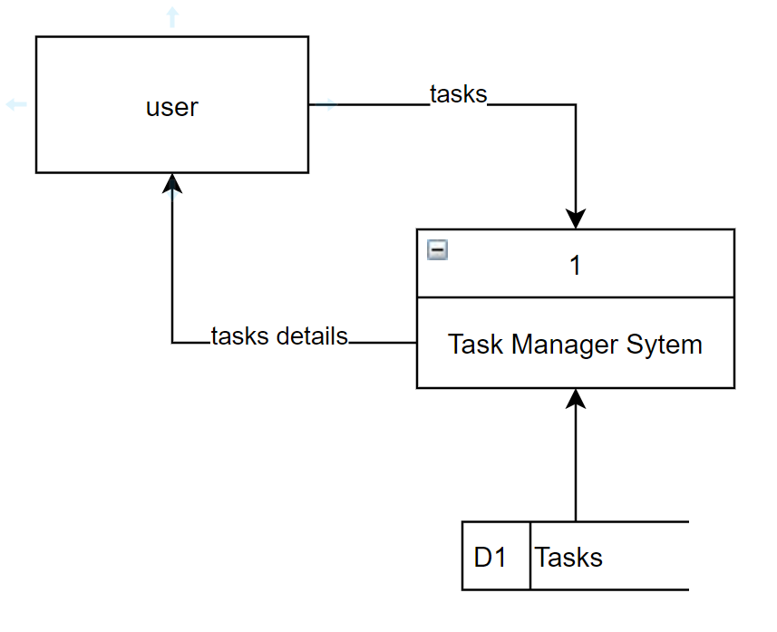

##### Figure 10. Dataflow Diagram of the Existing System (Productivity Planner) [38]

#### Flowchart of the Proposed System

#### 3.1.4.1. Flowchart of the Proposed System

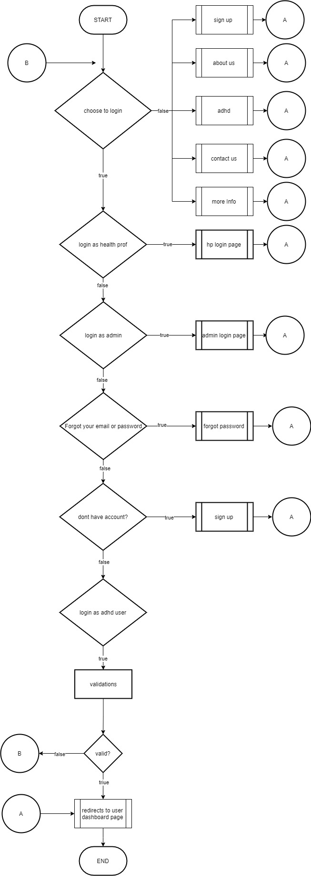

**Figure 11. Flowchart of the Proposed System (Main Login Page)**

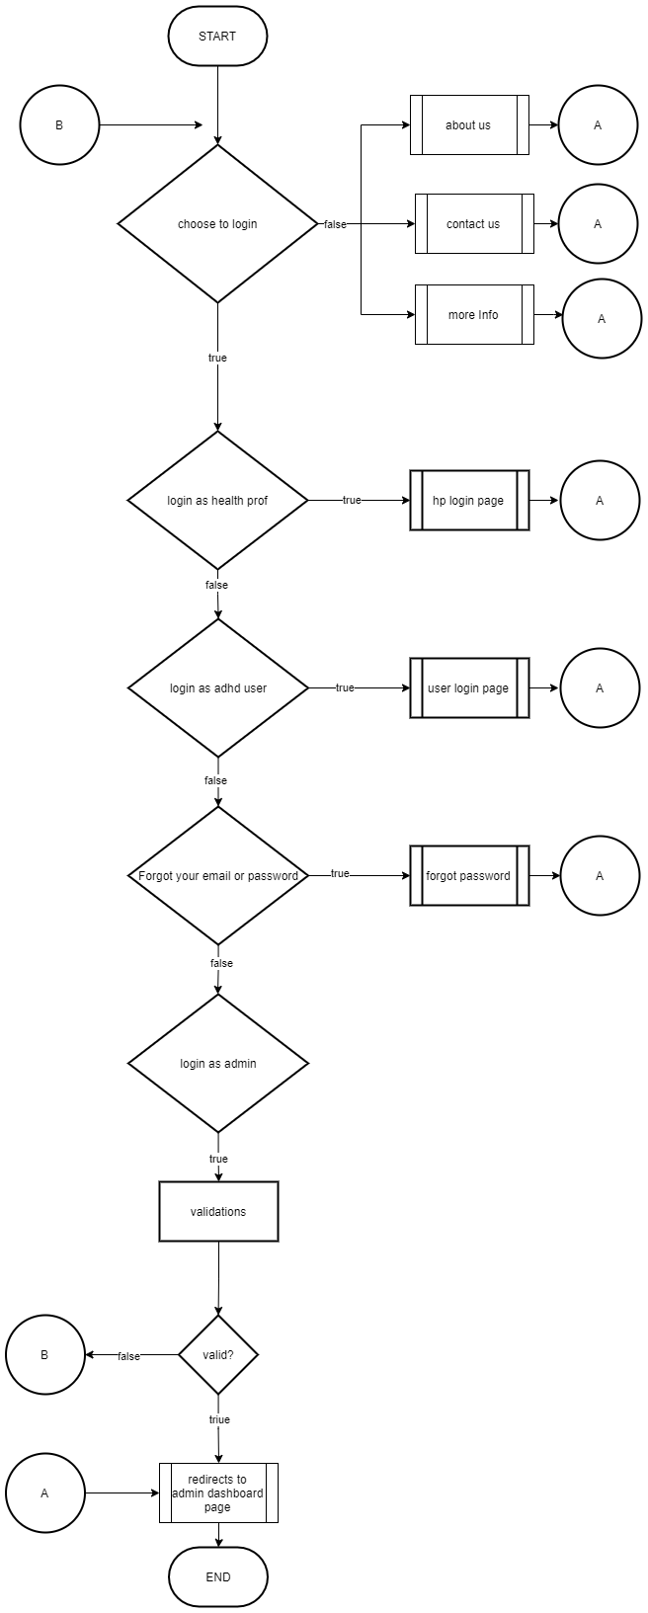

**Figure 12. Flowchart of the Proposed System (Admin Login Page)**

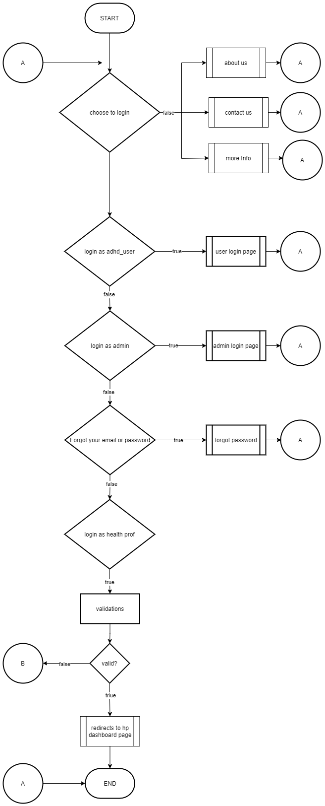

**Figure 13. Flowchart of the Proposed System (Health Professional Login Page)**

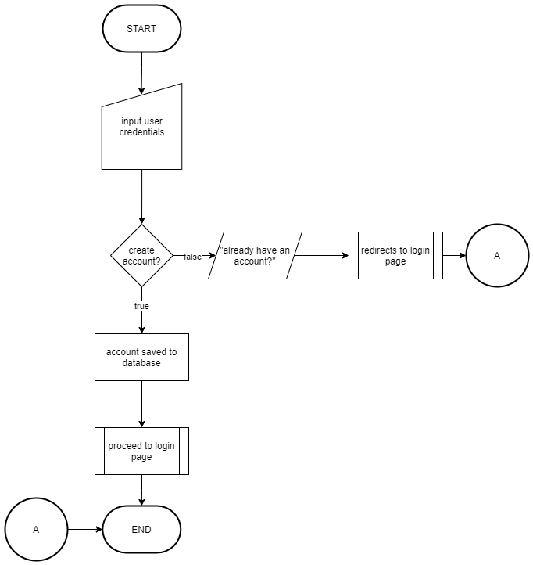

**Figure 14. Flowchart of the Proposed System (Create Account Page)**

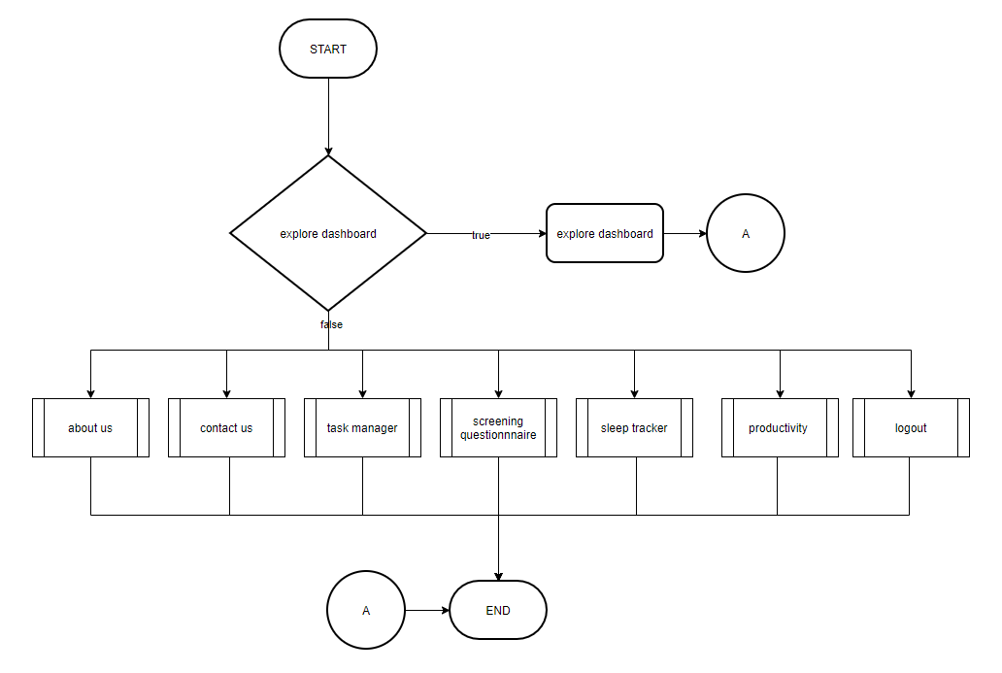

**Figure 15. Flowchart of the Proposed System (User Dashboard Page)**

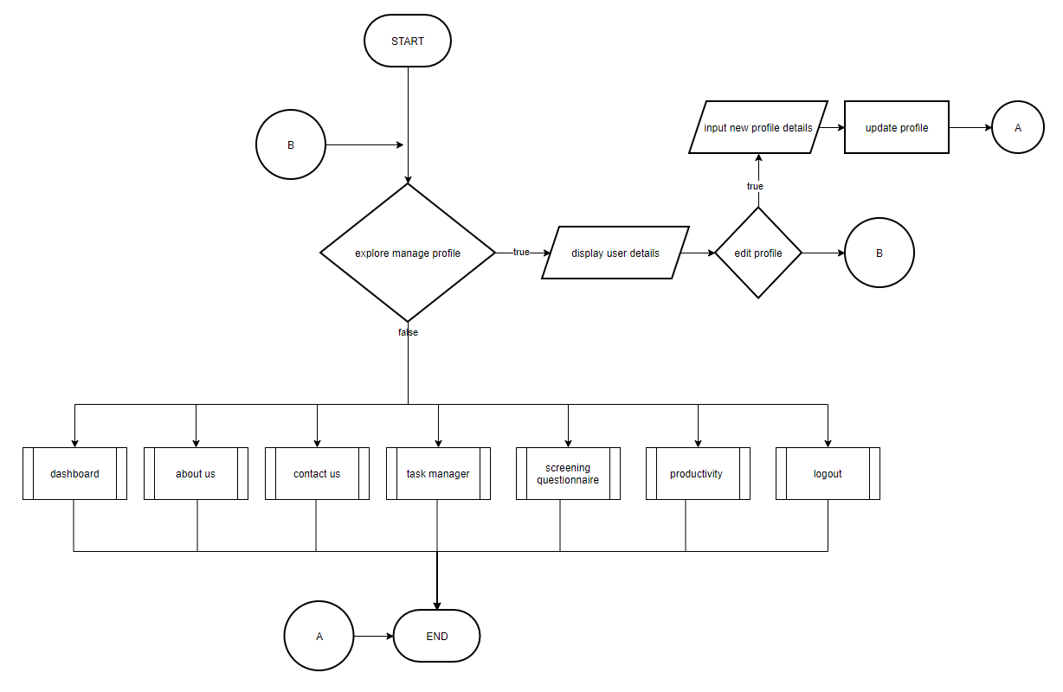

**Figure 16. Flowchart of the Proposed System (Manage Profile Page)**

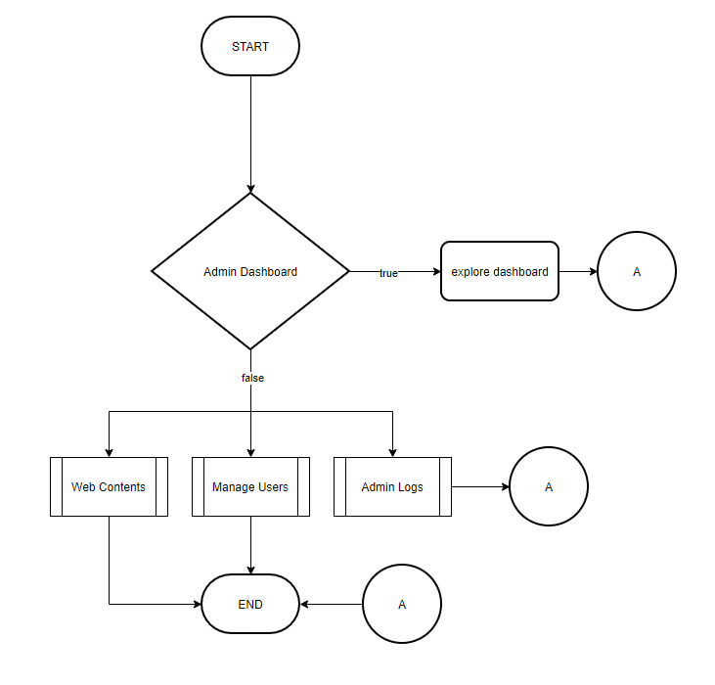

**Figure 17. Flowchart of the Proposed System (Admin Dashboard Page)**

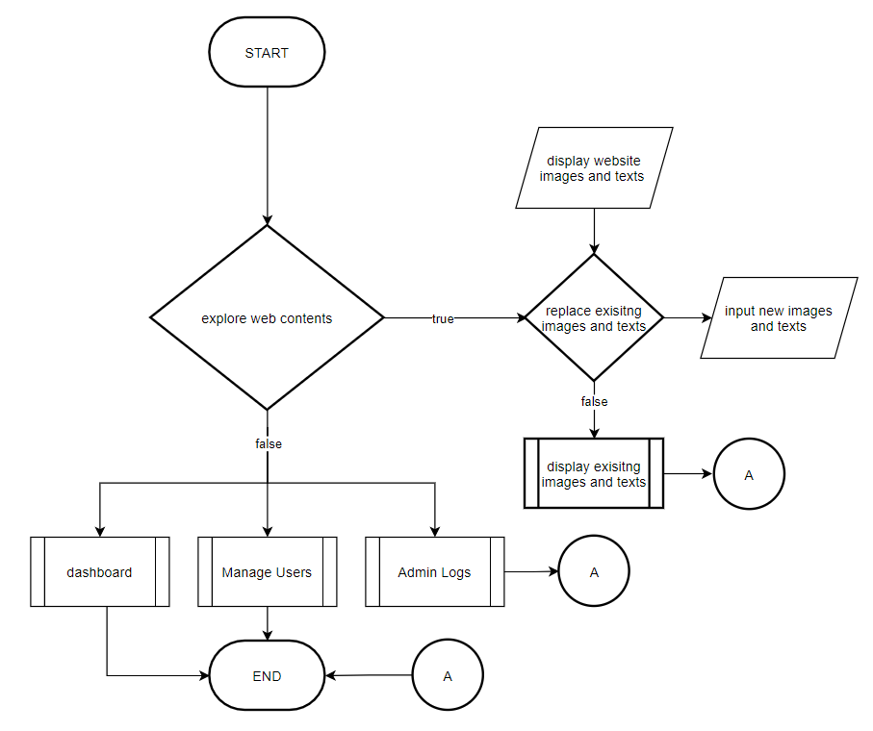

**Figure 18. Flowchart of the Proposed System (Admin Dashboard – Web Content)**

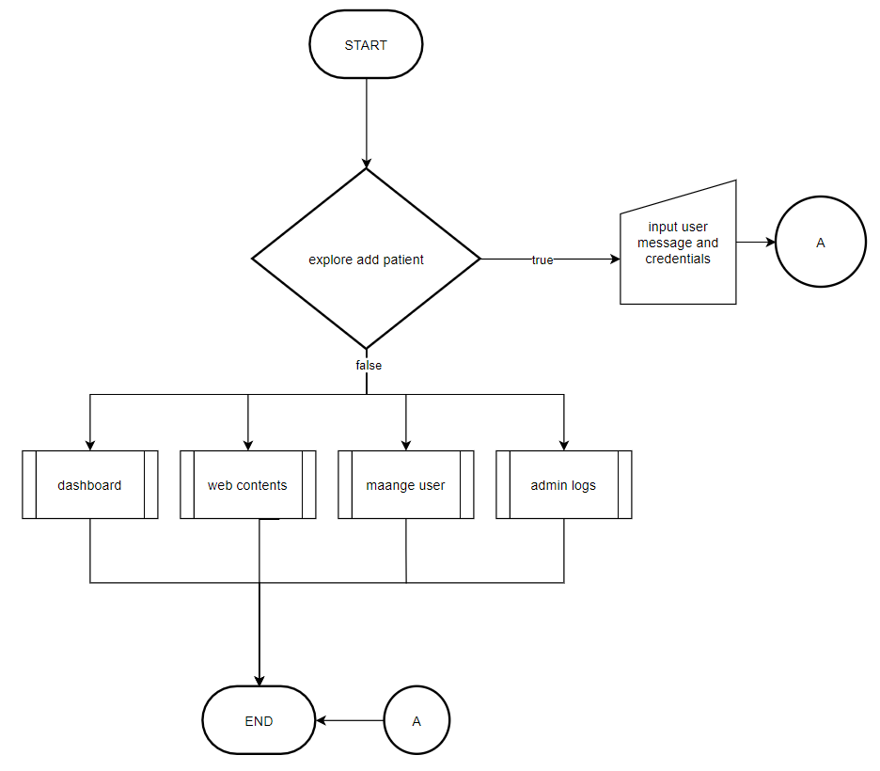

**Figure 19. Flowchart of the Proposed System (Admin Dashboard – Add Patient)**

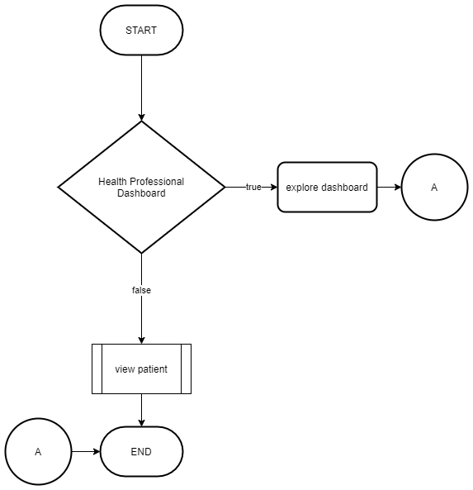

**Figure 20. Flowchart of the Proposed System (Health Professional Dashboard)**

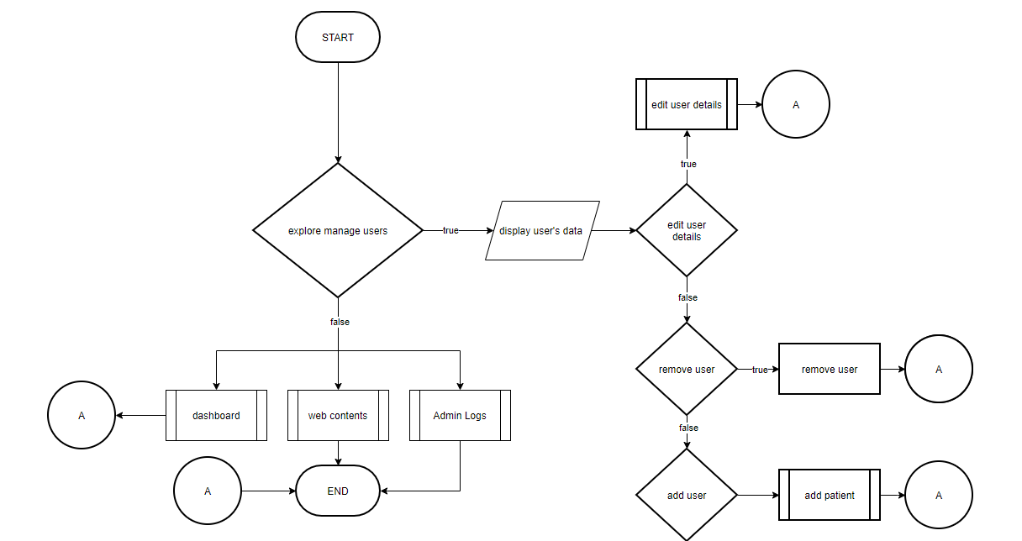

**Figure 21. Flowchart of the Proposed System (Health Professional Page – List of Patients)**

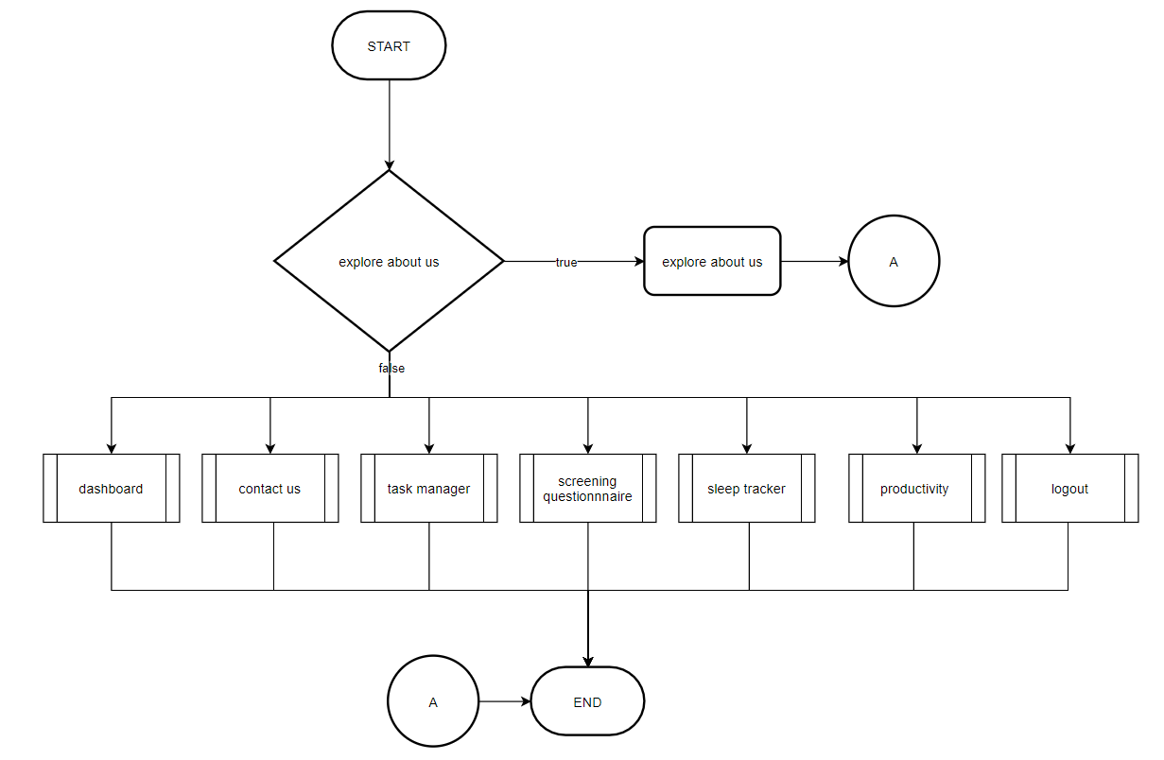

**Figure 22. Flowchart of the Proposed System (About Us Page)**

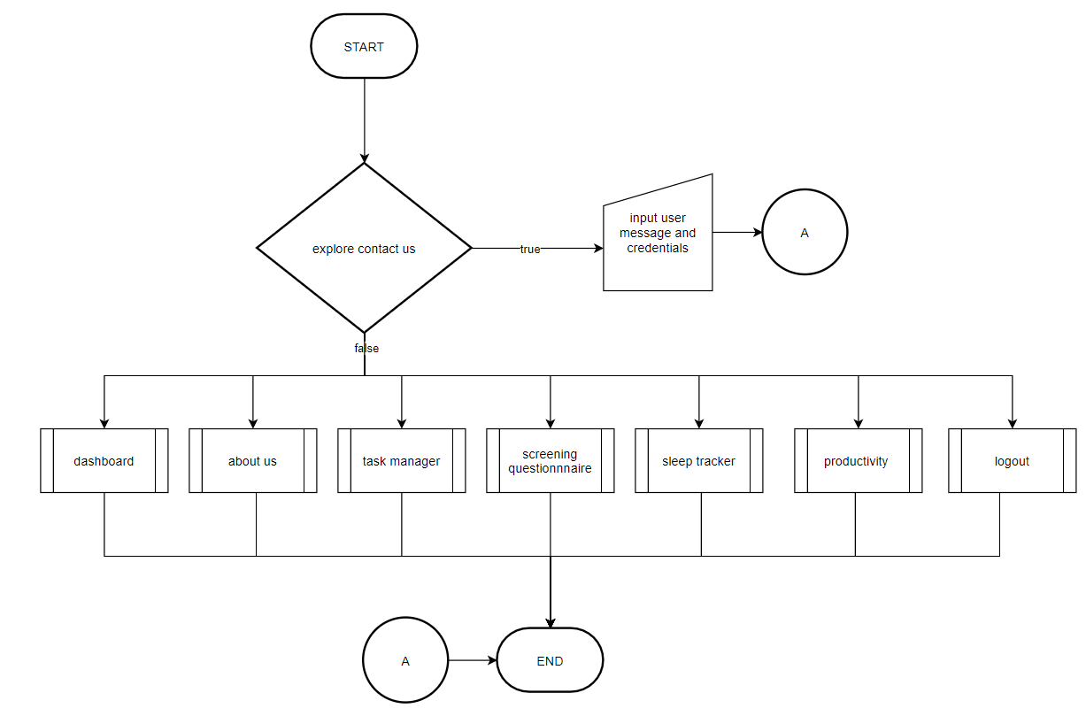

**Figure 23. Flowchart of the Proposed System (Contact Us Page)**

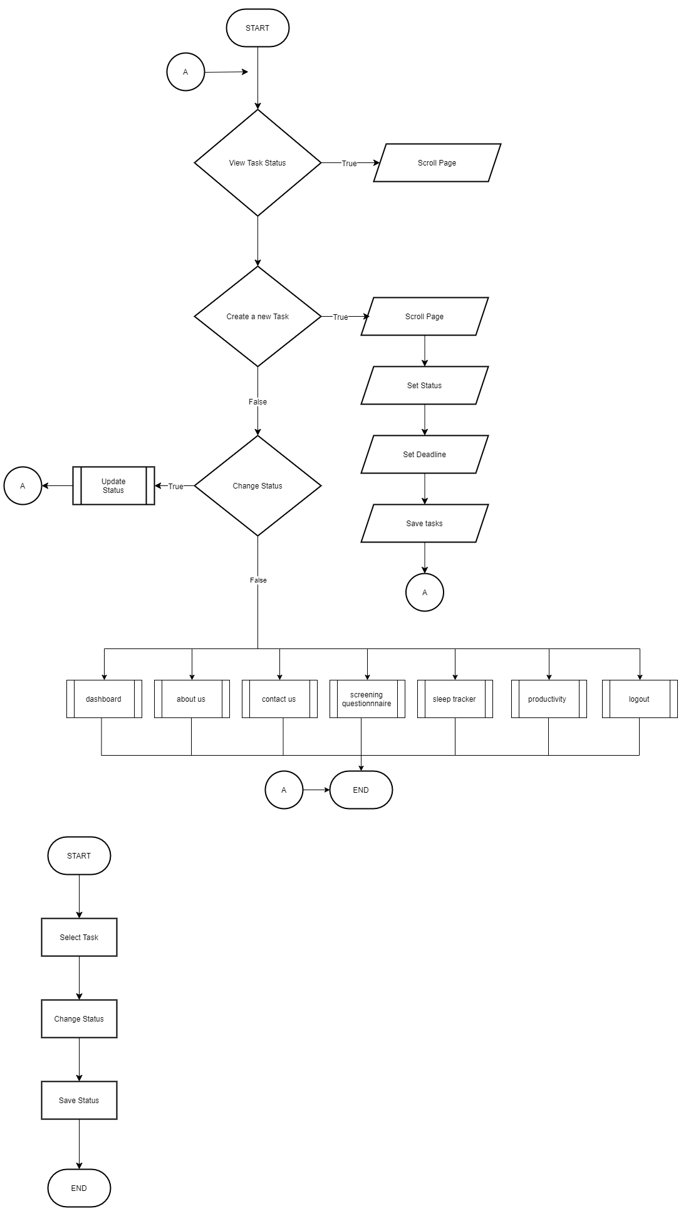

**Figure 24. Flowchart of the Proposed System (Task Manager Page)**

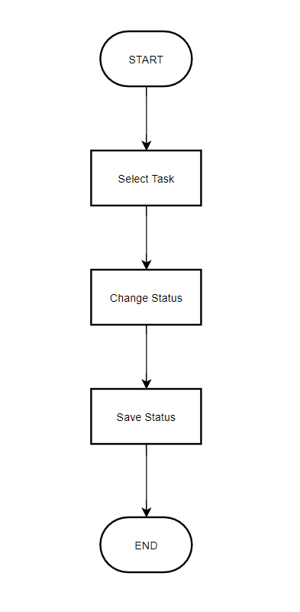

**Figure 25. Flowchart of the Proposed System (Update Task)**

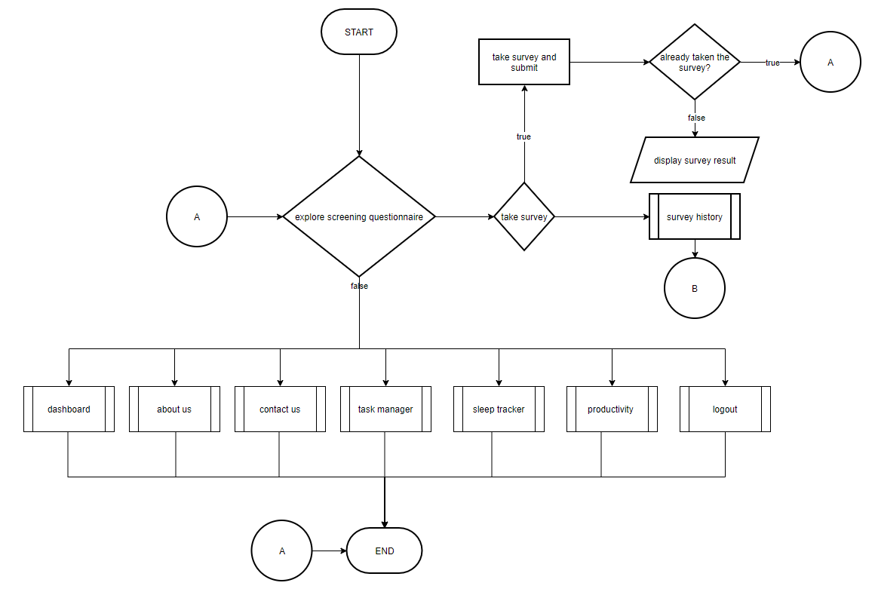

**Figure 26. Flowchart of the Proposed System (Self-Report Questionnaire Page)**

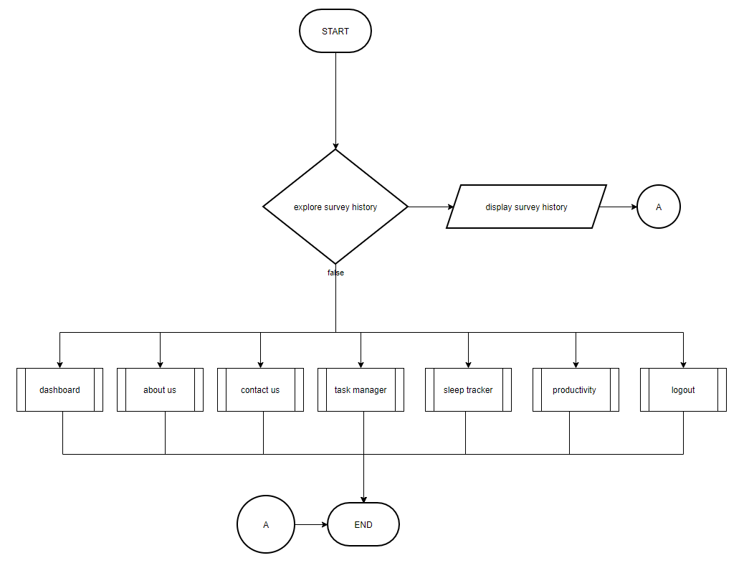

**Figure 27. Flowchart of the Proposed System (Self-Report Questionnaire History)**

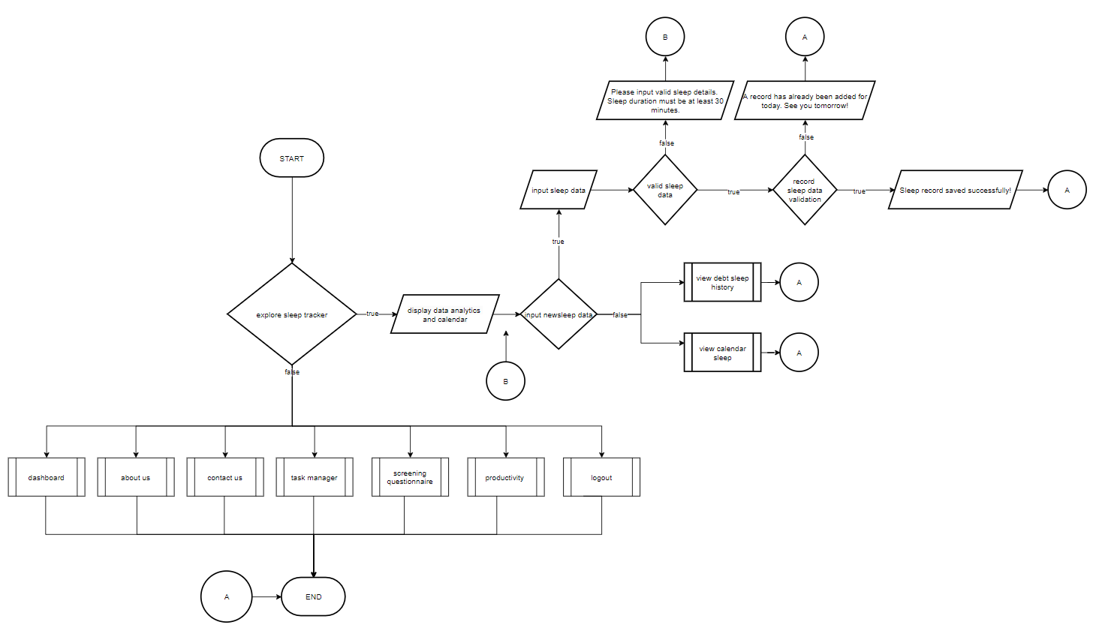

**Figure 28. Flowchart of the Proposed System (Sleep Tracker Page)**

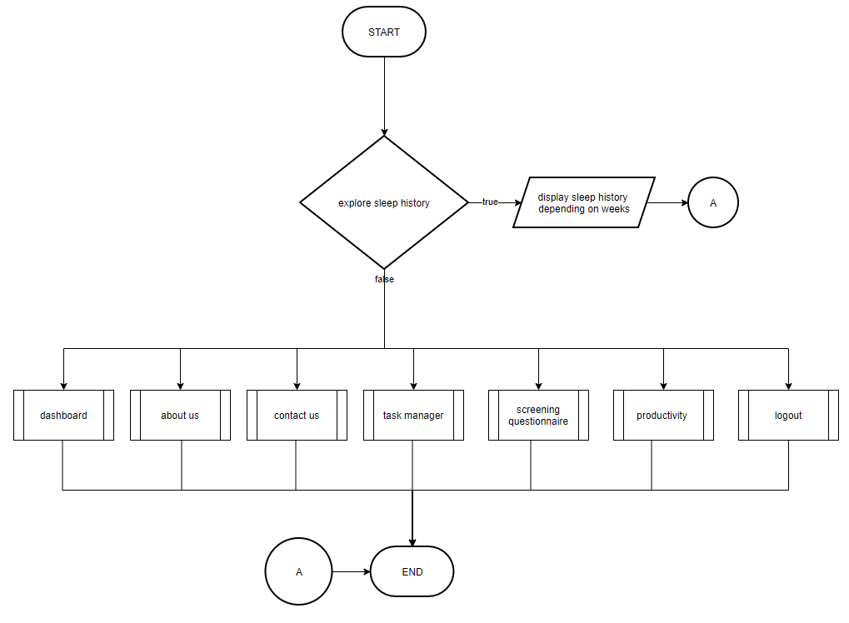

**Figure 29. Flowchart of the Proposed System (Sleep Debt History Page)**

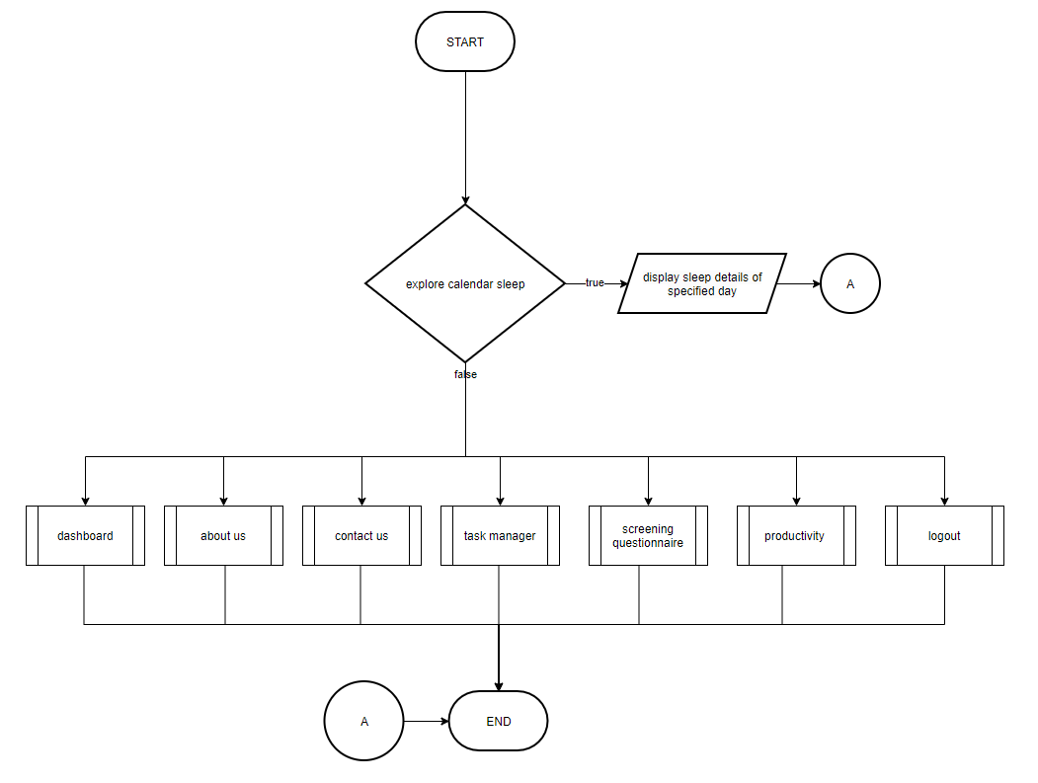

**Figure 30. Flowchart of the Proposed System (Sleep Calendar Page)**

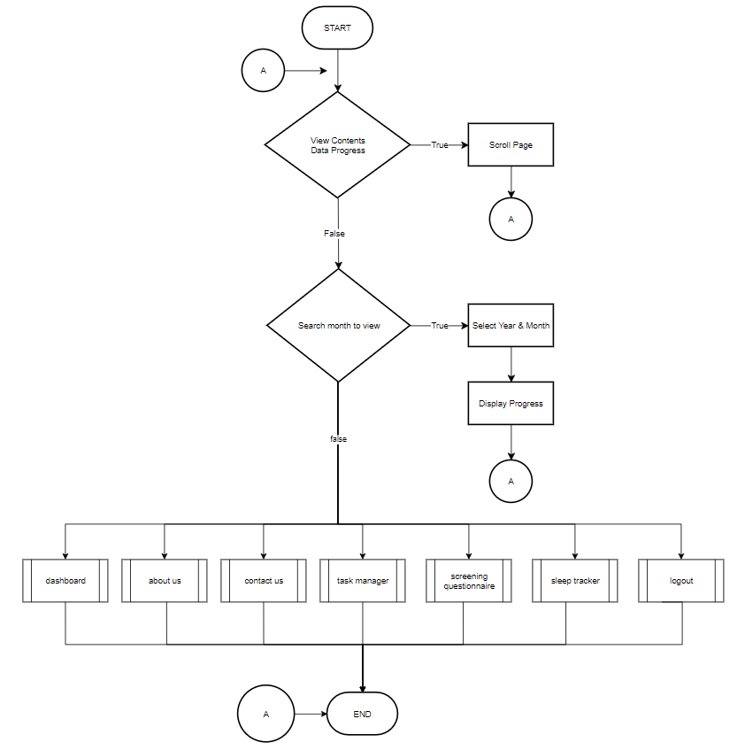

**Figure 31. Flowchart of the Proposed System (Progress Tracker Page)**

#### Data Flow Diagram of the Proposed System

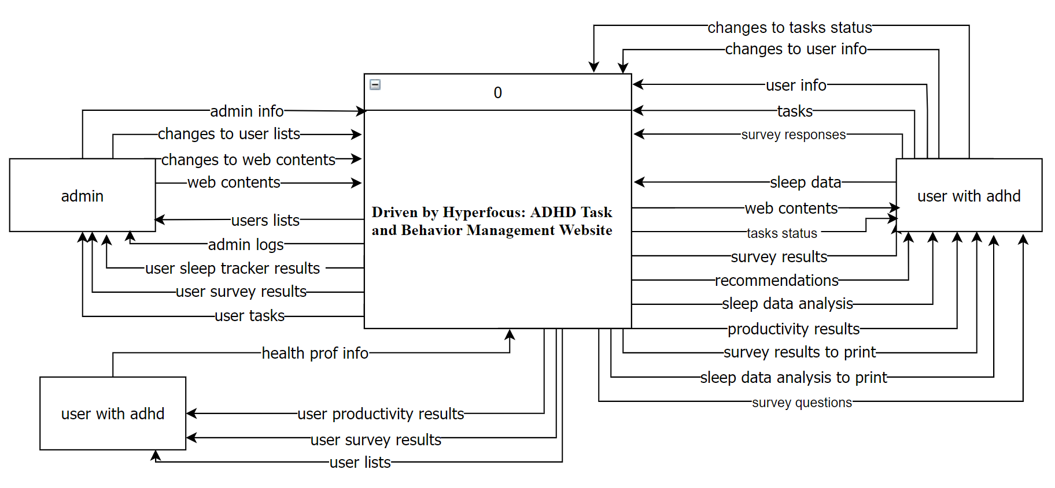

**Figure 32. Context Diagram of the Proposed System**

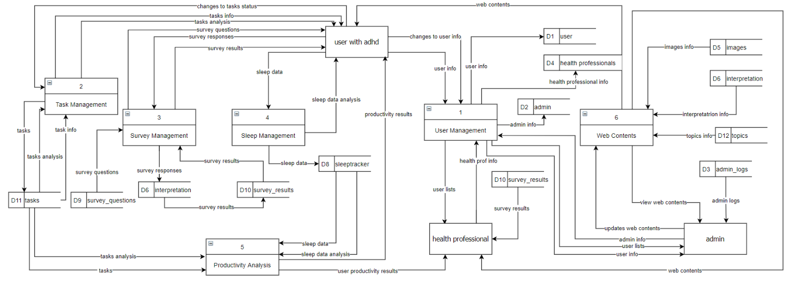

**Figure 33. Date Flow Diagram of the Proposed System (Level 0)**

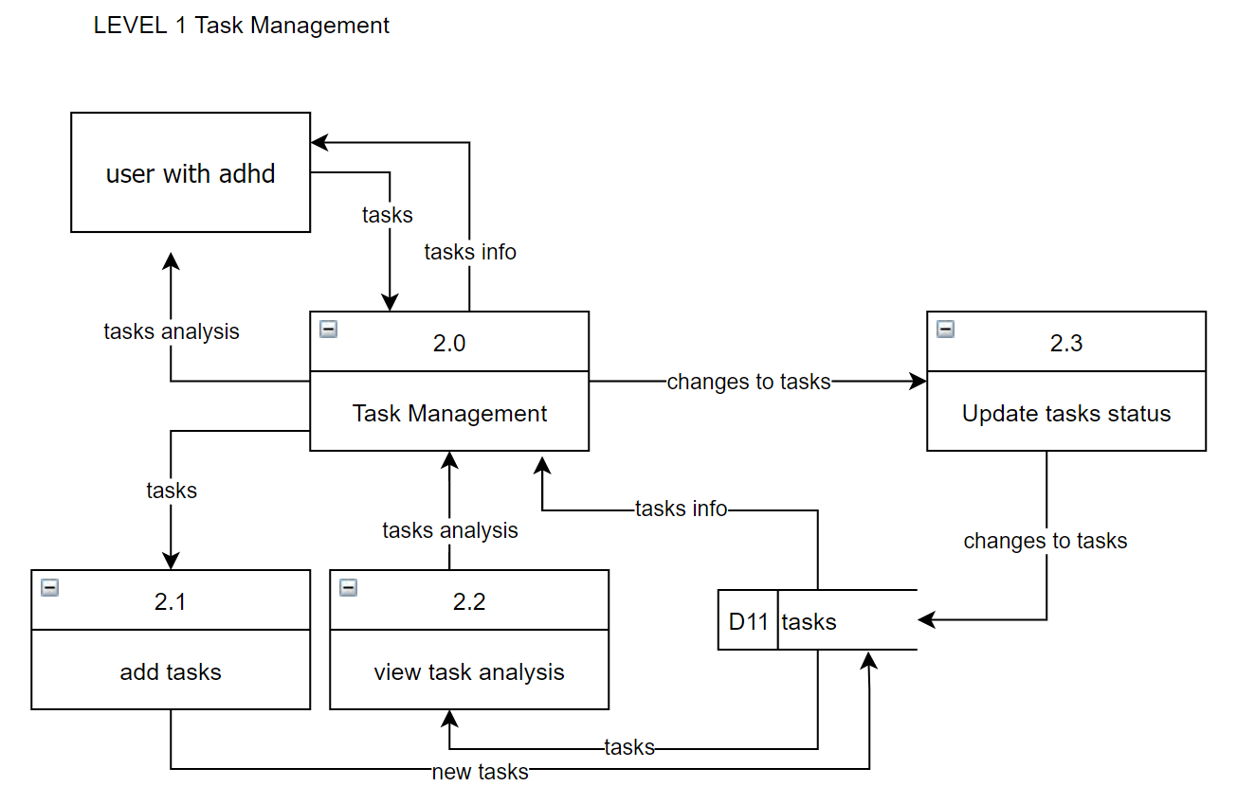

**Figure 34. Date Flow Diagram of the Proposed System – Task Management (Level 1)**

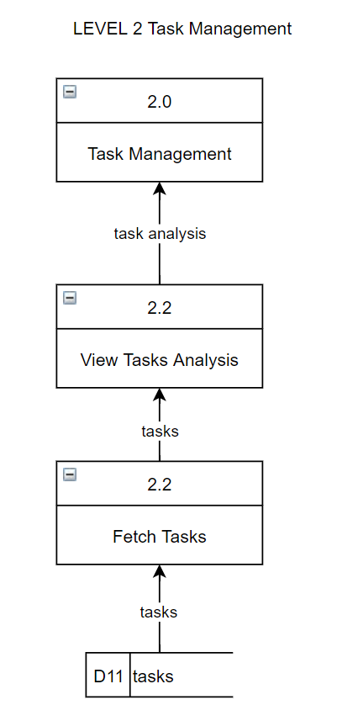

**Figure 35. Date Flow Diagram of the Proposed System – Task Management (Level 2)**

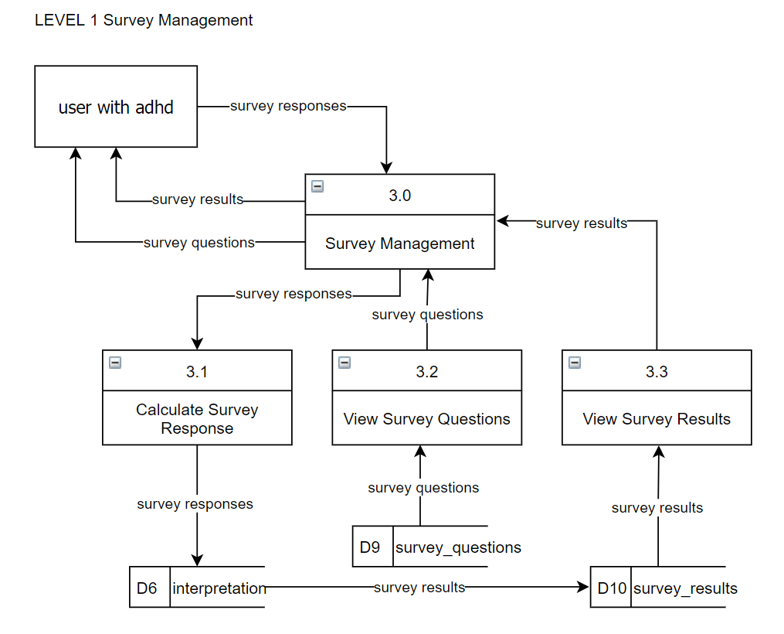

**Figure 36. Date Flow Diagram of the Proposed System – Self Report Survey Management (Level 1)**

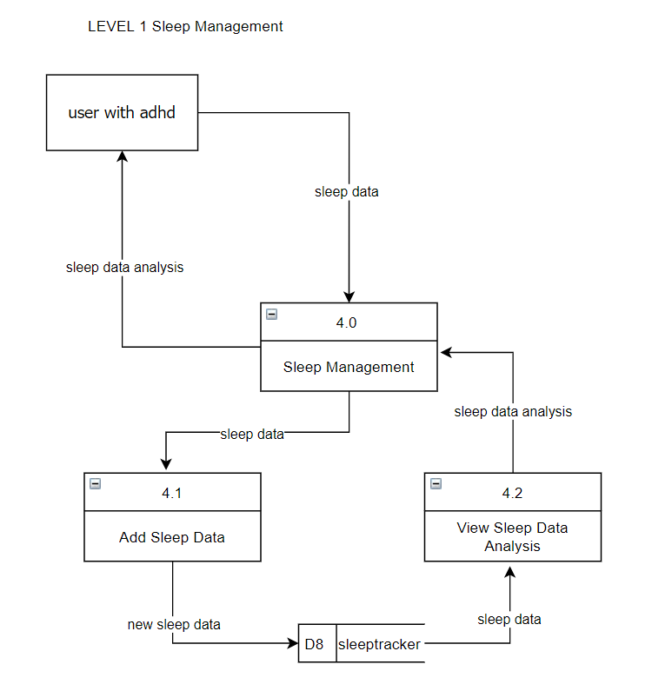

**Figure 37. Date Flow Diagram of the Proposed System – Sleep Management (Level 1)**

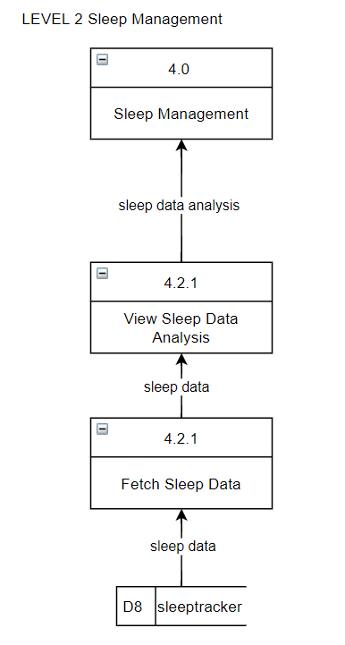

**Figure 38. Date Flow Diagram of the Proposed System – Sleep Management (Level 2)**

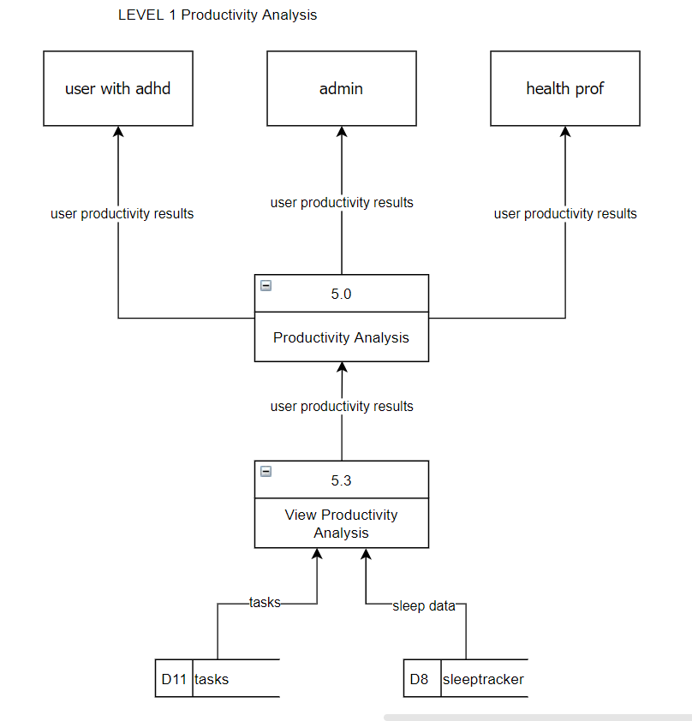

**Figure 39. Date Flow Diagram of the Proposed System – Progress Management (Level 1)**

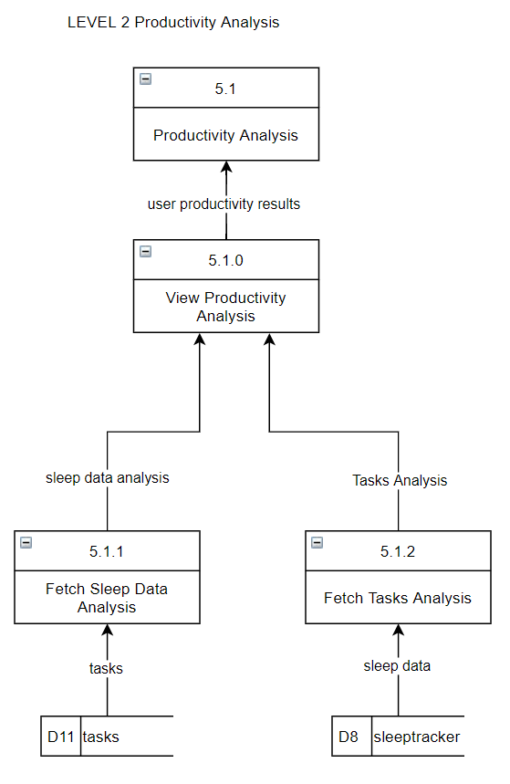

**Figure 40. Date Flow Diagram of the Proposed System – Progress Management (Level 2)**

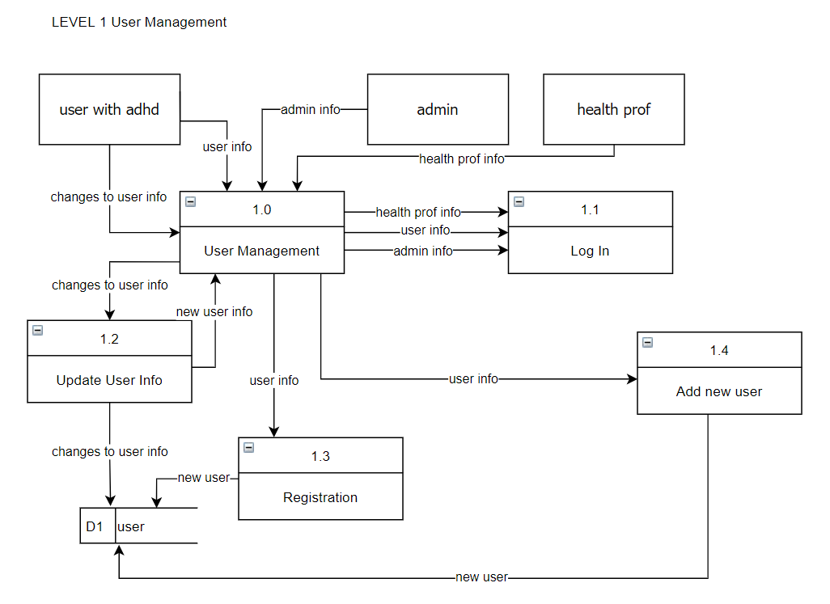

**Figure 41. Date Flow Diagram of the Proposed System – User Management (Level 1)**

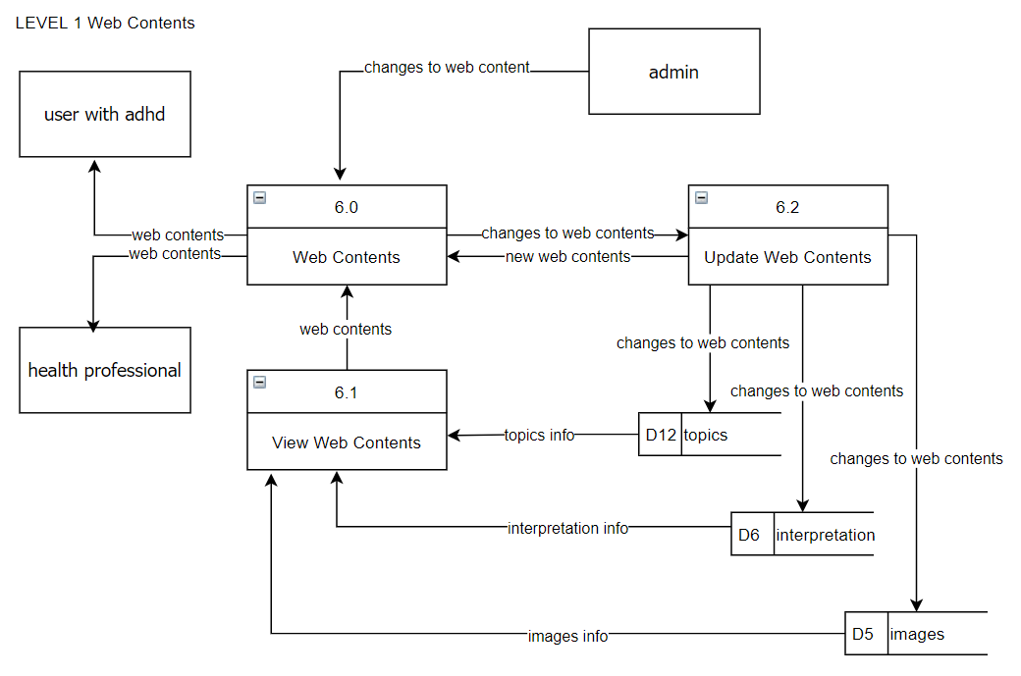

**Figure 42. Date Flow Diagram of the Proposed System – Web Contents (Level 1)**

### Requirements Documentation

#### Methods of Research

The researchers are employing the quantitative approach to gather ample and comprehensive numerical data for the assessment of the product. According to Mcleod (2023), quantitative research involves the process of objectively collecting and analyzing numerical data to describe, predict, or control variables of interest. The goals of quantitative research are to test causal relationships between variables, make predictions, and generalize results to wider populations [32].

The choice to apply quantitative research techniques is in line with our project's goals. Using these techniques, we want to collect quantifiable information that can be statistically examined and provide unbiased insights into a range of ADHD management issues. Williams (2021) stated the speed and efficiency of the quantitative method are attractive to many researchers. Data computing equipment makes it possible to process and analyze data quickly, even with large sample sizes. Surveys, polls, statistical analysis software and weather thermometers are all examples of instruments used to collect and measure quantitative data. [33]. Furthermore, bigger sample sizes are frequently used in quantitative research, which makes it easier to extrapolate findings that apply to a wider range of ADHD sufferers. By using statistical analysis, we can find patterns, connections, and trends in the data, which makes it possible to thoroughly evaluate how well interventions—like the ADHD Task and Behavior Management Website—support people with ADHD.

#### Research Instruments

The researchers have opted to employ survey questionnaires as the primary research instrument in their study. These questionnaires, designed to collect valuable data by gathering responses from beneficiaries, will utilize a 5-point Likert scale. The researchers distribute the survey online using Google Forms after user complete system testing, with the aim of reducing the use of printed materials.

ISO Evaluation Tool 25010

The Driven by Hyperfocus Website is being measured, described, and evaluated using this software quality standard. It offers a set of qualitative characteristics that can be contrasted to determine how closely the system complies with design requirements and how well it fulfills the non-functional requirements.

### Technical Background

#### Product Description

Driven by Hyperfocus: Task and Behavior Management Website is a Web-based system designed to aid people with ADHD (attention deficit hyperactivity disorder) in their daily work routines and behavior. It is specifically designed to cater the needs of people with ADHD in problems of Task Management, Behavioral Problems, Sleep, and Progress.

Driven by Hyperfocus: ADHD Task and Behavior Management Website is a brand-new platform that has been thoroughly designed to address the intricate problems caused by Attention- Deficit/Hyperactivity Disorder (ADHD) in the Philippines. This pioneering solution offers materials and tools that are easy to use to help manage work schedules and behavior patterns for people of all ages who are afflicted by ADHD. Utilizing profound discoveries from studies, such as the notion of "Hyperfocus," our platform seeks to increase efficiency and encourage self-control. There is a definite needfor easily available support materials, as ADHD is the neurological illness that people in the Philippines look for the most.

#### Economic Use of the Product

Driven by Hyperfocus is dedicated to providing Filipinos with Attention-Deficit/Hyperactivity Disorder (ADHD) with an affordable solution. The website offers an array of resources and solutions that are specially made to meet the unique problems associated with ADHD, assisting users in properly managing their symptoms without the need for pricey interventions or therapies.

However, the website will also have a feature that allows users to output their data in a form of a pdf so that they can use the results for their consultation in case they seek professional help for therapy. Through tools like task management and behavioral tracking, the platform can also help users become more productive and reduce the financial burden associated with lost productivity and healthcare expenses related to ADHD.

#### User Requirements

Users

* The users must have symptoms or must be diagnosed with ADHD.

Administrators:

* The admin must be able to have basic knowledge about how the system works and how they will monitor the account of the users.
* The admin must be the one to handle all the user request and concerns about the system itself.

Healthcare Professionals:

* Health professionals must have experience in the medical field particularly in neurology.
* Health professionals must be responsible for diagnosing patients with ADHD.

#### System Requirements

*3.3.4.1. Hardware Requirements*

* 1.8 GHz or faster processor. Quad-core or better recommended.
* GB of RAM; 8 GB of RAM recommended
* Hard disk space: Minimum of 800MB up to 210 GB of available space.
* An Internet Service Provider with at least 5 mbps speed is needed to use the system.

#### Software Requirements

* Windows 8, Windows 8.1, Windows 10
* Modern web browsers such as Google Chrome and other internet browsers are present in the mobile device for using the web application of the system.
* The mobile device must be able to connect to the Inernet either through Wi-Fi or mobile data.
* Database that will be present in the system will be PhpMyAdmin.
* Software: XAMPP Server 8.0.28 or Higher

### Development and Testing

Throughout the development of the system, the developers focused on creating a dynamic website for people diagnosed with ADHD. They used PhpMyAdmin for back-end programming and database management, ensuring a reliable system, while Native PHP was utilized for the front-end to meet the system's requirements. Hostinger was selected for its reliable hosting infrastructure, making it ideal for launching the website.

During the initial testing phase, the system was evaluated by five board members of the ADHD Society of the Philippines. Their feedback was crucial in ensuring the website's functionality and accessibility for individuals with ADHD. In the final testing phase, the system was tested by 30 respondents, including IT experts, additional board members, and users diagnosed with ADHD. This diverse group of testers helped ensure the system addressed the varied needs of its intended audience. A survey based on the ISO/IEC 25010 evaluation system was used to gather structured feedback after the testing process. This thorough approach allowed the team to refine the system, addressing any issues and improving the overall user experience of users and beneficiary.

### Description of the Prototype

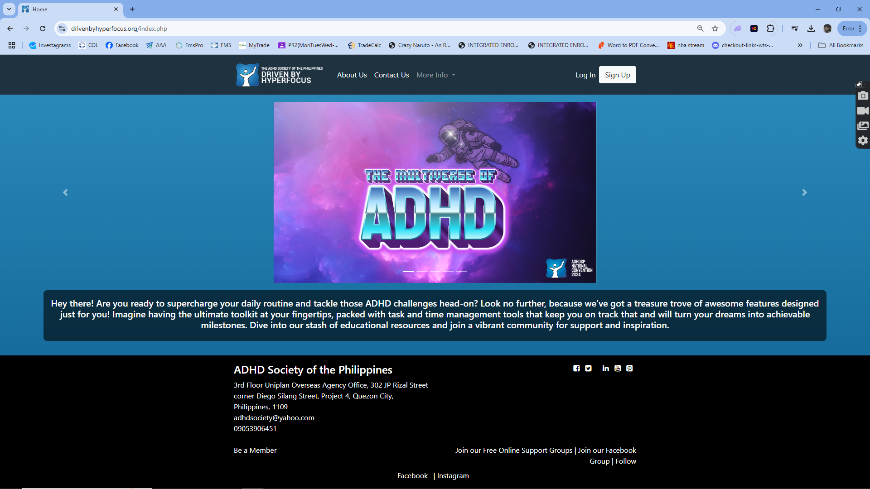

##### Figure 43. Guest Dashboard

This is the page where user lands when they connect to our website. user,admin, and adhd professionals can also log-in here.

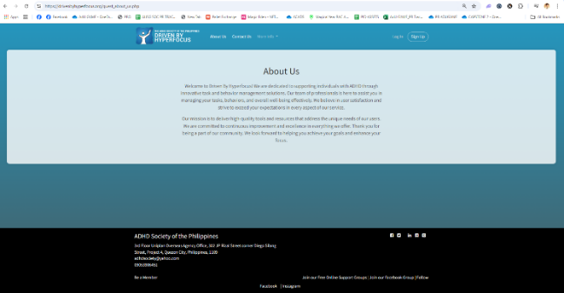

##### Figure 44. About Us Page

This is the page that contains the About Us section of our website

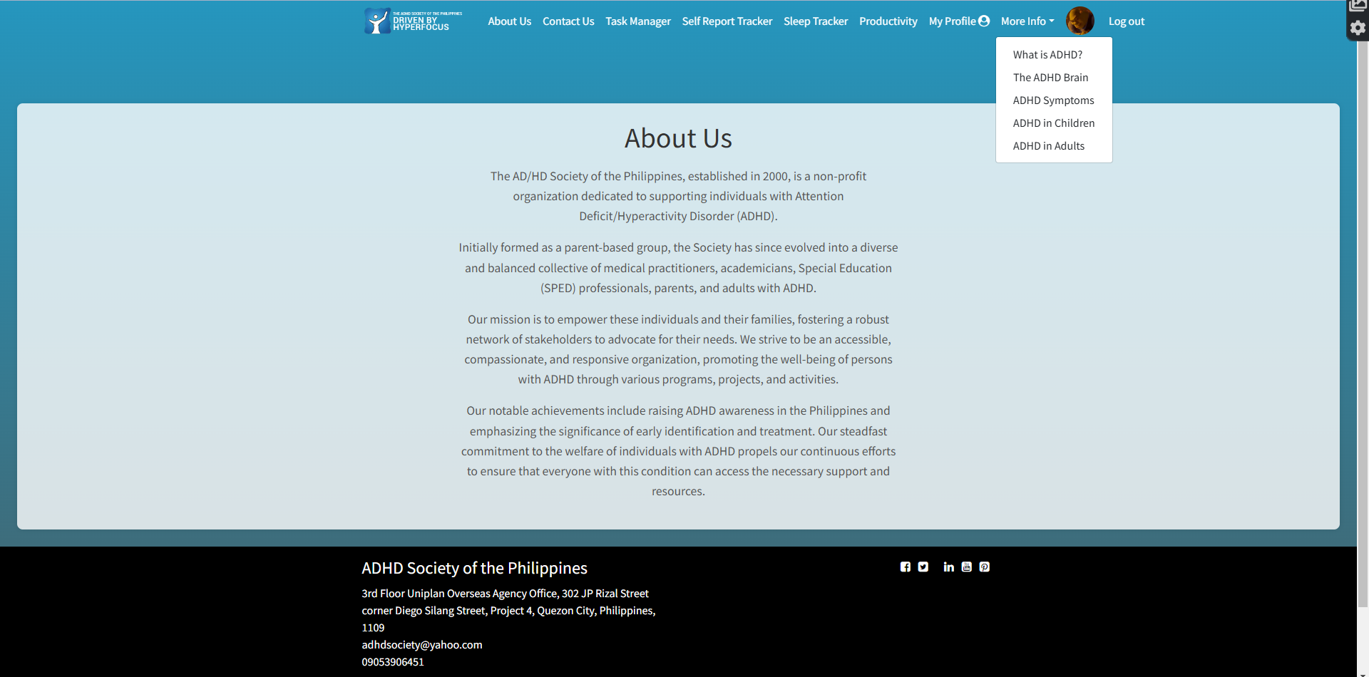

##### Figure 45. Drop Down Menu

This contains details about ADHD (Attention Deficit Hyperactive Disorder)

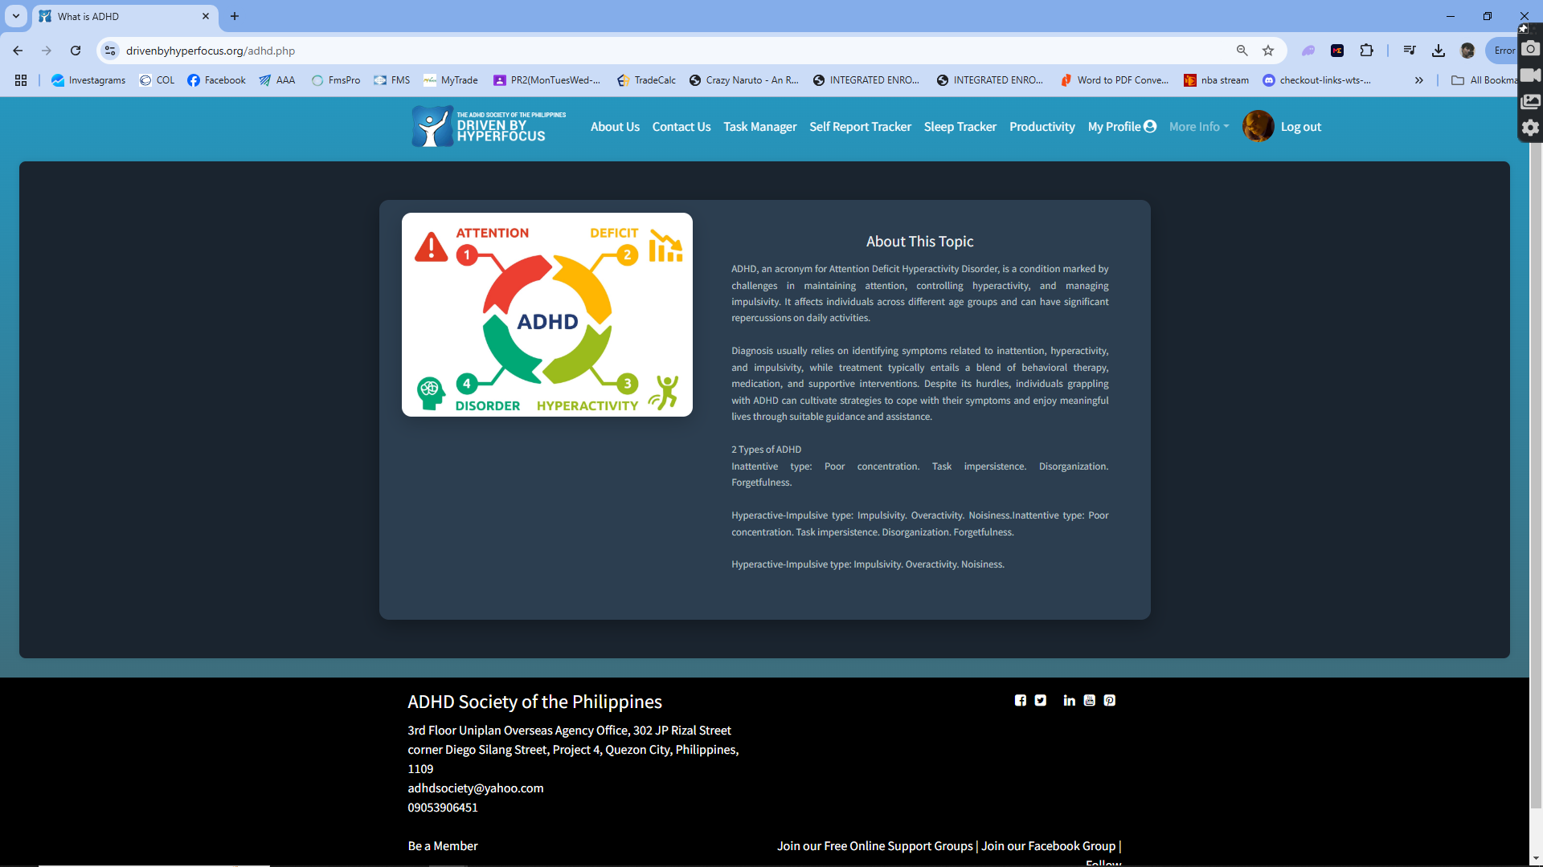

##### Figure 46. What is ADHD

This is an introduction about what is ADHD and what are the 3 types of ADHD.

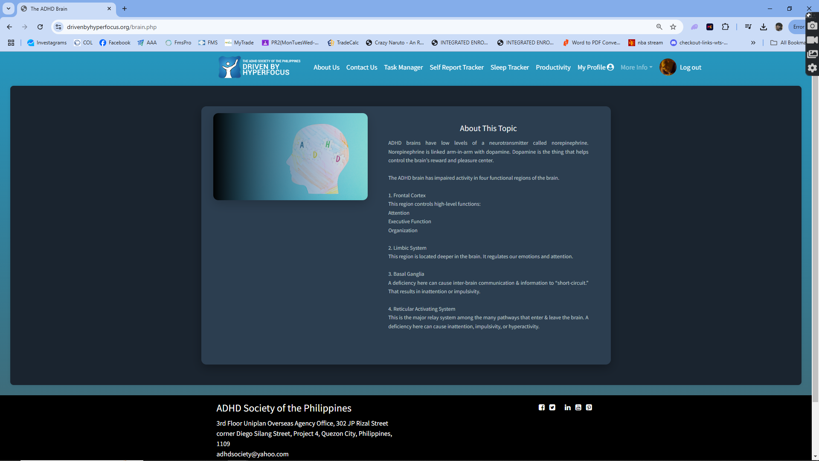

##### Figure 47. The ADHD Brain

This page contains details about how a person with ADHD thinks.

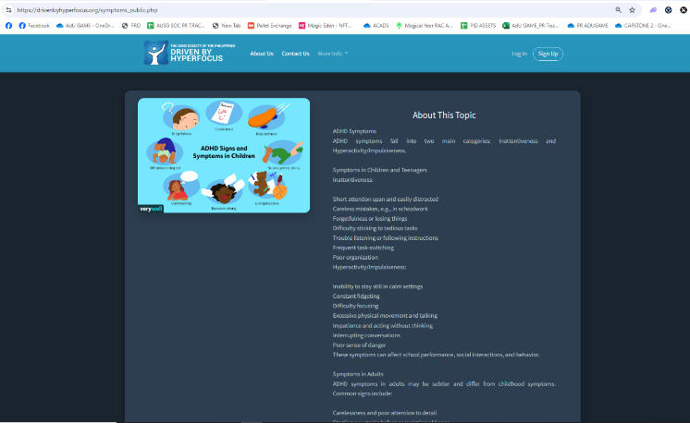 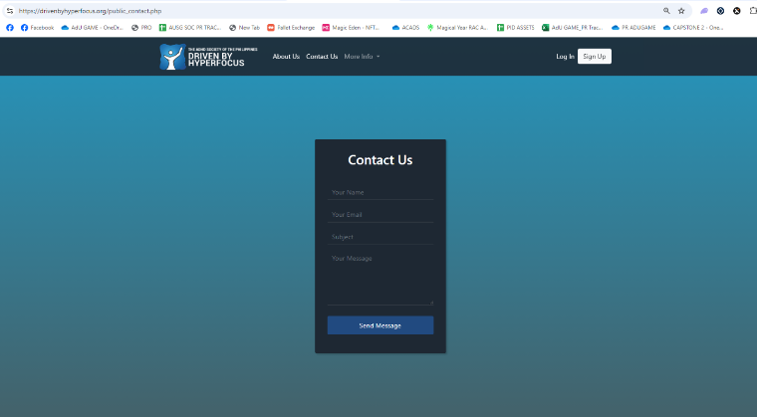

##### Figure 48. ADHD Symptoms

This page discusses the symptoms of ADHD.

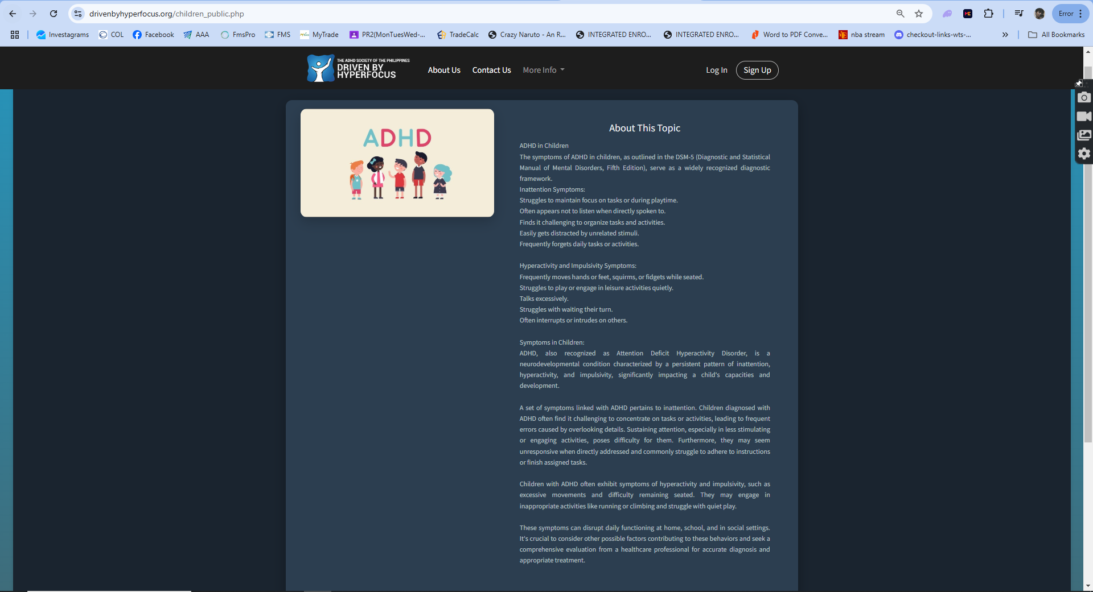

##### Figure 49. ADHD in Children

This page discusses the ADHD in children.

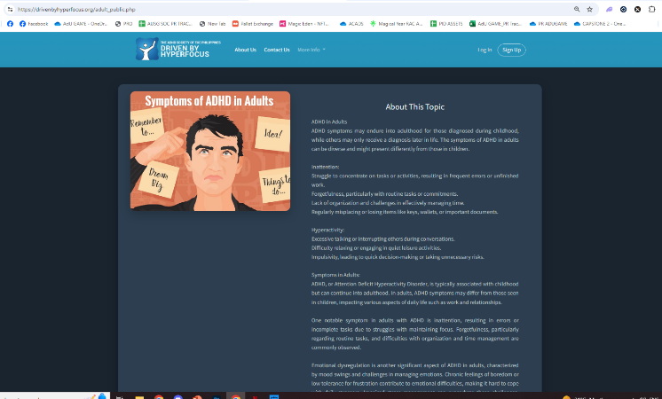

##### Figure 50. ADHD in Adult

This page discusses the ADHD in adults.

##### Figure 51. Contact Us Page

This is the page where the user can submit concerns for now the developers are the admin but once the project is finished the developers will turnover the admin role to the technical team of the beneficiary

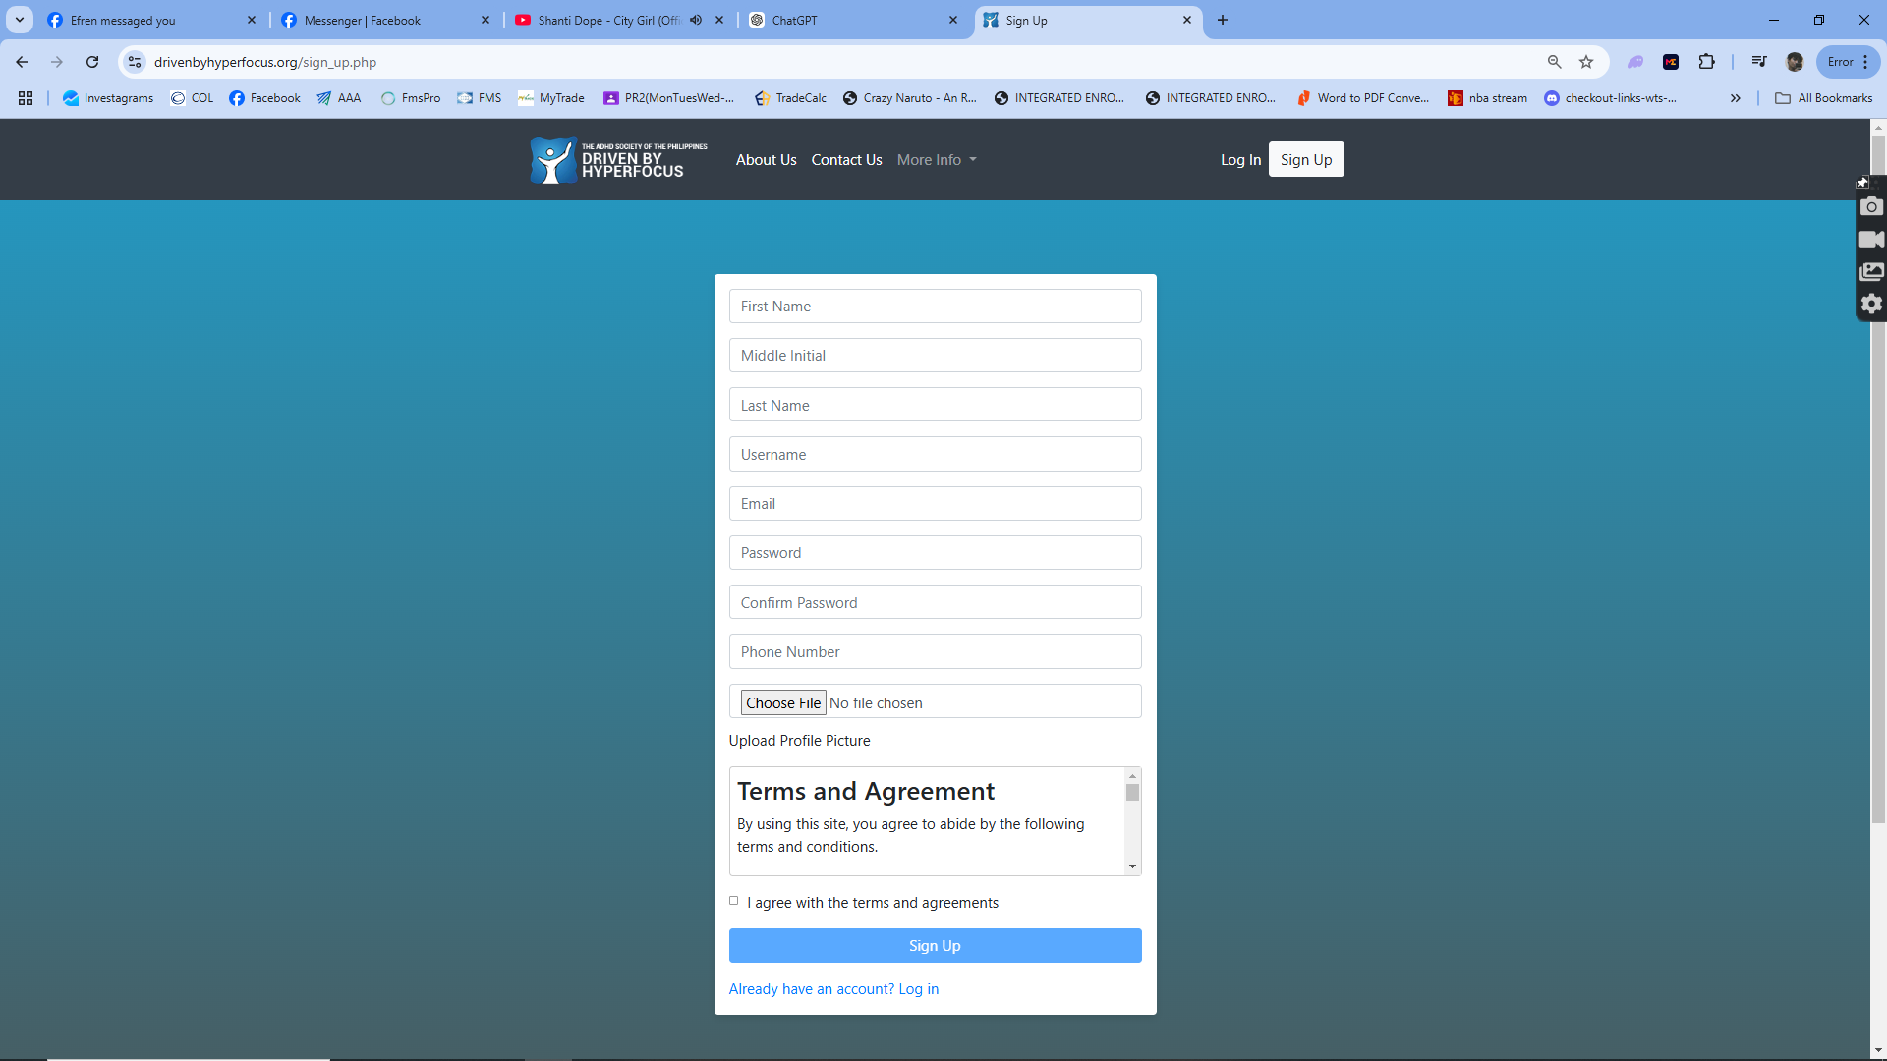

##### Figure 52. Create Account Page

This is the page where user lands when they want to create a user account on our website

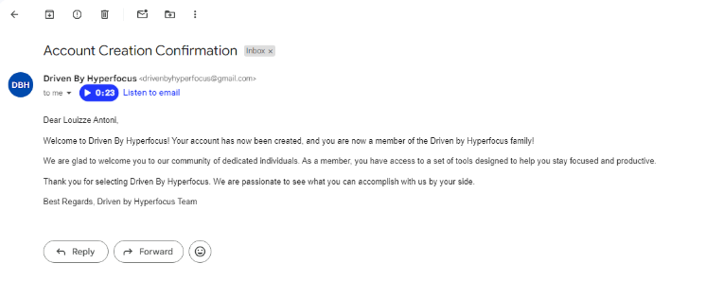

##### Figure 53. Email Notification

This is the page where the user gets notified upon registering on our website.

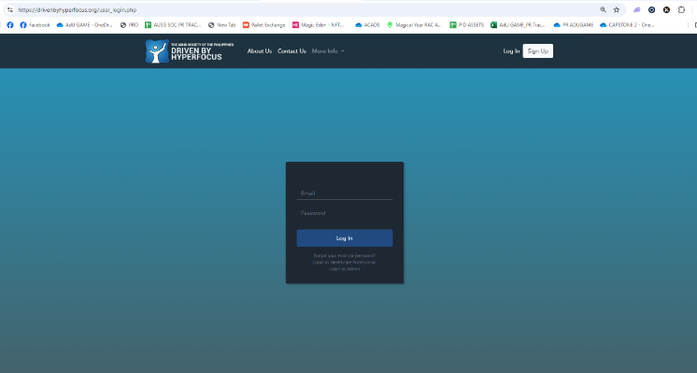

##### Figure 54. Sign-In Page

This is the page where the user and admin must sign in to access the features of the website

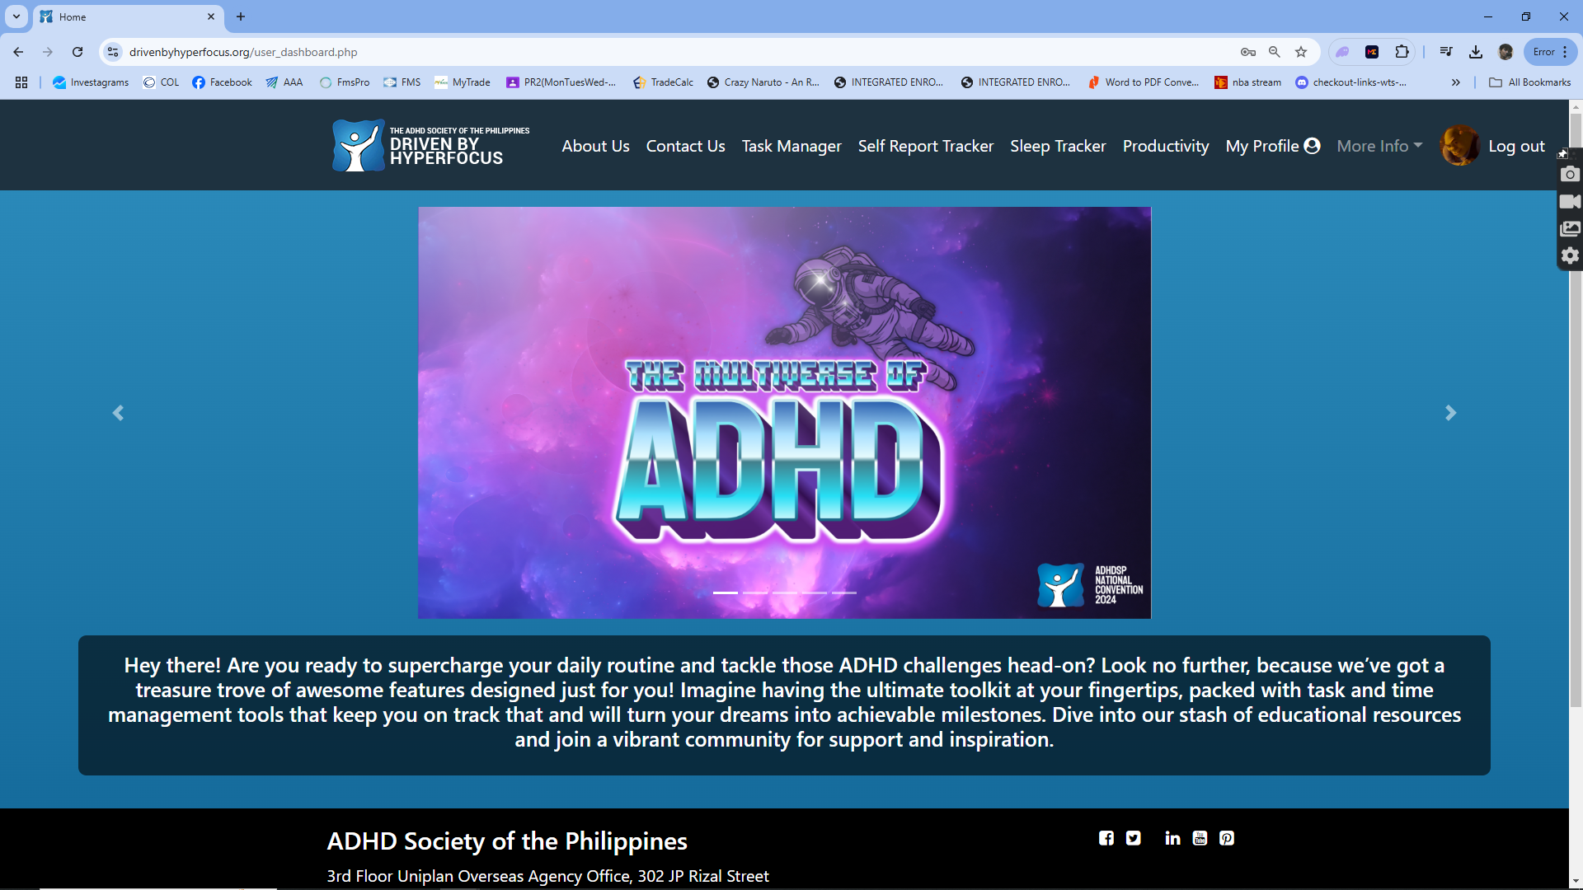

##### Figure 55. Home Landing Page

This is the page where the user is welcomed after signing in

##### Figure 56. Task Manager Page

This is the page where the user can manage tasks and have clear visual representation of his own data.

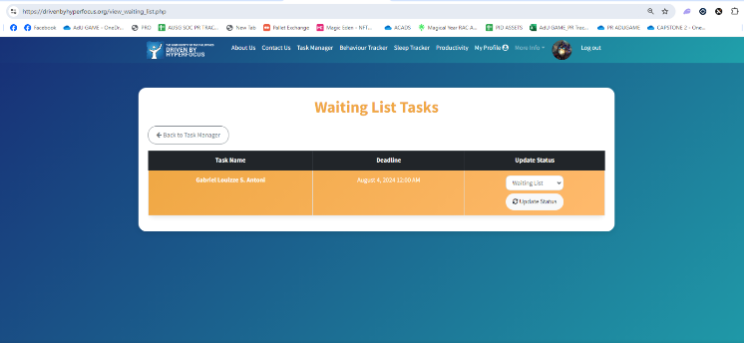

##### Figure 57. Update Task Details

This is the page where the user can view and update his Do Today Tasks.

##### 

##### Figure 58. Check User Details

##### This is the page where health professionals within the organization check the data of the users.

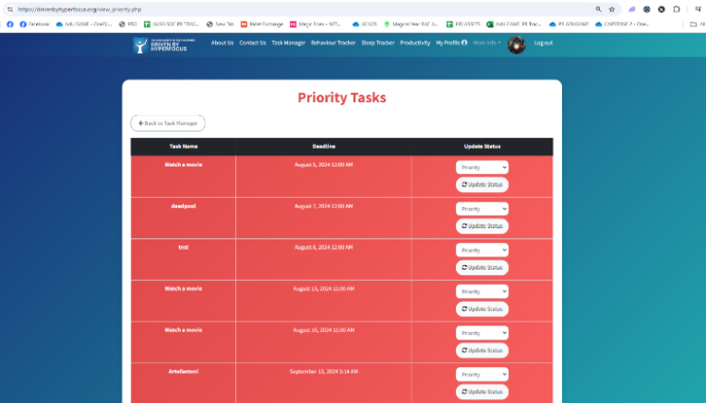

##### Figure 59. View Priority Tasks Page

This is the page where the user can view and update his Priority Tasks.

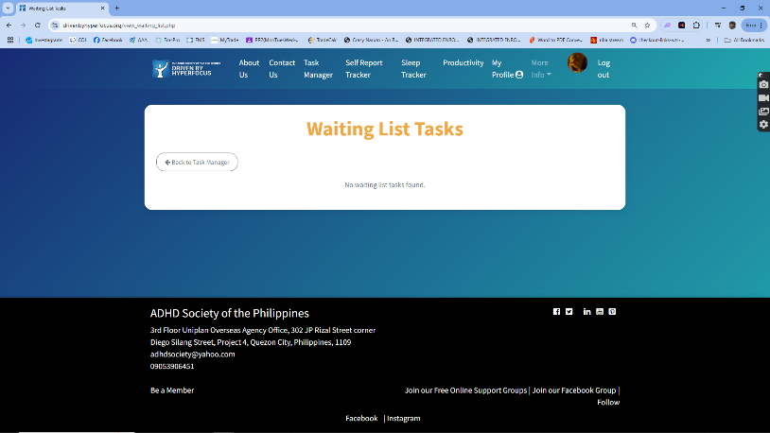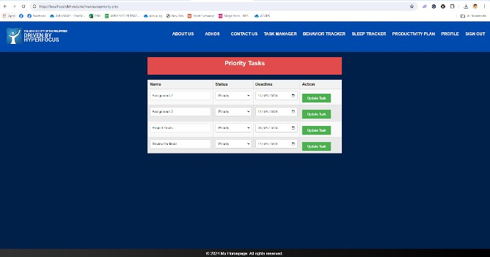  
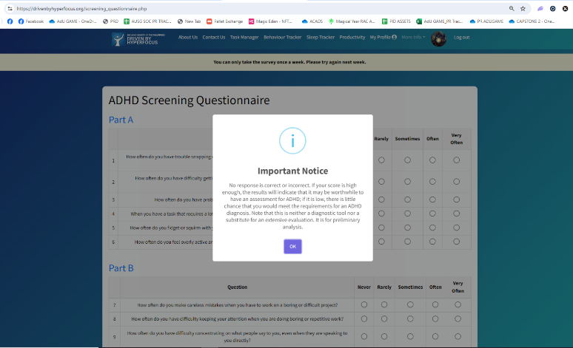

##### Figure 60. View Waiting List Page

This is the page where the user can view and update his Priority Tasks.

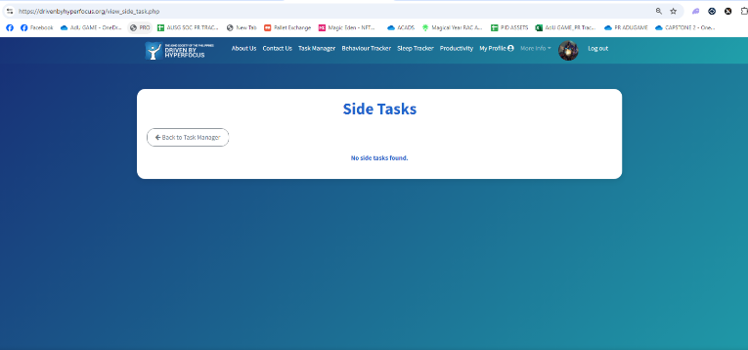

##### Figure 61. Side Tasks Page

This is the page where the user can view and update his Do Today Tasks.

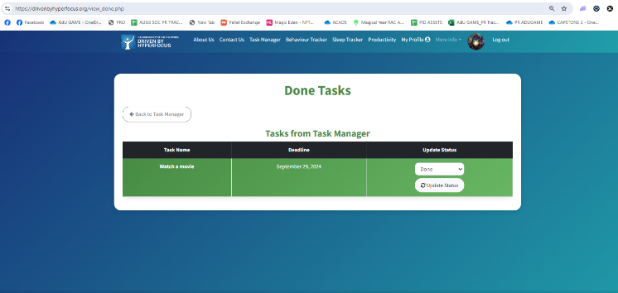

##### Figure 62. Done Tasks Page

This is the page where the user can view and update his Done Tasks.

##### Figure 63. Self-Report Test Page

##### This is the page where the user can answer a standardized and approved survey form for individuals with ADHD

##### 

##### Figure 64. Self-Report Test Results

##### This is the page where the user can view his/her results and decide if he/she wants to consult with a health professional

##### 

##### Figure 65. User Profile

##### This is the page where the user can update his username, email, profile picture, and password.

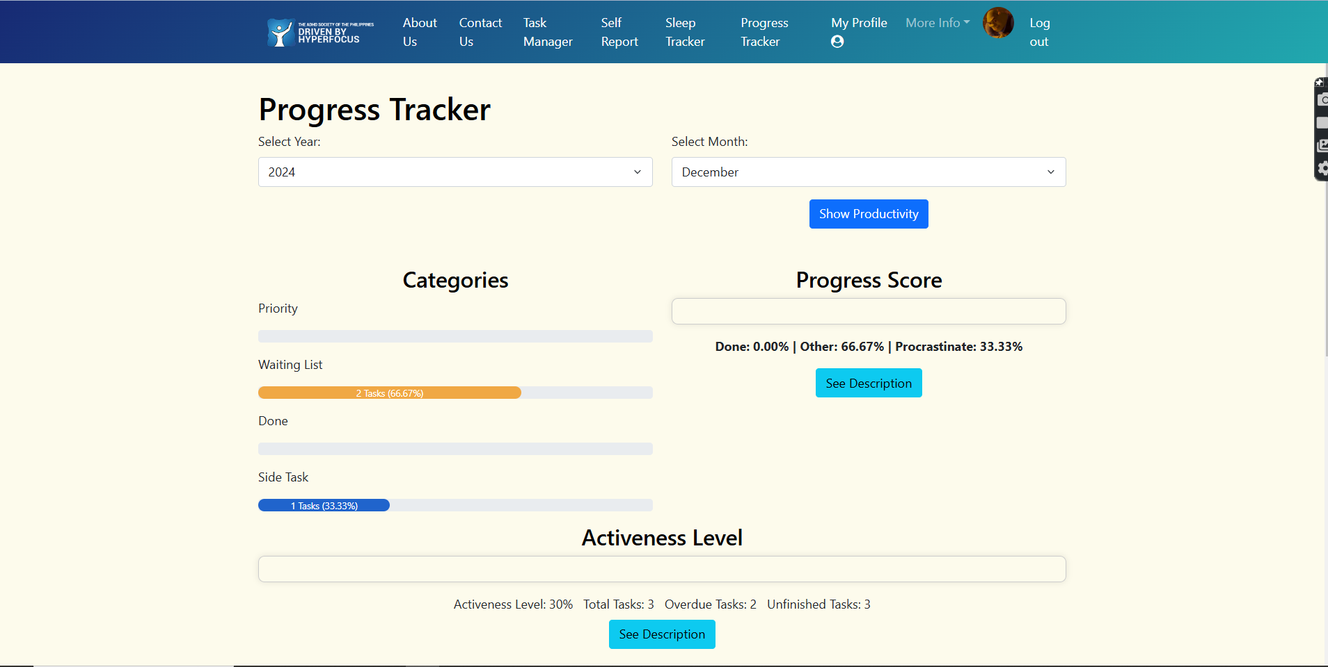

##### Figure 66. Progress Tracker

##### This is the summarized data of the users, which serves as progress depending on their tasks and performance.

##### 

##### Figure 67. Sleep Tracker Page

##### This is the page where the user can input their time of sleep and the time they woke up; it also includes some analytics based on the users’ input.

##### 

##### Figure 68. Calendar Sleep Page

##### This is the page where the sleep data inputted by the user in the same day are displayed.

##### 

##### Figure 69. Sleep Debt History

##### This is the page where you can view the simplified current and previous weeks’ history.

##### 

##### Figure 70. Sleep Debt Details

##### This the page where you can view the sleep debt and overslept of the user within the current week.

##### 

##### Figure 71. Admin Log-in page

##### This is the page where an admin can log in.

##### 

##### Figure 72. Admin Dashboard

##### This is the page where the admin is logged in.

##### 

##### Figure 73. Web Contents

##### This is the page where the admin can replace information and images inside the website.

##### 

##### Figure 74. Manage Users

##### This is the page where the admin can manage the users on the website.

### Implementation Plan

Driven by Hyperfocus intends to create a web-based platform designed to support individuals with ADHD. Additionally, the platform seeks to increase users' self-esteem by highlighting that they are capable of developing important skills that can lead to success and personal development, despite ADHD-related obstacles. Additionally, encouraging individuals with ADHD to become self-aware is the primary objective of the website. The developers are willing to give users, particularly the primary beneficiaries, full-time training because the database will store all of the system's data, track inputs and outputs automatically, and require users to understand their roles, how to use the system, and what it can and cannot do. As soon as the system is established, training for the beneficiaries will begin. Given that the system must be accessible for people diagnosed with ADHD and other health professionals, it will be made available to the target users via a live server that is also accessible to the public. In terms of technical support, the developers will visit the beneficiary on a regular basis to ensure that the system is still functioning properly and to ward off any potential problems.

### Implementation Results

The system was fully implemented by the researchers at the time of implementation, operational, and to verify there are no mistakes and that the suggested system is stable, functional and satisfies the demands of the intended individuals, including the people diagnosed with ADHD, Administrator, and Healthcare Professionals.

### SUMMARY, CONCLUSION, AND RECOMMENDATION

### Summary

The responses given by the target users justify the need for the tool. The proposed system serves their purposes and solves some of the major problems encountered by the ADHD population and attending healthcare professionals. Table 2 shows that the majority, having a 4.51 mean score and strongly agreeing, believed that all of the designated tasks and user objectives are covered by the features of the website.

The techniques and technology now in use for managing and supporting ADHD are comprehensively addressed. The research emphasizes the lack of personalized easily navigable platforms designed especially for people with ADHD. Many current systems, as was mentioned, are not flexible enough to accommodate a wide range of user needs. By include features like adaptable learning features, effective data analytics, and dashboards that can be customized, the suggested system fills in these gaps. The comparison of the suggested system with current solutions is shown in Figure 3 and Figure 24, which demonstrates its superiority in terms of usability, functionality, and ease of use.

Demonstrated how to develop and test the system using the ISO 25010 quality model, which evaluated the system's quality. Quantitative surveys with target users, such as people with ADHD, medical professionals, board members of the beneficiary organization, and IT specialists, were conducted using a mixed-methods approach.

Evaluation of the proposed system using ISO 25010 Quality Model  
  
**Table 1. Total Mean Indicator**

|  |  |
| --- | --- |
| **Mean Range** | **Indicator** |
| 4.5 - 5.0 | Excellent |
| 4.0 - 4.49 | Very Good |
| 3.5 - 3.99 | Good |
| 3.0 - 3.49 | Fair |
| 0.0 – 2.99 | Poor |

**Table 2. Testing Result using ISO 25010 Quality Model**

|  |  |  |
| --- | --- | --- |
| **Indicators** | **Mean** | **Interpretation** |
| 1. Functionality Suitability | 4.51 | Excellent |
| 1. Performance Efficiency | 4.46 | Very Good |
| 1. Compatibility | 4.7 | Excellent |
| 1. Usability | 4.46 | Very Good |
| 1. Reliability | 4.47 | Very Good |
| 1. Security | 4.51 | Excellent |
| 1. Maintainability | 4.51 | Excellent |
| 1. Portability | 4.62 | Excellent |
| Total Mean | 4.45 | Very Good |

According to the ISO 25010 Quality Model evaluation results, the developed system received an average of 4.45, which is interpreted as "Very Good". These findings can be explained by the following factors:

1. The proposed system provides features that exceed the needs and expectations of the users.
2. The proposed system performs exceptionally well when it comes to processing requests and responding to them in a timely manner.
3. The proposed system is highly responsive, capable of performing its functions on other devices or products with minimal adjustments to its interface design.
4. The proposed system includes advanced features that significantly enhance task efficiency and user satisfaction.
5. The proposed system is consistently available and reliable whenever a user requests information or makes a request.
6. The proposed system ensures that the data being processed is only accessible to authorized users, with robust security measures in place.
7. The proposed system is adaptable and can be easily modified without compromising its overall quality or performance.
8. The proposed system is flexible and can be seamlessly applied to a wide variety of situations and use cases.

Following a comprehensive discussion of the evaluation's responders, the researchers offer the respondents suggestions to enhance the viability of this proposal's output. Each respondent is an expert in their respective field, including individuals with ADHD, healthcare professionals related to ADHD, board members of our beneficiary organization, and IT experts. They were chosen for their training and experience, ensuring that all responders have relevant expertise in their areas. This is crucial to ensure that all responders possess the necessary knowledge to assess the project's effectiveness from multiple perspectives.

### Conclusion

Based on the results, the researchers therefore conclude that all the objectives for the system were successfully met, as confirmed by the evaluation using the ISO 25010 Quality Model for Websites. The system was rated “Excellent” overall, with outstanding functionality and performance. This is attributed to the wide range of features designed specifically to support individuals with ADHD. The system received a 4.7 rating for compatibility, making it highly suitable for individuals with ADHD, healthcare professionals, and other related stakeholders. The platform effectively supports individuals with ADHD by helping them develop essential skills, improve self-esteem, and become more self-aware despite the challenges they face. It also offers valuable resources for personal development and success. The website is accessible on both desktops and smartphones, ensuring users have a seamless and engaging experience across devices. The task management system effectively helps break down tasks and prioritize important activities, which is essential for users with ADHD. Additionally, the self-report tracker, sleep tracker, and progress tracker are fully functional, enabling users to monitor their behaviors, sleep patterns, and progress. Personalized recommendations based on analyzed survey data further enhance the user experience by providing tailored insights for self-improvement and goal achievement. Furthermore, the website’s design and features cater specifically to the unique needs of individuals with ADHD, ensuring it serves as an invaluable resource for both personal growth and practical support. The successful testing and evaluation process has validated the system’s effectiveness, confirming that it meets the goals of enhancing emotional intelligence, task management, and overall well-being for its users.

### Recommendations

In light of the findings and conclusions, the following recommendations are made:

1. Add more customization options to allow users to personalize their experience on the platform.
2. Increase the utilization of existing features to enhance user engagement and support.
3. Update the UI interface for both administrators and healthcare professionals to improve usability and functionality.
4. Include adaptive learning modules that are suited to the needs and progress of specific users.
5. Strengthen data security measures to further ensure the protection of user information.

### Acknowledgement

### The accomplishment of this study was made possible by the important individuals who counseled and helped the proponents during the preparation of this capstone project. The following individuals have helped the proponents expand their thoughts during this study, and they have our deepest gratitude for it.

### First, we would like to dedicate this to almighty God for providing us our needed knowledge and wisdom as well as motivation in the stages of the development and completion of our capstone project.

### To Mrs. Charlene Vergara-Gonzales, our technical adviser, for her patience, assistance, guidance and for pushing us even further whenever we are lacking at times. This Capstone Project wouldn’t be possible without her insightful criticisms and guidance.

### To Dr. Leonard L. Alejandro and Mrs. Ma. Carmela Racelis, our Information Technology Capstone Class Advisers, for sharing their knowledge and experience with us and demonstrating to us how to format the paper correctly.

### To our dear Panelists, Dr. Leonard Alejandro, Mr. Jasper Jude Medina, Ms. Marielle Villarey and Ms. Florence May B. Resontoc, for freely giving of their time, skills, and knowledge to us. Their recommendations and astute critiques enhanced the system.

### To ATTENTION DEFICIT HYPERACTIVITY DISORDER (ADHD) SOCIETY OF THE PHILIPPINES, our beneficiary, for their collaboration, willingness, and valuable time during the capstone project's creation.

### To our Respondents, who helped the system's proponents achieve their goals by taking the time to analyze, evaluate, and reply to the surveys.

### To our colleagues and friends, we appreciate all of your unwavering encouragement, support, and readiness to stand by us in difficult times.

### Lastly, to the proponents’ loving Parents and Family, who during the research project consistently offered us assistance in the form of financial, psychological, and spiritual resources. Their support lifted the proponents' morale.

### REFERENCES

1. Russell A. Barkley, PhD. (2018, July 20). *ADHD and Executive Functioning - CHADD*. CHADD. <https://chadd.org/attention-article/adhd-and-executive-functioning/>
2. ADHD Society of the Philippines. (2023, August 9). *The ADHD Society of the Philippines*. The ADHD Society of the Philippines. <https://www.adhdsocphils.org>
3. Adler, L., Kessler, R., & Spencer, T. (2003). *Adult ADHD Self-Report Scale (ASRS-v1.1) Symptom Checklist Instructions*. <https://add.org/wp-content/uploads/2015/03/adhd-questionnaire-ASRS111.pdf>
4. Adult ADHD Self-Report Scale (ASRSv1.1). (2024). *Adult ADHD Self-Report Scale (ASRSv1.1)*. Psychology Tools. <https://psychology-tools.com/test/adult-adhd-self-report-scale>
5. Alonto, A. H. D., Apor, A. D. A. O., & Jamora, R. D. G. (2022). Burden of Neurological Diseases in the Philippines as Revealed by Web Searches: An Infodemiological Study. *International Journal of Environmental Research and Public Health*, *19*(24), 16736. <https://doi.org/10.3390/ijerph192416736>
6. American Psychiatric Association. (2000). *Diagnostic and Statistical Manual of Mental Disorders, Fourth Edition, Text Revision (DSM-IV-TR)*. American Psychiatric Association. <https://doi.org/10.1176/appi.books.9780890423349>
7. Ashinoff, B. K., & Abu-Akel, A. (2019). Hyperfocus: the Forgotten Frontier of Attention. *Psychological Research*, *85*(1), 1–19. <https://doi.org/10.1007/s00426-019-01245-8>
8. Biederman J, S V Faraone, T Spencer, T Wilens, D Norman, K A Lapey, E Mick , B K Lehman, & A Doyle. (1993). Patterns of psychiatric comorbidity, cognition, and psychosocial functioning in adults with attention deficit hyperactivity disorder. *American Journal of Psychiatry*, *150*(12), 1792–1798. <https://doi.org/10.1176/ajp.150.12.1792>
9. Flores, J. L., Hernandez, M. A., Leyva, E. W., Marysol Cacciata, Tuazon, J., & Evangelista, L. (2018). PREVALENCE AND CORRELATES OF DEPRESSION, ANXIETY, AND DISTRESS AMONG FILIPINOS FROM LOW-INCOME COMMUNITIES IN THE PHILIPPINES. *The Philippine Journal of Nursing*, *88*(2), 8. <https://pmc.ncbi.nlm.nih.gov/articles/PMC8088195/>
10. Glaiza Madulara. (2021). Association Between Allergic Diseases and Attention-Deficit/Hyperactivity Disorder (ADHD) Symptoms in Children Aged 6–12 Years Using the Filipino Version of the Vanderbilt ADHD Parent Rating Scale. *Journal of Medicine, University of Santo Tomas*, *5*(1), 628–641. <https://www.academia.edu/81652316/Association_Between_Aller>
11. Hamilton, N. J., & Astramovich, R. L. (2016). Teaching Strategies for Students with ADHD: Findings from the Field. *Education*, *136*(4), 451–460. <https://eric.ed.gov/?id=EJ1104213>
12. Heiervang, E., & Goodman, R. (2009). Advantages and limitations of web-based surveys: evidence from a child mental health survey. *Social Psychiatry and Psychiatric Epidemiology*, *46*(1), 69–76. <https://doi.org/10.1007/s00127-009-0171-9>
13. INTERQUALITY. (2024). *AGILE METHODOLOGY*. Interqualitybg.com. <https://interqualitybg.com/en/resources/scrum-and-agile-resources/agile-methodology>
14. Johansen, E. B., Aase, H., Meyer, A., & Sagvolden, T. (2002). Attention-deficit/hyperactivity disorder (ADHD) behaviour explained by dysfunctioning reinforcement and extinction processes. *Behavioural Brain Research*, *130*(1-2), 37–45. <https://doi.org/10.1016/s0166-4328(01)00434-x>
15. Jørgensen, M. (2018). Do Agile Methods Work for Large Software Projects? *Lecture Notes in Business Information Processing*, 179–190. <https://doi.org/10.1007/978-3-319-91602-6_12>
16. Jr, B. Z. (2017, August 9). *Prevalence of Behavioral Symptoms Leading to Attention Deficit Hyperactivity Disorder (ADHD) Among Grade I Learners*. Academia.edu. <https://www.academia.edu/34185714/Prevalence_of_Behavioral_>
17. Kim, J. (2014). A Qualitative Analysis of User Experiences With a Self-Tracker for Activity, Sleep, and Diet. *Interactive Journal of Medical Research*, *3*(1), e8. <https://doi.org/10.2196/ijmr.2878>
18. Knox, R. (2018). *Increasing on task behavior in students with attention deficit hyperactivity disorder using a PBIS approach*. CSU. <https://scholarworks.calstate.edu/concern/theses/n583xv92s>
19. Kofler, M. J., Sarver, D. E., Harmon, S. L., Moltisanti, A., Aduen, P. A., Soto, E. F., & Ferretti, N. (2017). Working memory and organizational skills problems in ADHD. *Journal of Child Psychology and Psychiatry*, *59*(1), 57–67. <https://doi.org/10.1111/jcpp.12773>
20. Kuja-Halkola, R., Lichtenstein, P., D’Onofrio, B. M., & Larsson, H. (2014). Codevelopment of ADHD and externalizing behavior from childhood to adulthood. *Journal of Child Psychology and Psychiatry*, *56*(6), 640–647. <https://doi.org/10.1111/jcpp.12340>
21. Linterman, I., & Weyandt, L. (2001). Divided Attention Skills in College Students with ADHD: Is it Advantageous to have ADHD? *The ADHD Report*, *9*(5), 1–6. <https://doi.org/10.1521/adhd.9.5.1.19059>
22. Lorie Anne Socorro R. Moreno. (2024). *ASJ | Liceo de Cagayan University*. Asianscientificjournals.com. <https://asianscientificjournals.com/new/publication/index.php/ljhe>
23. Luo, Y., Weibman, D., Halperin, J. M., & Li, X. (2019). A review of heterogeneity in attention deficit/hyperactivity disorder (ADHD). *Frontiers in Human Neuroscience*, *13*(42). <https://doi.org/10.3389/fnhum.2019.00042>
24. Mcleod, S. (2022, November 3). *Qualitative vs Quantitative Research: Methods & Data Analysis*. Simply Psychology. <https://www.simplypsychology.org/qualitative-quantitative.html#What-Is-Quantitative-Research>
25. Monday.com. (2014). *The Work Operating System That Makes Teamwork Click | monday.com*. Monday.com. <https://monday.com>
26. Nbsp, R. L. V. (2018, December 12). *Online Gaming Addiction among BSIT Students of Leyte Normal University Philippines its Implication towards Academic Performance*. Indian Journal of Science and Technology. <https://indjst.org/articles/online-gaming-addiction-among-bsit-students-of-leyte-normal-university-philippines-its-implication-towards-academic-performance>
27. Paulhus, D., & Vazire, S. (2007). *The Self-Report Method*. <https://www2.psych.ubc.ca/~dpaulhus/research/SDR/downloads/CHAPTERS/2008%20Handbook%20Research%20Methods/paulhus-vazire%2007%20chap.pdf>
28. Redshaw, R., & McCormack, L. (2022). “Being ADHD”: a Qualitative Study. *Advances in Neurodevelopmental Disorders*, *6*(1), 20–28. <https://doi.org/10.1007/s41252-021-00227-5>
29. Republic of the Philippines NATIONAL PRIVACY COMMISSION Metro Manila. (2012). *Republic of the Philippines NATIONAL PRIVACY COMMISSION Metro Manila*. <https://www.privacy.gov.ph/wp-> content/uploads/2016/07/updated-draft-July-12-2016.pdf
30. Researchgate. (2024). *Researchgate*. ResearchGate; ResearchGate. <https://www.researchgate.net>
31. Rose, F., & De Castro, A. (2015). *I AM FOR ADHD: An Exploration in the Lives of and its Effects in Children with ADHD*. <https://papers.iafor.org/wp-> content/uploads/papers/acp2015/ACP2015_06679.pdf
32. Sedgwick, J. A., Merwood, A., & Asherson, P. (2018a). The positive aspects of attention deficit hyperactivity disorder: A qualitative investigation of successful adults with ADHD. *ADHD Attention Deficit and Hyperactivity Disorders*, *11*, 241–253. <https://doi.org/10.1007/s12402-018-0277-6>
33. Sedgwick, J. A., Merwood, A., & Asherson, P. (2018b). The positive aspects of attention deficit hyperactivity disorder: A qualitative investigation of successful adults with ADHD. *ADHD Attention Deficit and Hyperactivity Disorders*, *11*, 241–253. <https://doi.org/10.1007/s12402-018-0277-6>
34. Selikowitz, M. (2004). *ADHD*. Google Books. <https://books.google.com/books/about/ADHD.html?id=H9oDMHppS_4C>
35. Sharma, A., & Couture, J. (2013). A Review of the Pathophysiology, Etiology, and Treatment of Attention-Deficit Hyperactivity Disorder (ADHD). *Annals of Pharmacotherapy*, *48*(2), 209–225. <https://doi.org/10.1177/1060028013510699>
36. Subia, G. S., Amaranto, J. L., Amaranto, J. C., Bustamante, J. Y., & Damaso, I. C. (2019). Chess and Mathematics Performance of College Players: An Exploratory Analysis. *OALib*, *06*(02), 1–7. <https://doi.org/10.4236/oalib.1105195>
37. Visual Paradigm Online. (2019). *Visual Paradigm User-Contributed Diagrams / Designs -*. Visual-Paradigm.com. <https://online.visual-paradigm.com/community/share/sequence->
38. Weiss, M. D., & Salpekar, J. (2010). Sleep Problems in the Child with Attention-Deficit Hyperactivity Disorder. *CNS Drugs*, *24*(10), 811–828. <https://doi.org/10.2165/11538990-000000000-00000>
39. Williams, T. (2021, June 14). *Why is quantitative research important?* Grand Canyon University. <https://www.gcu.edu/blog/doctoral-journey/why-quantitative-research-important>
40. Yo, C. G. (2018). a Taskboard System Based On Website (Case Study: CV Nukegraphic Indonesia). *Tech-E*, *1*(2), 10. https://doi.org/10.31253/te.v1i2.46
41. Yuvallos, A. (2021, March 16). *Play these Filipino lullabies when you need an express ticket to dreamland*. NOLISOLI. <https://nolisoli.ph/95533/filipino-lullabies-sleeping-ayuvallos-20210316/>
42. Zen Flowchart . (2024). *Getting Things Done (GTD) Flowchart: A Complete Guide*. Www.zenflowchart.com. <https://www.zenflowchart.com/guides/gtd-flowchart>

## APPENDIX

1. **Certificate of Implementation**

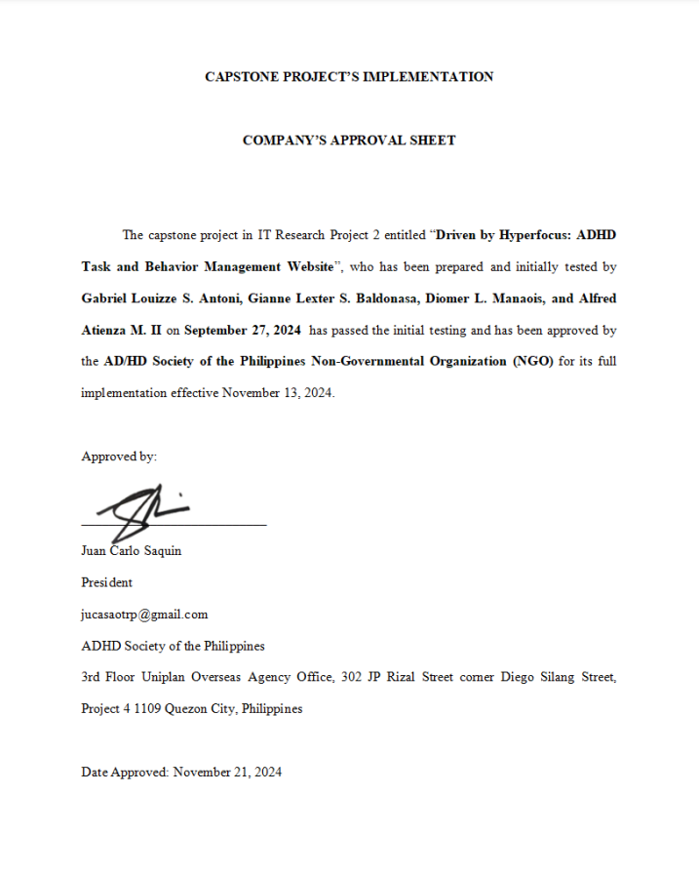

1. **Certificate of Authentic Authorship**



1. **Presentation of Findings**
2. **Profile of the Respondents**

**Table 3. Percentage Distribution of the Profile of the Respondent’s Profession**

|  |  |  |
| --- | --- | --- |
| Profession | Frequency | Percentage |
| Health Professional | 2 | 6.67% |
| IT Professional | 4 | 13.33% |
| Student | 11 | 36.67% |
| Administrative Director | 1 | 3.33% |
| BS Psychology Graduate | 1 | 3.33% |
| Freelance Video Producer | 1 | 3.33% |
| PARENT OF ADHD | 1 | 3.33% |
| Mechanical Engineer | 1 | 3.33% |
| Sales Executive | 1 | 3.33% |
| Self Employed | 1 | 3.33% |
| Volunteer | 1 | 3.33% |
| Business Owner | 1 | 3.33% |
| Accountant | 1 | 3.33% |
| Engineer | 1 | 3.33% |
| Total | 30 | 100% |

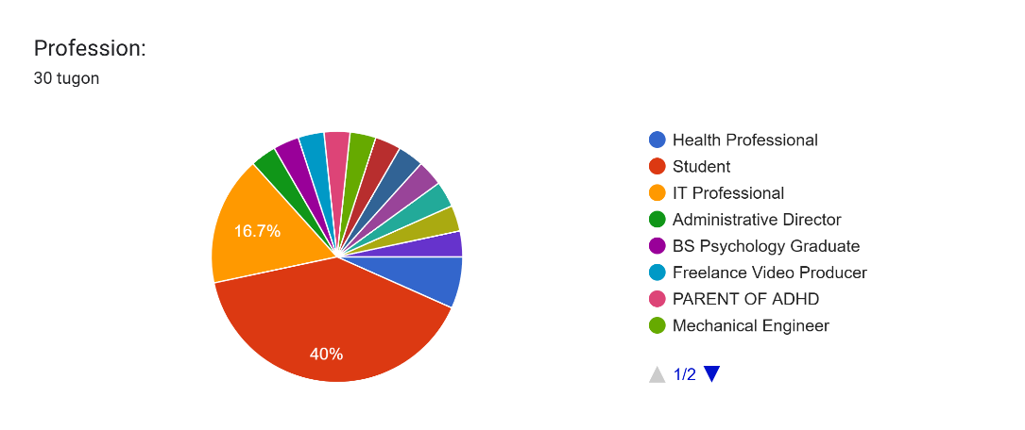

**Table 4. Percentage Distribution of the Profile of the Respondent’s Type of ADHD**

|  |  |  |
| --- | --- | --- |
| ADHD Type | Frequency | Percentage |
| I don't know | 8 | 26.67% |
| Combined type (Self-assessed) | 10 | 33.33% |
| Combined type (Diagnosed) | 3 | 10% |
| Hyperactive/Impulsive (Self-assessed) | 3 | 10% |
| Inattentive (Diagnosed) | 5 | |  | | --- | |  | |  |  |  | | --- | | 16.67% | |
| Hyperactive/Impulsive (Diagnosed) | 2 | 6.67% |
| Inattentive (Self-assessed) | 1 | 3.33% |
| Total | 30 | 100% |

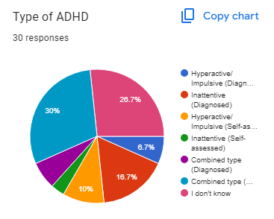

1. **Functional Suitability**

**Table 5. Percentage Distribution of the Completeness**

|  |  |  |
| --- | --- | --- |
| Response | Frequency | Percentage |
| 1 | 0 | 0% |
| 2 | 0 | 0% |
| 3 | 3 | 10% |
| 4 | 10 | 33.33% |
| 5 | 17 | 56.67% |
| Total | 30 | 100% |

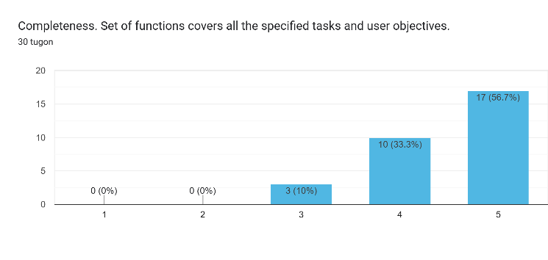

**Table 6. Percentage Distribution of the Correctness**

|  |  |  |
| --- | --- | --- |
| Response | Frequency | Percentage |
| 1 | 0 | 0% |
| 2 | 0 | 0% |
| 3 | 3 | 10% |
| 4 | 10 | 33.33% |
| 5 | 17 | 56.67% |
| Total | 30 | 100% |

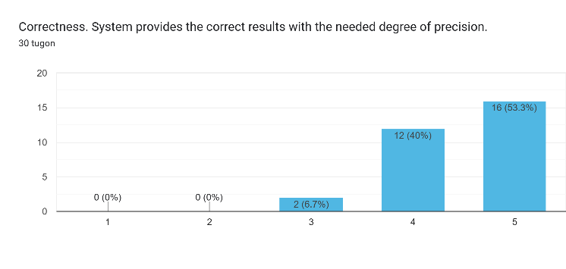

**Table 7. Percentage Distribution of the Appropriateness**

|  |  |  |
| --- | --- | --- |
| Response | Frequency | Percentage |
| 1 | 0 | 0% |
| 2 | 0 | 0% |
| 3 | 1 | 3.33% |
| 4 | 11 | 36.67% |
| 5 | 18 | 60.00% |
| Total | 30 | 100% |

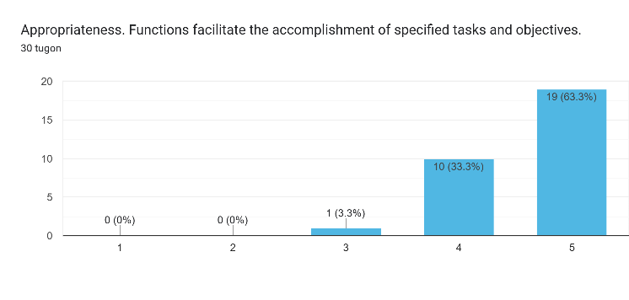

1. **Performance Efficiency**

**Table 8. Percentage Distribution of the Time Behavior**

|  |  |  |
| --- | --- | --- |
| Response | Frequency | Percentage |
| 1 | 0 | 0% |
| 2 | 0 | 0% |
| 3 | 3 | 10% |
| 4 | 15 | 50% |
| 5 | 12 | 40% |
| Total | 30 | 100% |

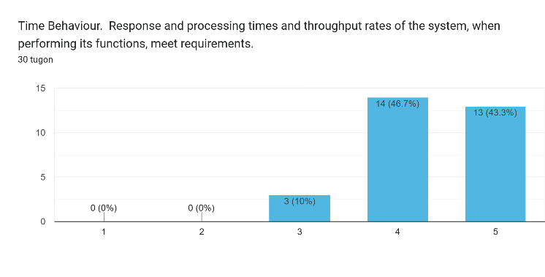

**Table 9. Percentage Distribution of the Time Resource utilization**

|  |  |  |
| --- | --- | --- |
| Response | Frequency | Percentage |
| 1 | 0 | 0% |
| 2 | 0 | 0% |
| 3 | 4 | 13.33% |
| 4 | 7 | 23.33% |
| 5 | 19 | 63.33% |
| Total | 30 | 100% |

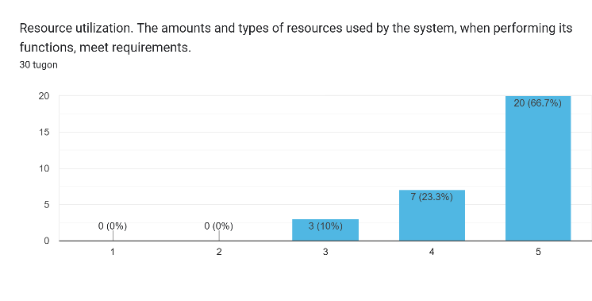

**Table 10. Percentage Distribution of the Capacity**

|  |  |  |
| --- | --- | --- |
| Response | Frequency | Percentage |
| 1 | 0 | 0% |
| 2 | 0 | 0% |
| 3 | 4 | 13.33% |
| 4 | 8 | 26.67% |
| 5 | 18 | 60.00% |
| Total | 30 | 100% |

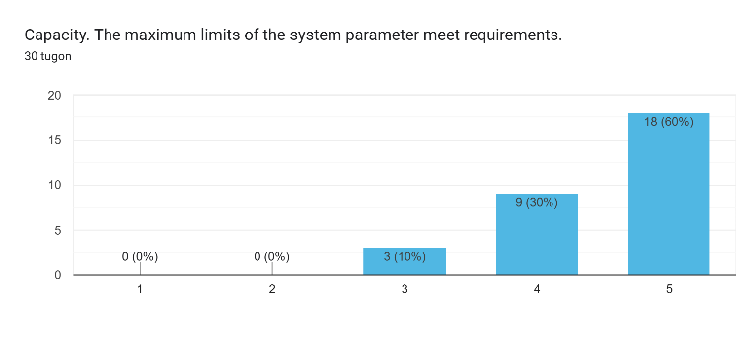

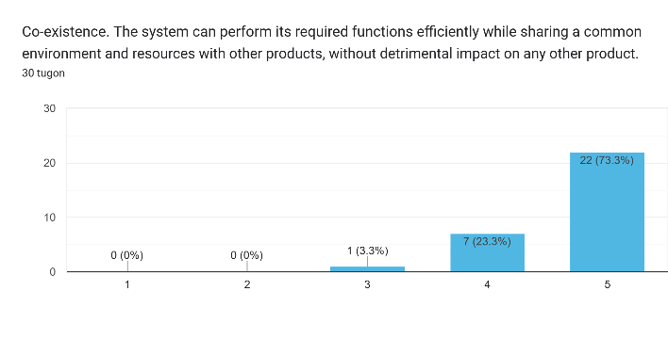

1. **Usability**

**Table 12. Percentage Distribution of the Appropriateness Recognizability**

|  |  |  |
| --- | --- | --- |
| Response | Frequency | Percentage |
| 1 | 0 | 0% |
| 2 | 0 | 0% |
| 3 | 2 | 6.67% |
| 4 | 9 | 30% |
| 5 | 19 | 63.33% |
| Total | 30 | 100% |

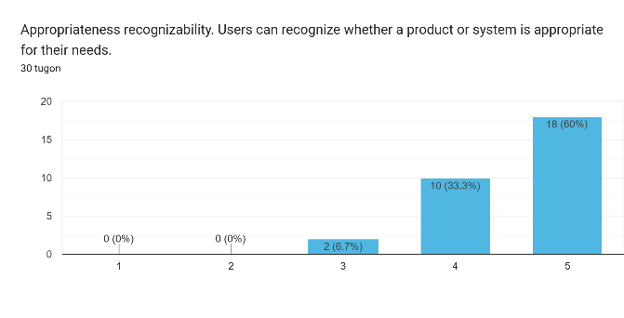

**Table 13. Percentage Distribution of the Learnability**

|  |  |  |
| --- | --- | --- |
| Response | Frequency | Percentage |
| 1 | 0 | 0% |
| 2 | 0 | 0% |
| 3 | 1 | 3.33% |
| 4 | 9 | 30% |
| 5 | 20 | 66.67% |
| Total | 30 | 100% |

1. **Compatibility**

**Table 11. Percentage Distribution of the Co-existence**

|  |  |  |
| --- | --- | --- |
| Response | Frequency | Percentage |
| 1 | 0 | 0% |
| 2 | 0 | 0% |
| 3 | 1 | 3.33% |
| 4 | 7 | 23.33% |
| 5 | 22 | 73.33% |
| Total | 30 | 100% |

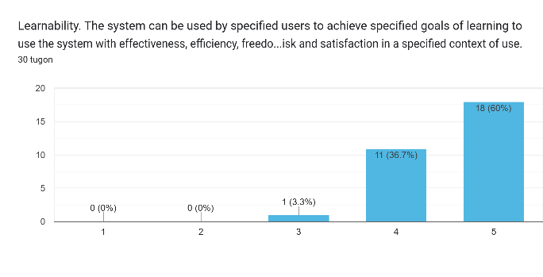**Table 14. Percentage Distribution of the Operability**

|  |  |  |
| --- | --- | --- |
| Response | Frequency | Percentage |
| 1 | 0 | 0% |
| 2 | 0 | 0% |
| 3 | 4 | 13.33% |
| 4 | 8 | 26.67% |
| 5 | 18 | 60% |
| Total | 30 | 100% |

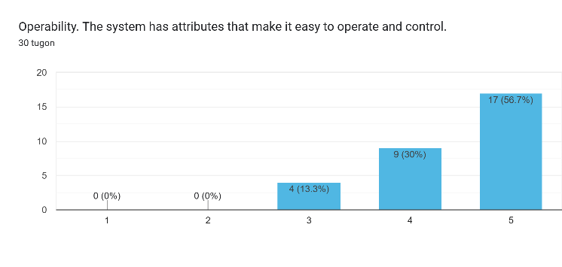

**Table 15. Percentage Distribution of the User Error Protection**

|  |  |  |
| --- | --- | --- |
| Response | Frequency | Percentage |
| 1 | 0 | 0% |
| 2 | 0 | 0% |
| 3 | 5 | 16.67% |
| 4 | 11 | 36.67% |
| 5 | 14 | 46.67% |
| Total | 30 | 100% |

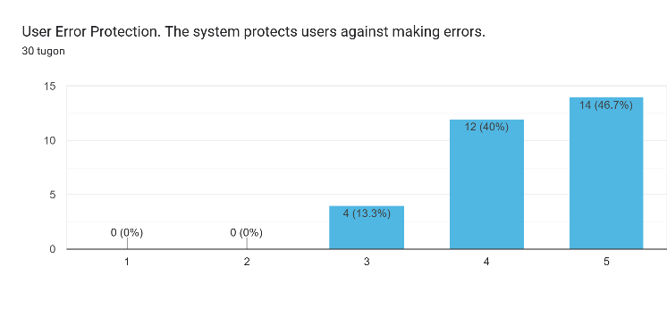

**Table 16. Percentage Distribution of the User User-Interface Aesthetics**

|  |  |  |
| --- | --- | --- |
| Response | Frequency | Percentage |
| 1 | 0 | 0% |
| 2 | 0 | 0% |
| 2 | 1 | 3.33% |
| 3 | 3 | 10.00% |
| 4 | 8 | 26.67% |
| Total | 30 | 100% |

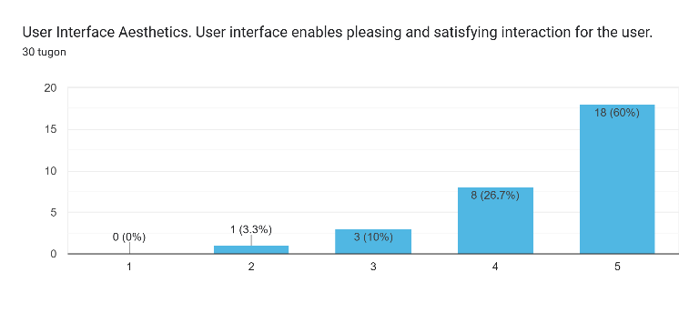

**Table 17. Percentage Distribution of the Accessibility**

|  |  |  |
| --- | --- | --- |
| Response | Frequency | Percentage |
| 1 | 0 | 0% |
| 2 | 0 | 0% |
| 2 | 1 | 3.33% |
| 3 | 3 | 10.00% |
| 4 | 8 | 26.67% |
| 5 | 18 | 60.00% |
| Total | 30 | 100% |

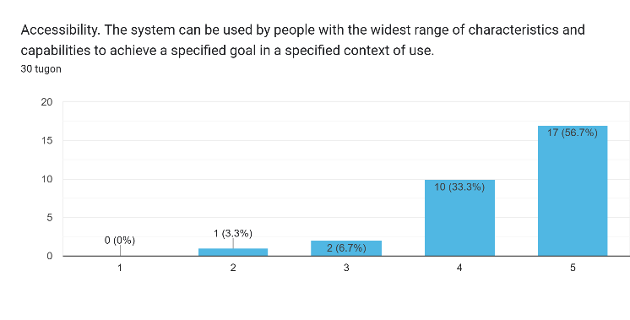

1. **Reliability**

**Table 18. Percentage Distribution of the Maturity**

|  |  |  |
| --- | --- | --- |
| Response | Frequency | Percentage |
| 1 | 0 | 0% |
| 2 | 0 | 0% |
| 3 | 5 | 16.67% |
| 4 | 5 | 16.67% |
| 5 | 20 | 66.67% |
| Total | 30 | 100% |

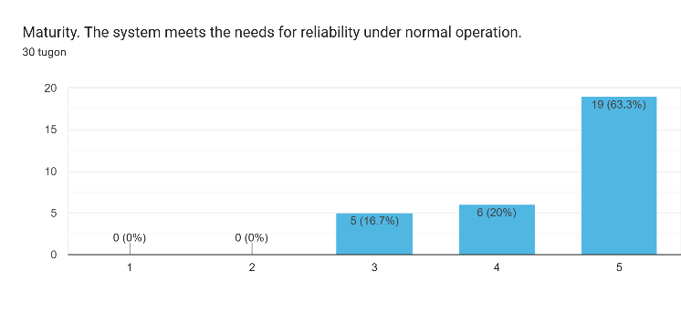

**Table 19. Percentage Distribution of the Availability**

|  |  |  |
| --- | --- | --- |
| Response | Frequency | Percentage |
| 1 | 0 | 0% |
| 2 | 0 | 0% |
| 3 | 2 | 6.67% |
| 4 | 9 | 30% |
| 5 | 19 | 63.33% |
| Total | 30 | 100% |

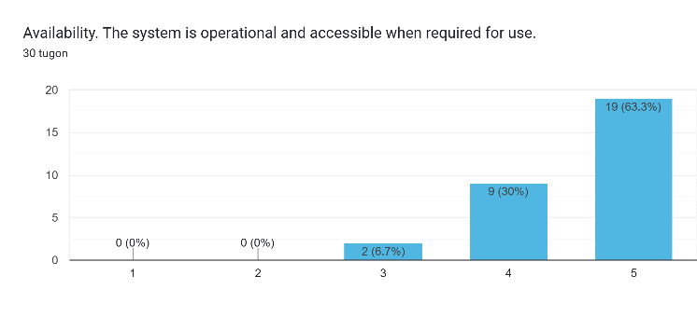

**Table 20. Percentage Distribution of the Recoverability**

|  |  |  |
| --- | --- | --- |
| Response | Frequency | Percentage |
| 1 | 0 | 0% |
| 2 | 0 | 0% |
| 3 | 6 | 20% |
| 4 | 8 | 26.67% |
| 5 | 16 | 53.33% |
| Total | 30 | 100% |

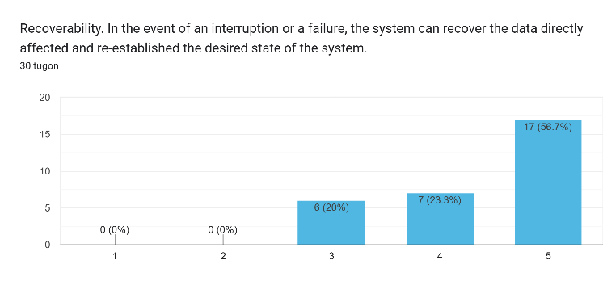

1. **Security**

**Table 21. Percentage Distribution of the Confidentiality**

|  |  |  |
| --- | --- | --- |
| Response | Frequency | Percentage |
| 1 | 0 | 0% |
| 2 | 0 | 0% |
| 3 | 3 | 10% |
| 4 | 9 | 30% |
| 5 | 18 | 60% |
| Total | 30 | 100% |

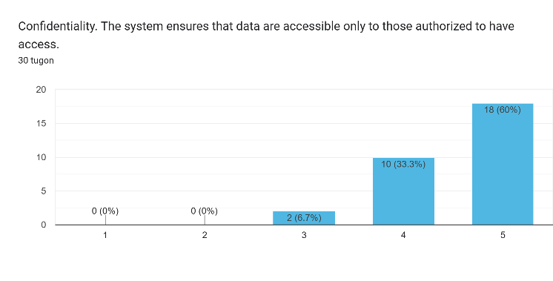

**Table 22. Percentage Distribution of the Integrity**

|  |  |  |
| --- | --- | --- |
| Response | Frequency | Percentage |
| 1 | 0 | 0% |
| 2 | 0 | 0% |
| 3 | 3 | 10% |
| 4 | 9 | 30% |
| 5 | 18 | 60% |
| Total | 30 | 100% |

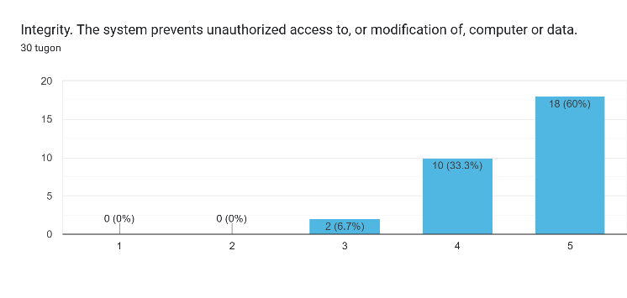

**Table 23. Percentage Distribution of the Non-repudiation**

|  |  |  |
| --- | --- | --- |
| Response | Frequency | Percentage |
| 1 | 0 | 0% |
| 2 | 0 | 0% |
| 3 | 3 | 10% |
| 4 | 9 | 30% |
| 5 | 18 | 60% |
| Total | 30 | 100% |

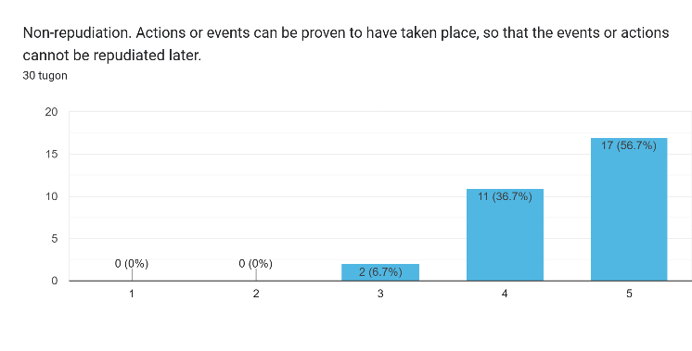

**Table 24. Percentage Distribution of the Accountability**

|  |  |  |
| --- | --- | --- |
| Response | Frequency | Percentage |
| 1 | 0 | 0% |
| 2 | 0 | 0% |
| 3 | 3 | 10% |
| 4 | 9 | 30% |
| 5 | 18 | 60% |
| Total | 30 | 100% |

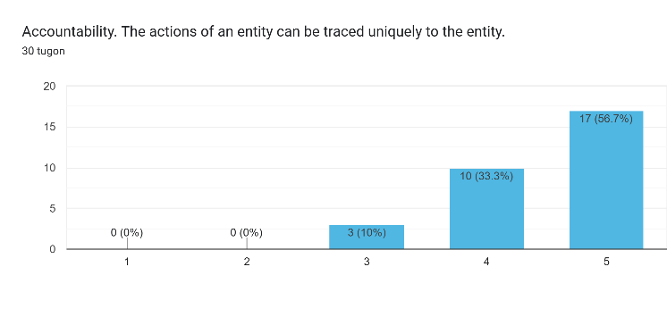

**Table 25. Percentage Distribution of the Authenticity**

|  |  |  |
| --- | --- | --- |
| Response | Frequency | Percentage |
| 1 | 0 | 0% |
| 2 | 0 | 0% |
| 3 | 3 | 10% |
| 4 | 9 | 30% |
| 5 | 18 | 60% |
| Total | 30 | 100% |

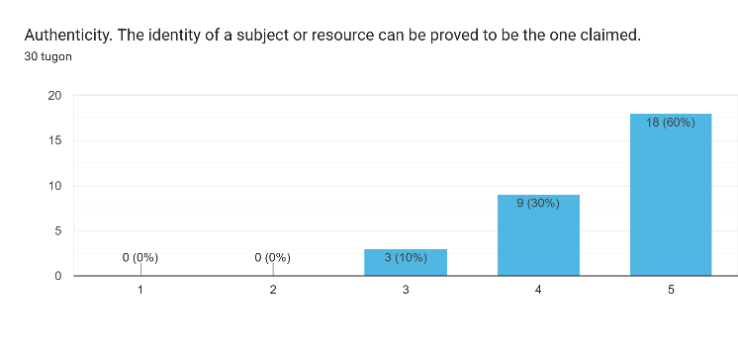

1. **Maintainability**

**Table 26. Percentage Distribution of the Modularity**

|  |  |  |
| --- | --- | --- |
| Response | Frequency | Percentage |
| 1 | 0 | 0% |
| 2 | 0 | 0% |
| 3 | 3 | 10% |
| 4 | 9 | 30% |
| 5 | 18 | 60% |
| Total | 30 | 100% |

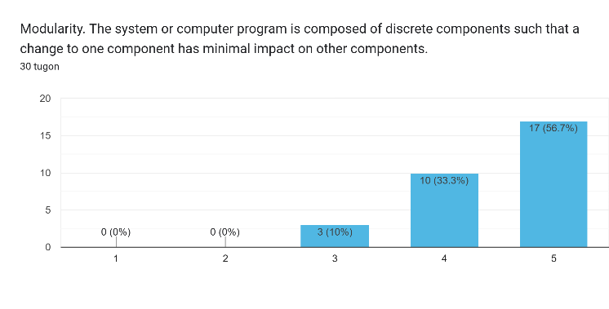

**Table 27. Percentage Distribution of the Modifiability**

|  |  |  |
| --- | --- | --- |
| Response | Frequency | Percentage |
| 1 | 0 | 0% |
| 2 | 0 | 0% |
| 3 | 3 | 10% |
| 4 | 9 | 30% |
| 5 | 18 | 60% |
| Total | 30 | 100% |

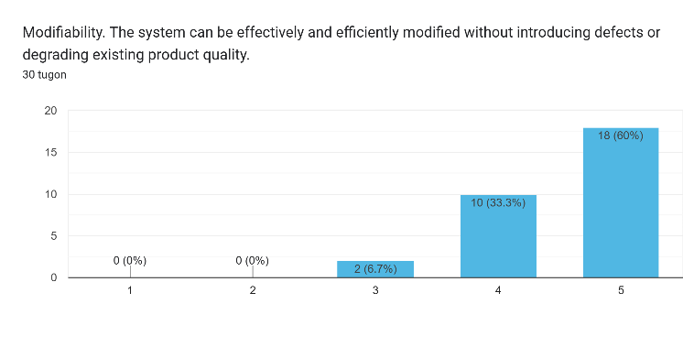

**Table 28. Percentage Distribution of the Testability**

|  |  |  |
| --- | --- | --- |
| Response | Frequency | Percentage |
| 1 | 0 | 0% |
| 2 | 0 | 0% |
| 3 | 1 | 3.33% |
| 4 | 10 | 33.33% |
| 5 | 19 | 63.33% |
| Total | 30 | 100% |

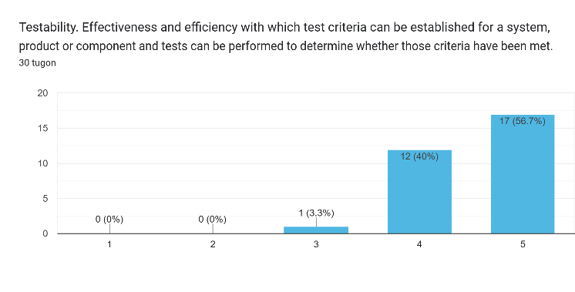

1. **Portability**

**Table 29. Percentage Distribution of the Adaptability**

|  |  |  |
| --- | --- | --- |
| Response | Frequency | Percentage |
| 1 | 0 | 0% |
| 2 | 0 | 0% |
| 3 | 1 | 3.33% |
| 4 | 10 | 33.33% |
| 5 | 19 | 63.33% |
| Total | 30 | 100% |

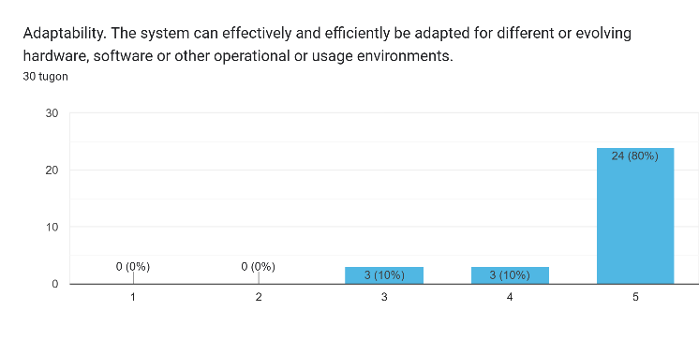

**Table 30. Percentage Distribution of the Installability**

|  |  |  |
| --- | --- | --- |
| Response | Frequency | Percentage |
| 1 | 0 | 0% |
| 2 | 0 | 0% |
| 3 | 4 | 13.33% |
| 4 | 8 | 26.67% |
| 5 | 18 | 60% |
| Total | 30 | 100% |

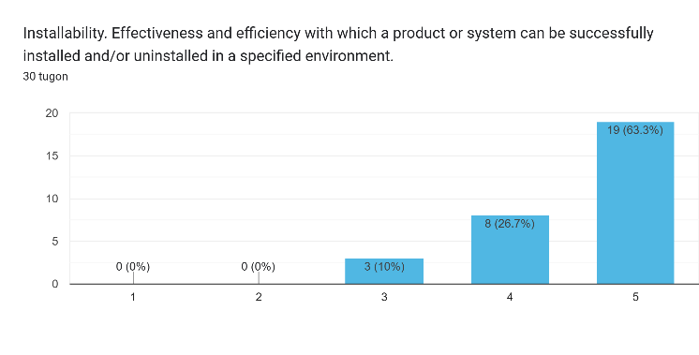

1. **Evaluation Tool/Test Documents**

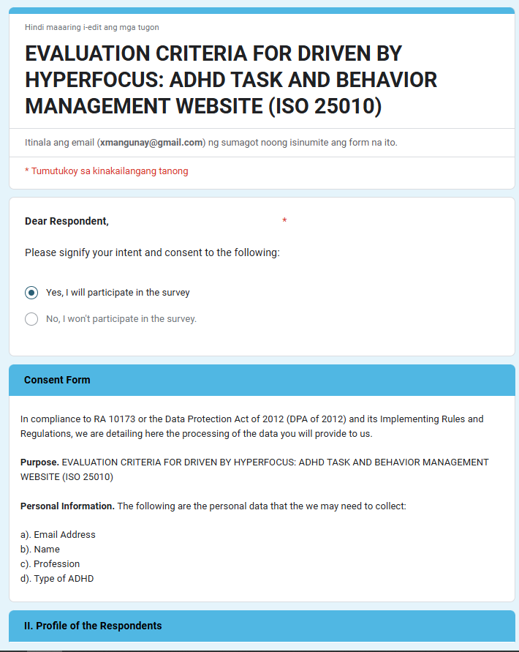

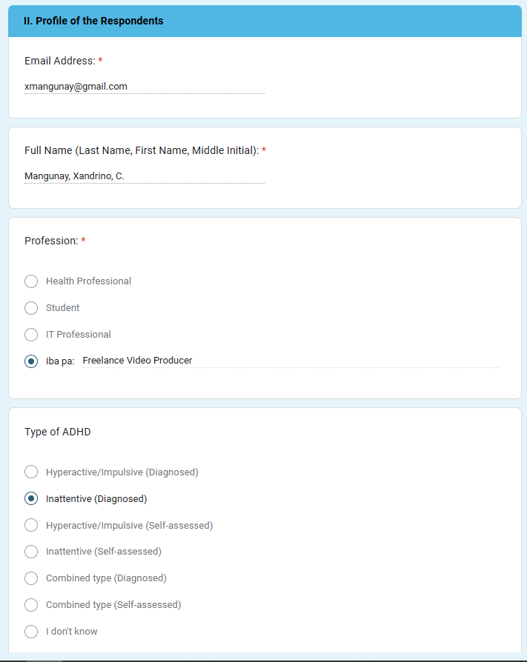

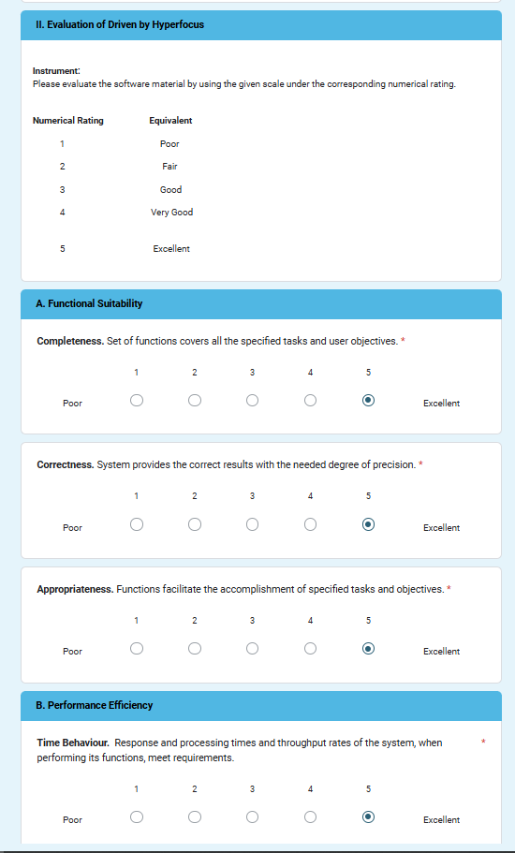

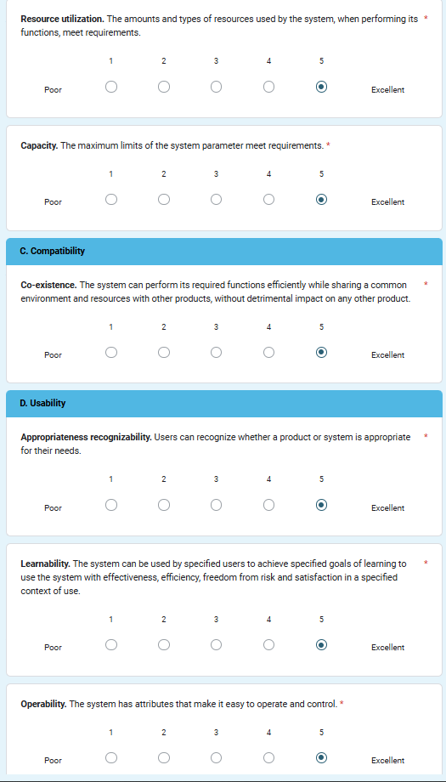

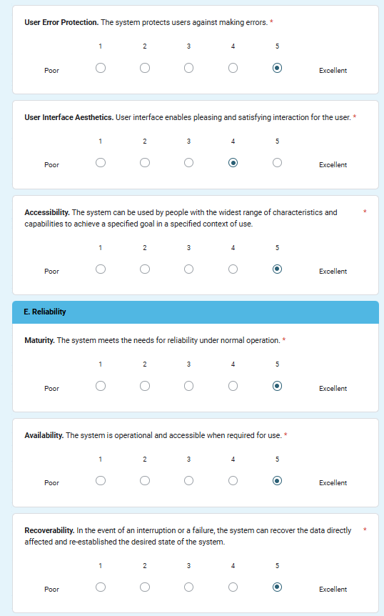 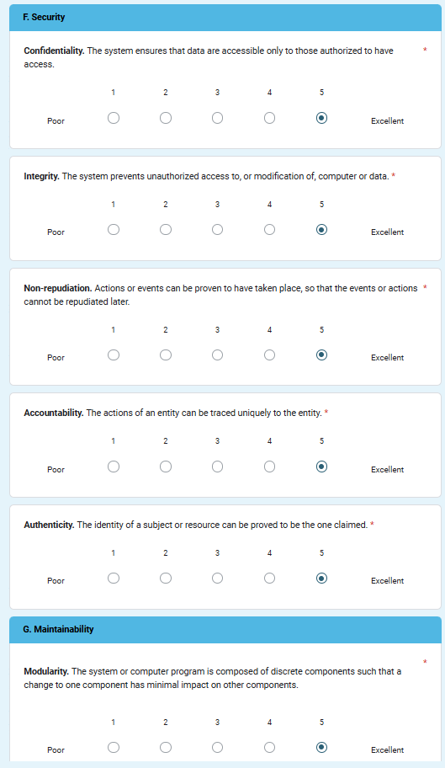

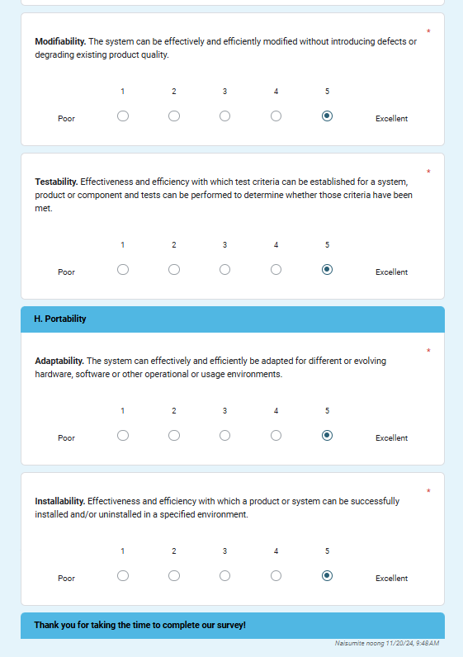

1. **Certificate of Initial and Final Testing**

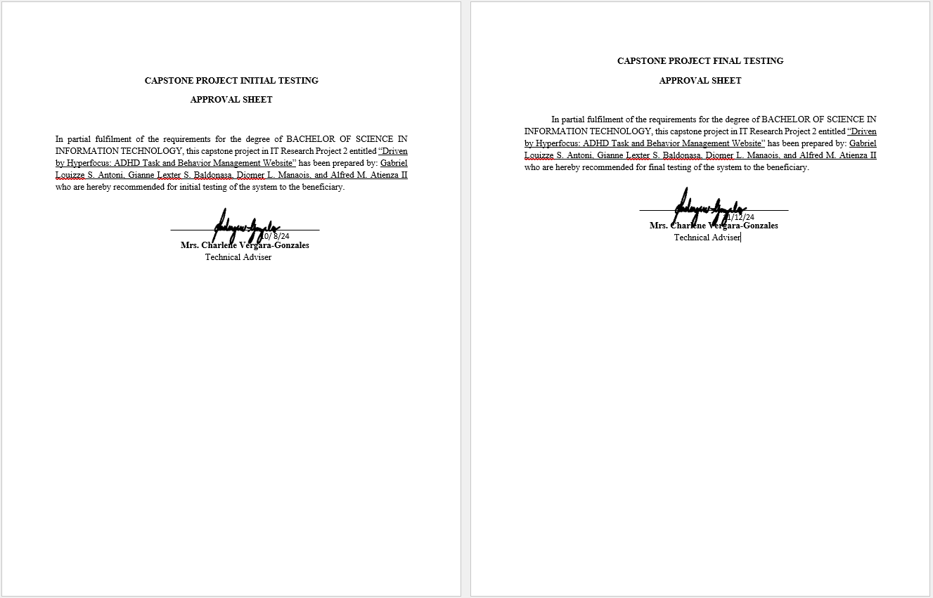

s

1. **Letter of Approval of the Beneficiary**



1. **Gantt Chart of the Developmental Schedule**

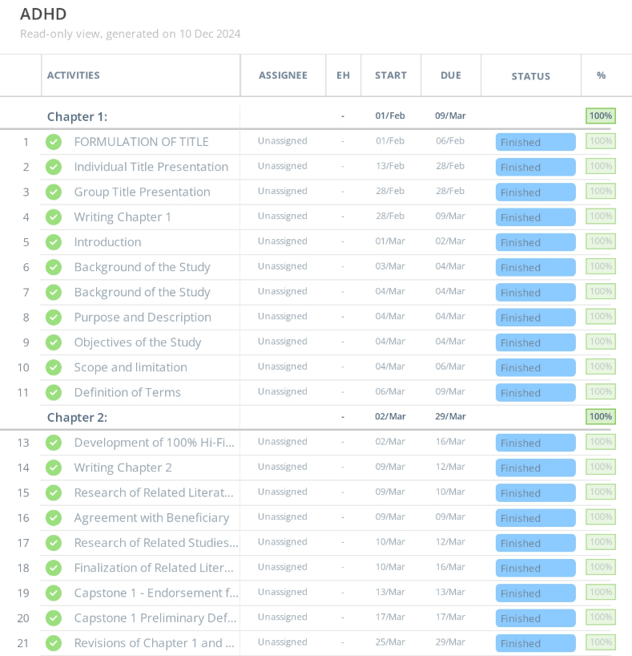

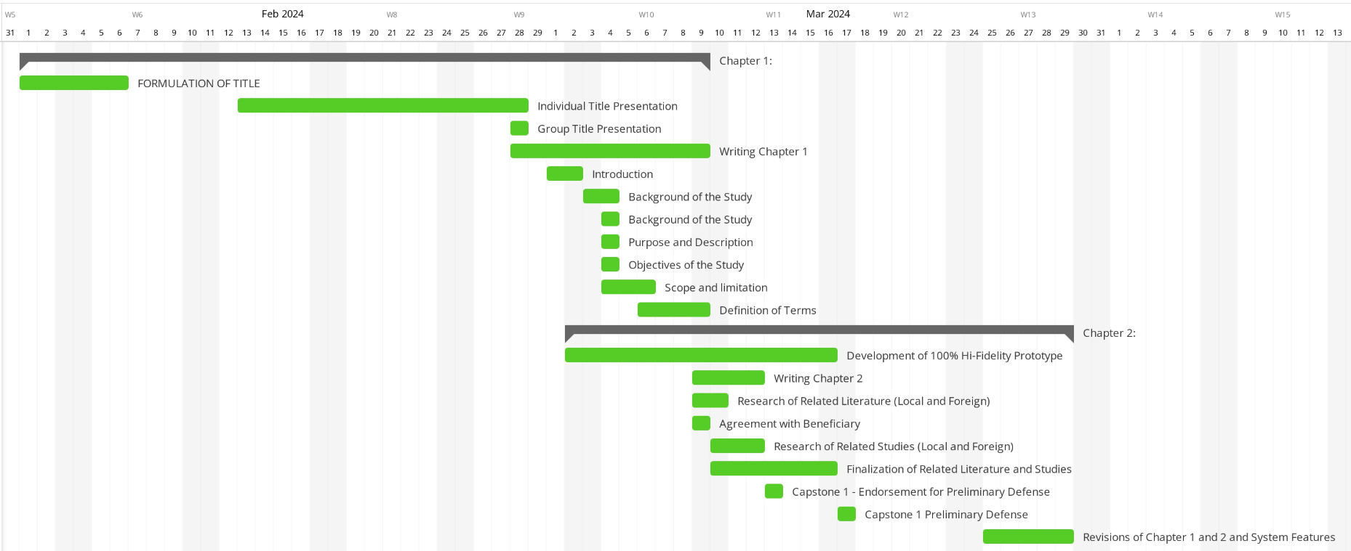

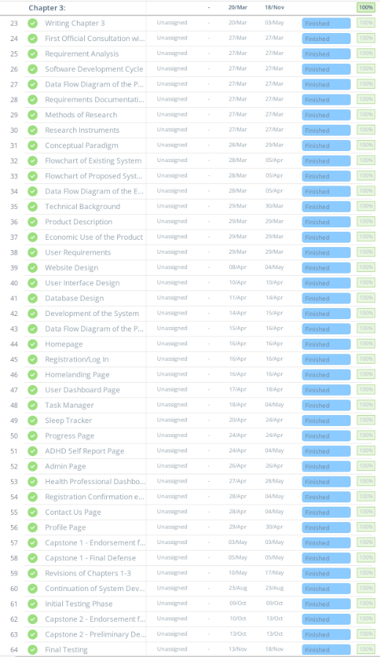



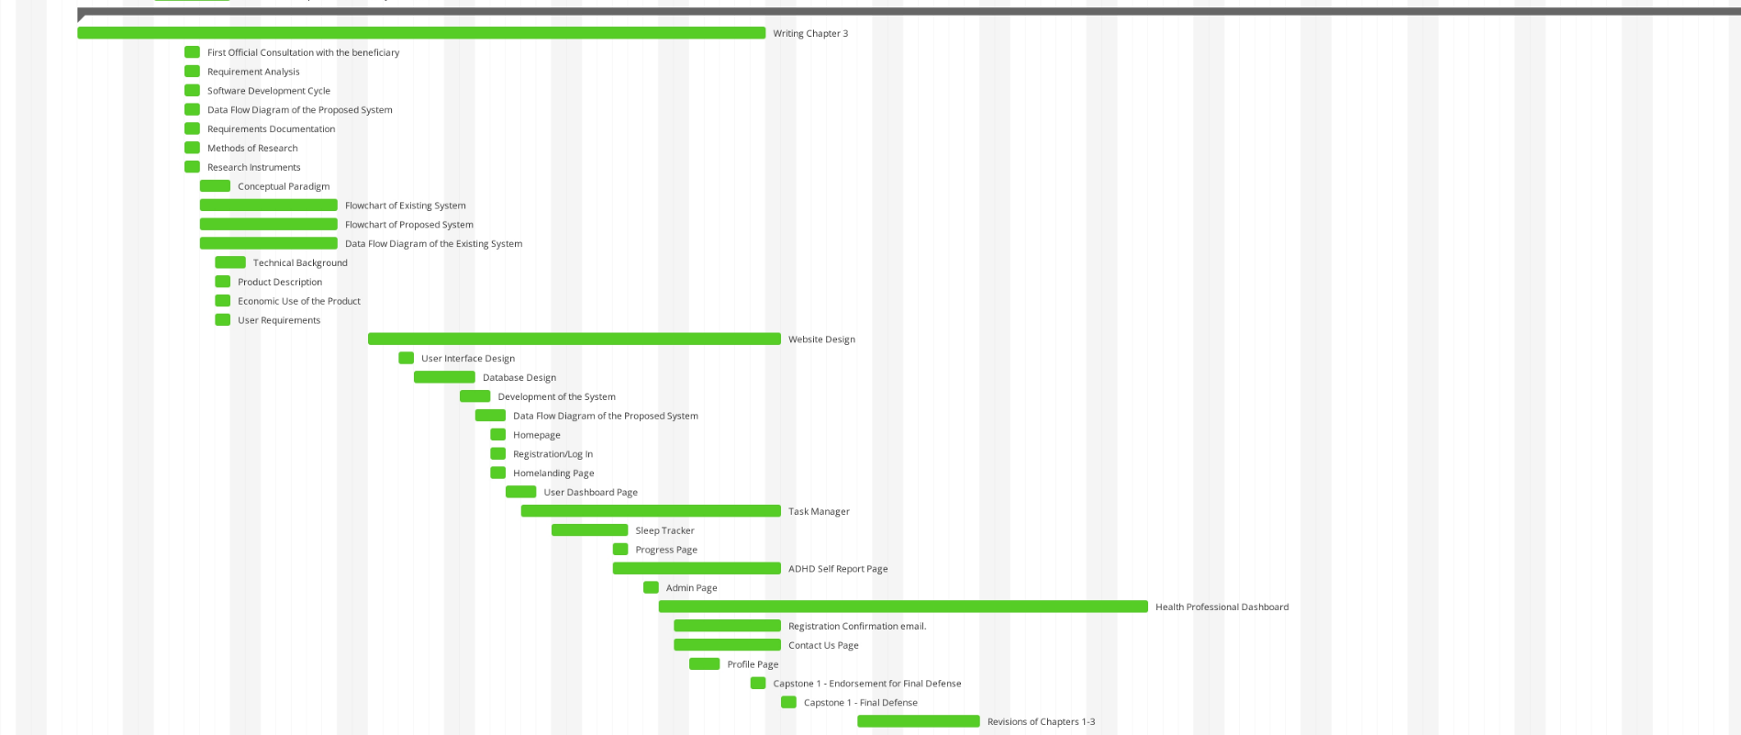

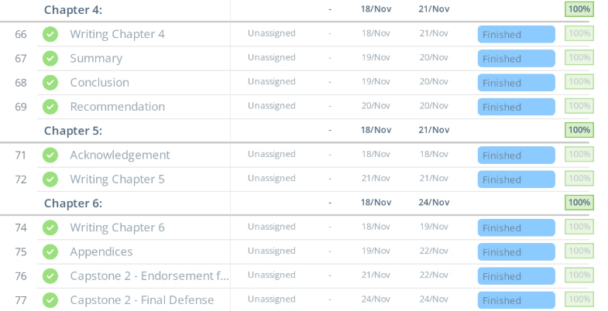



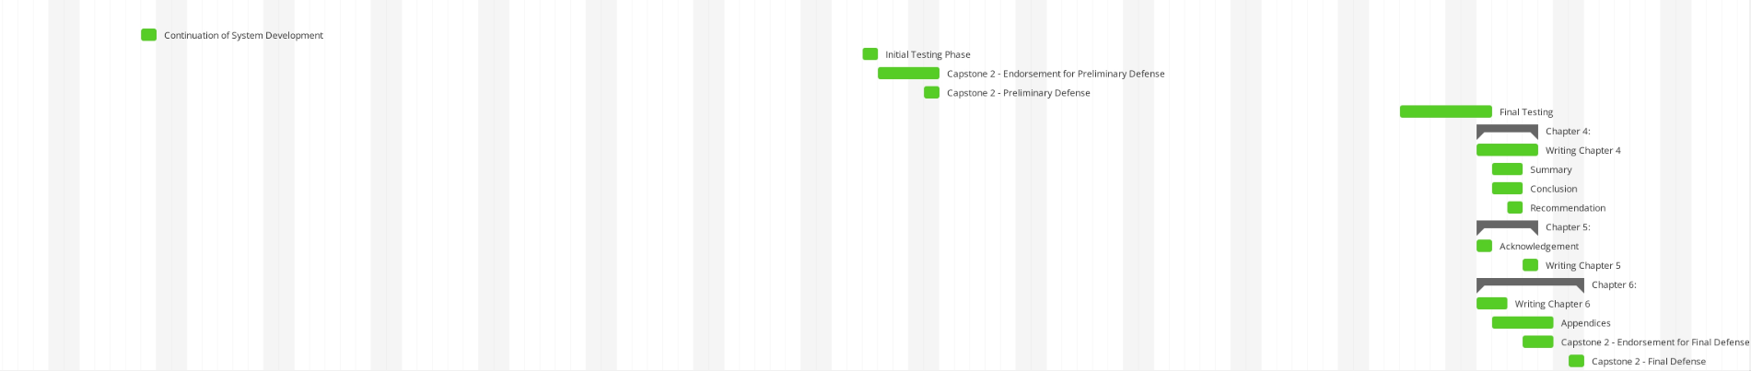

1. **User’s Guide**

**Driven by Hyperfocus: ADHD Task and Behavior Management Website**

**TABLE OF CONTENTS**

1. **Login Module**
2. **Forget Password Module**
3. **Registration Module**
4. **How to use the Task Manager**
5. **How to use the Self Report**
6. **How to use the Sleep Tracker**
7. **How to use the Progress Trackers**
8. **How to manage your User Profile**
9. **Health Professional Dashboard**
10. **How to manage Web Contents**
11. **How to manage User Accounts**
12. **How to manage Admin Logs**

**A. Login Module**

**Steps:**

1. Navigate to the website via the default link: <https://drivenbyhyperfocus.org/index.php>
2. After accessing the website, the user will be redirected to this page

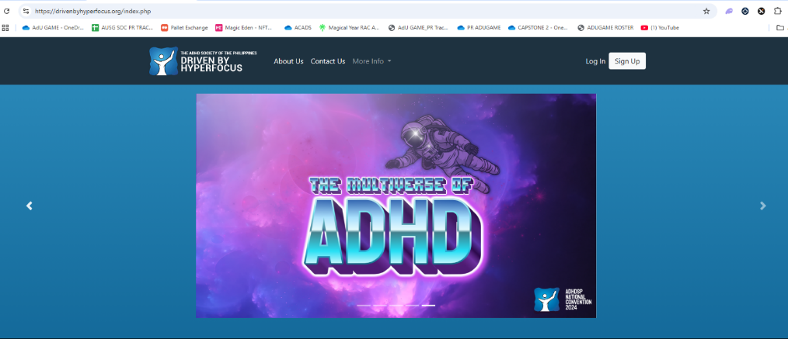

1. The user must click the Login Button in order to be redirected to the Login Page.
2. The user must enter his/her email address and password. They must put their right credentials to have access to the website.

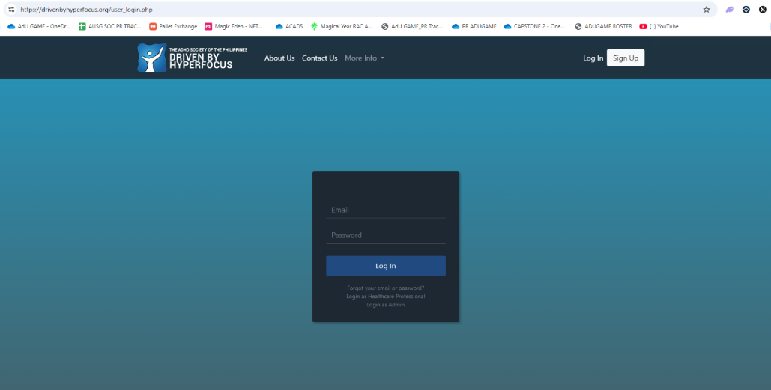

1. Click the “Log In” button to login.



**B. Forget Password Module**

**Steps:**

1. Click the “Forget Password” and the user will be redirected to this page

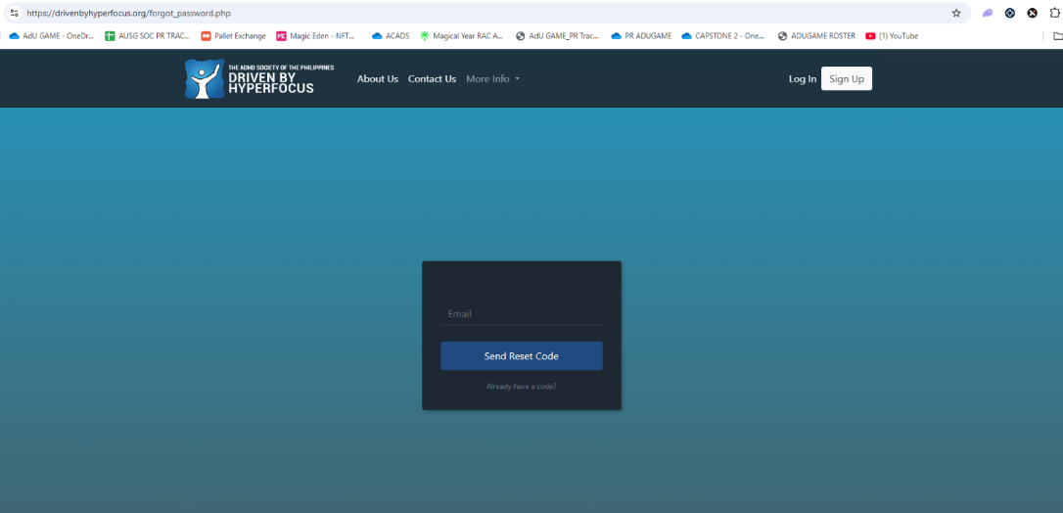

1. The user must enter their email in order to get their verification code on their email address.
2. Click the “Send Reset Code” to redirect to the submission of verification code.
3. The user must enter their verification code that is sent through their email.

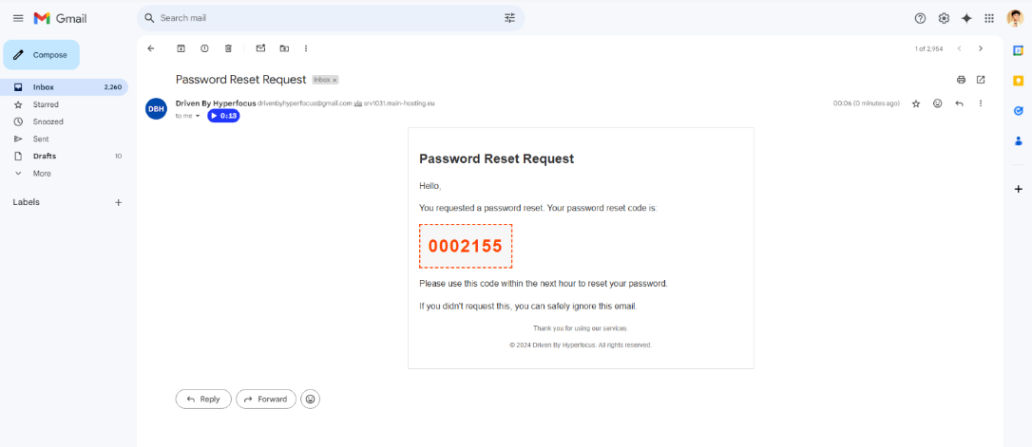

1. The user must enter the verification received from their received email

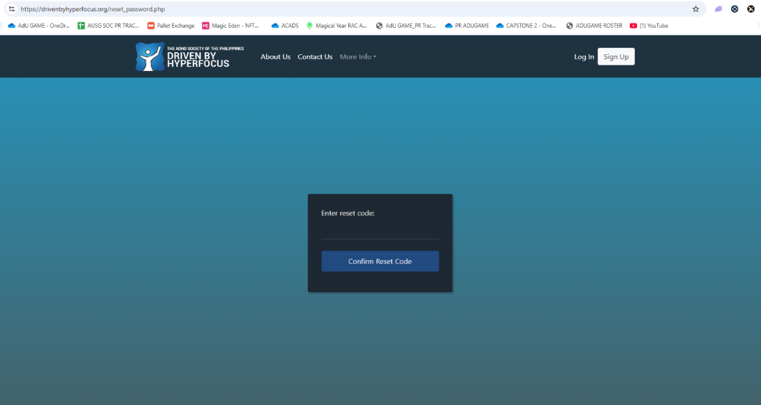

1. The user must enter their new password in order to recover their account and sign-in again.

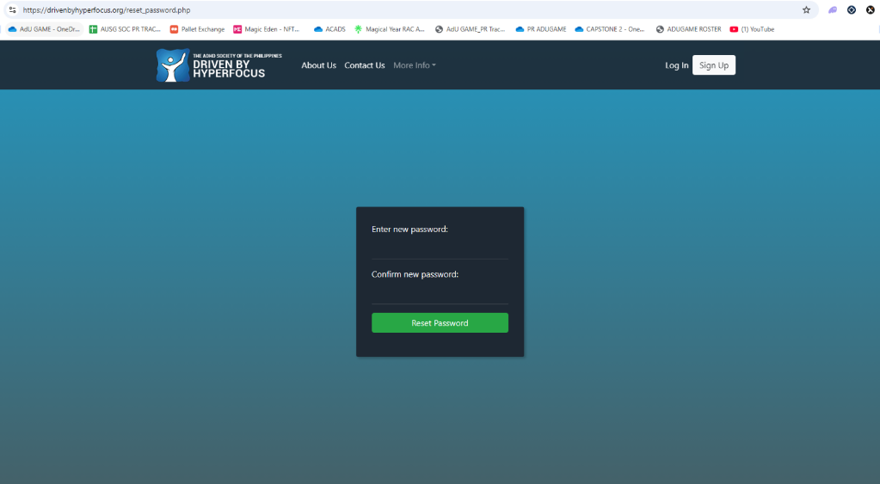

1. Once done, click the “Reset Password” button to change your password.
2. Go to the Login Module to insert your password

**C. Registration Module**

**Steps:**

1. The user must click the Sign-Up Button to be redirected to the Sign-Up Page

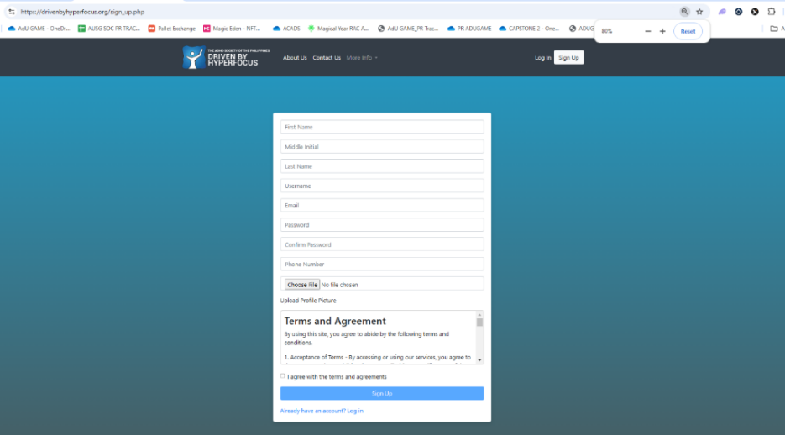

1. The user must insert their credentials as well as their email address, name, profilepicture

and password

1. Once done, click the “Sign-Up” button to confirm your registration.
2. After registration, an email will be sent to your email address to be verified by the admin of the website.
3. Once verified, you’ll be able to access the website and use its features

**D. How to use the Task Manager**

**Steps:**

1. Navigate to the Task Manager page and input the name of your task inside the textbox
2. Set the status and choose from the following: Priority, Waiting List, Side Task, and Done
3. Set the deadline

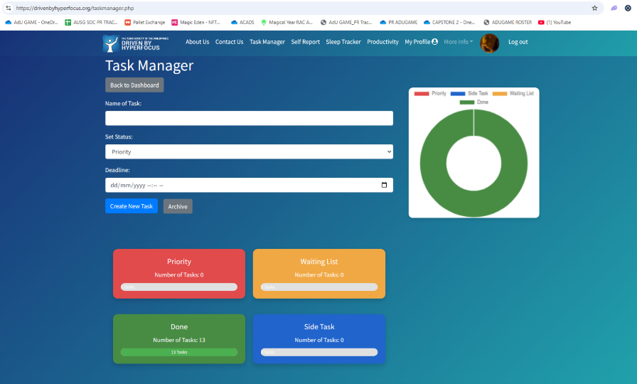

1. After all the details are in place, click the create task button to save your task
2. The chart will now represent the status of the tasks that are active of finished in your Task Manager

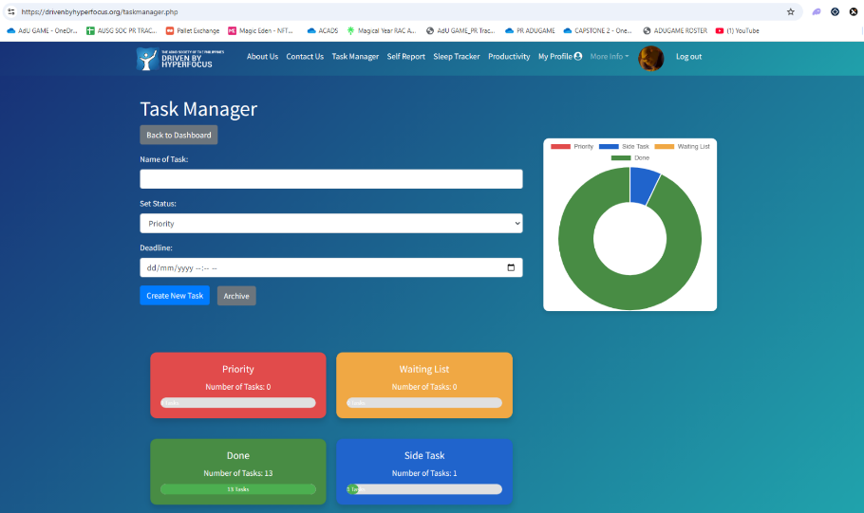

1. By clicking any of the 4 quadrants you will be able to see your tasks according to the category, you can also edit your tasks inside these quadrants

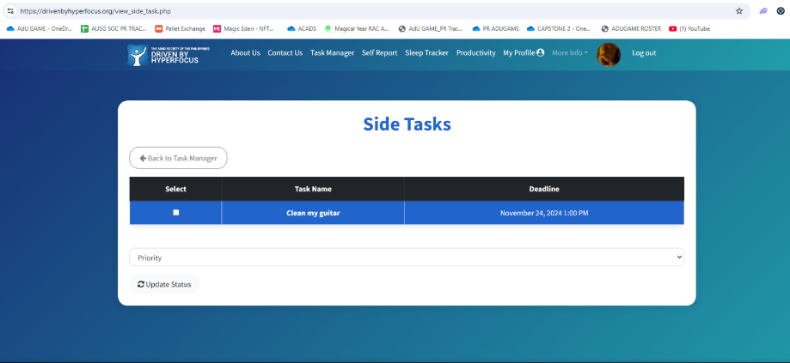

1. In this example I will be updating the status of side task into “Priority”

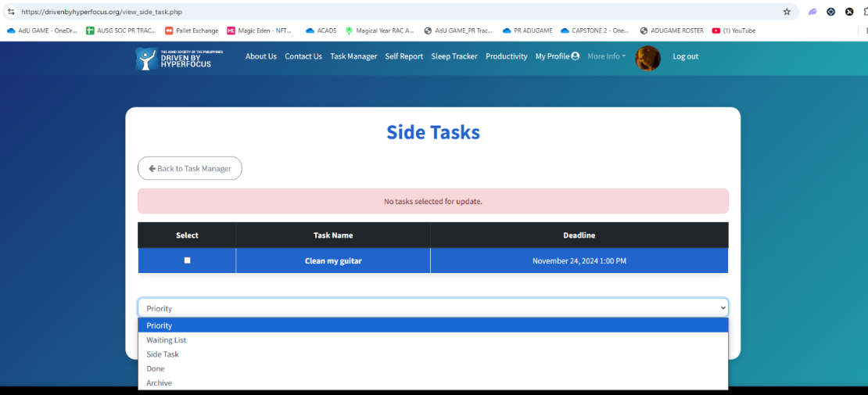

1. After selecting the task, you will then proceed to clicking the “Update Status” Button

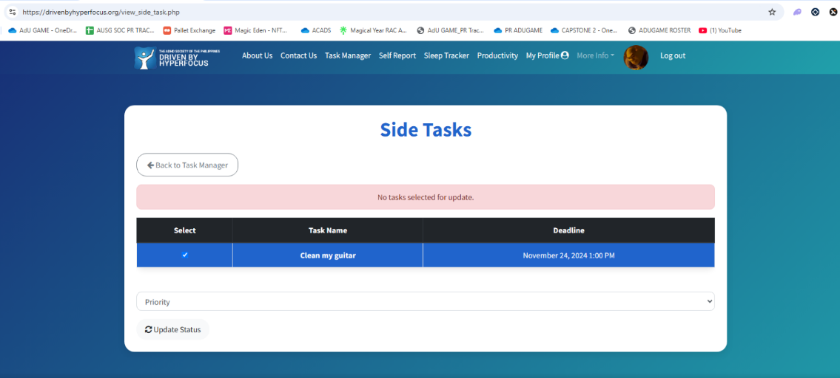

1. Task is now updated successfully

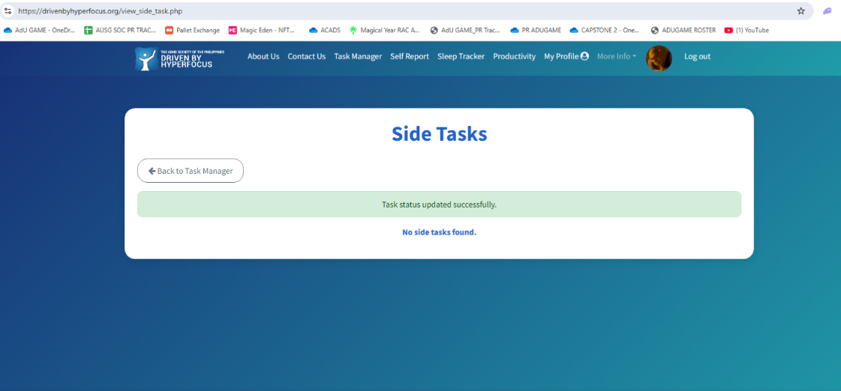

1. Go back to the Task Manager page to check if your task is saved properly

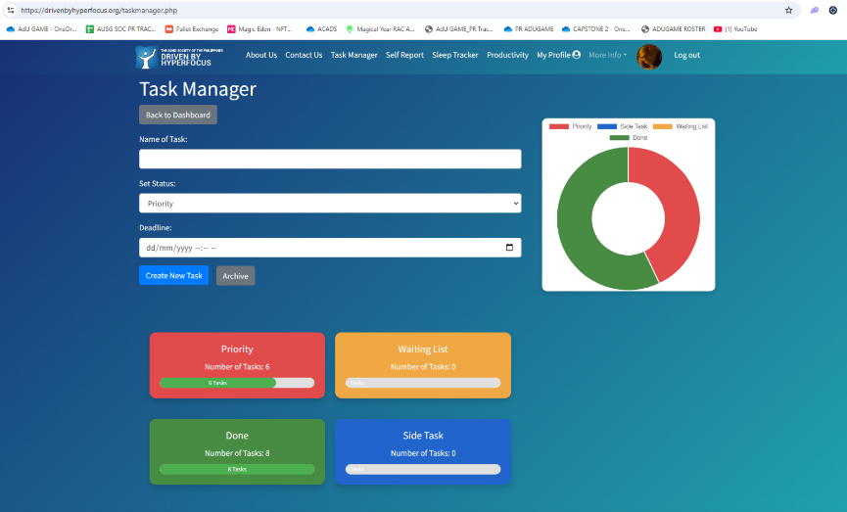

1. If you have a task that you added by mistake or finished tasks that you want to remove, select it then you can simply update the task into “Archive” Archive will remove it from your quadrant and will be stored in the quadrants page where you can decide if you want to delete it or recover it.

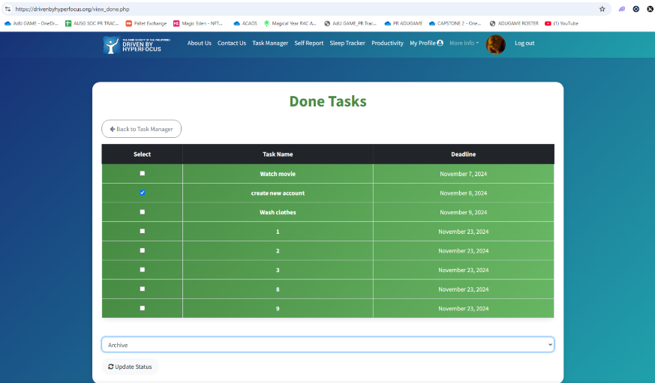

1. Click the Update Status Button to move your task into the Archive

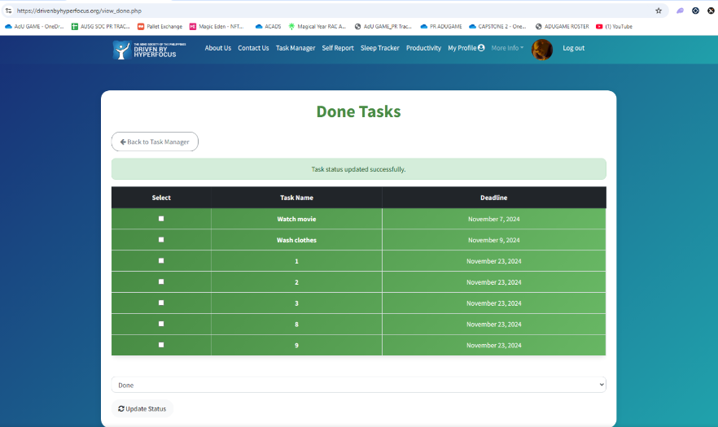

1. Go back to Task Manager and click the “Archive”Button.

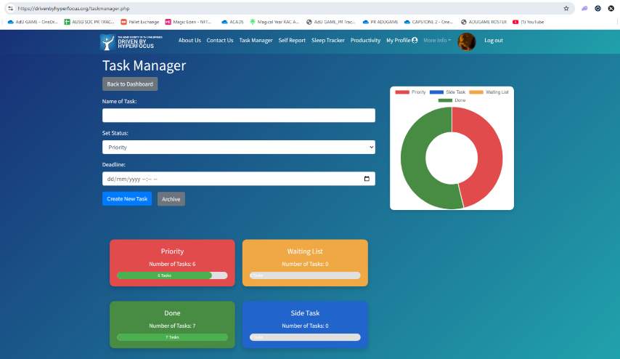

1. In this page you will be able to delete or restore it your desired status of task by simply selecting the single or multiple tasks then clicking the “Delete” or “Update Status” Button

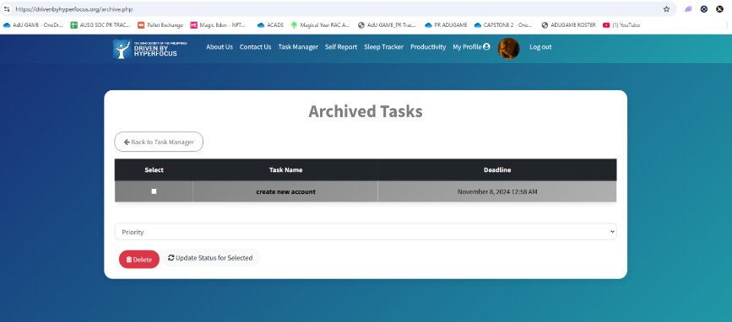

**E. How to use the Self Report**

**Steps:**

1. Navigate to the Self Report page
2. Read the Important Notice then click ok to confirm that you have read the details

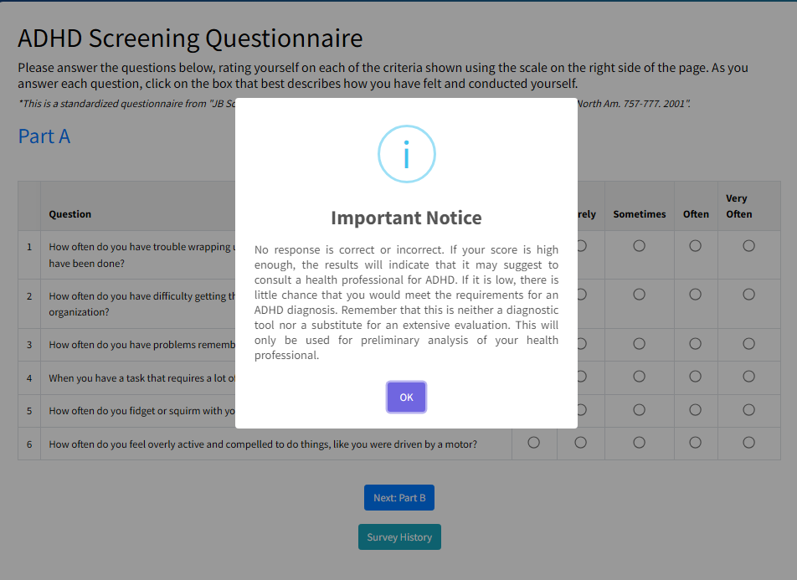

1. Answer the ADHD Screening Questionnaire part A
2. After filling all the questions, click “Next Part B”

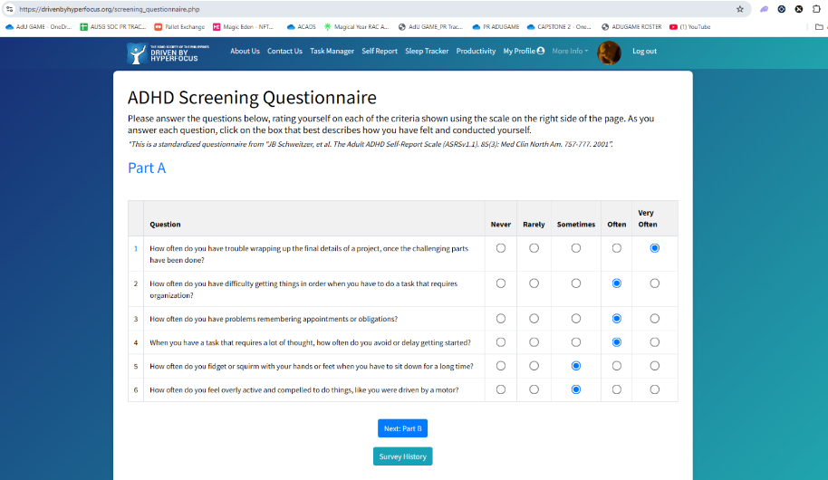

1. Answer the ADHD Screening Questionnaire part B

**S**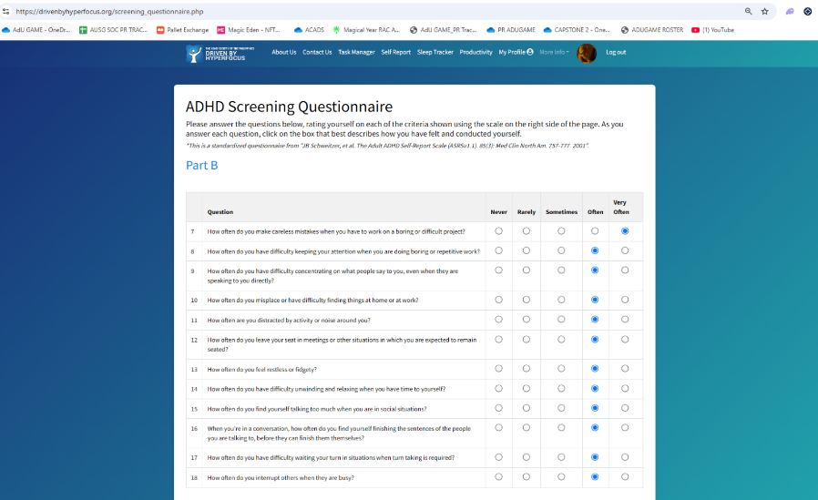

1. Submit the survey by clicking the “Submit Survey” Button
2. After submitting the survey, your results will now be shown

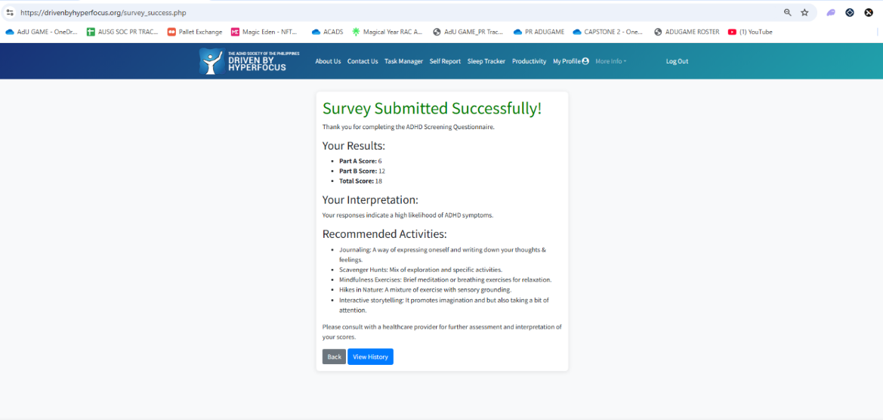

1. Click the “View History” Button to access your records for the month

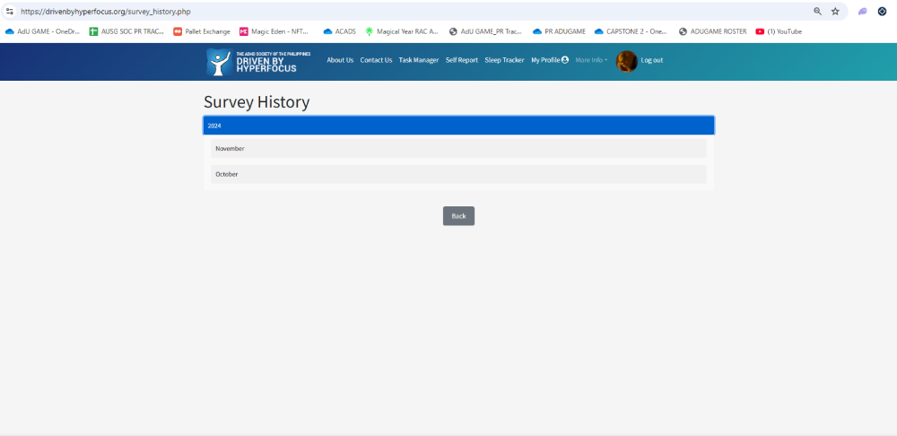

1. If you want to print your records, select the month then click the “Print Monthly Summary” Button

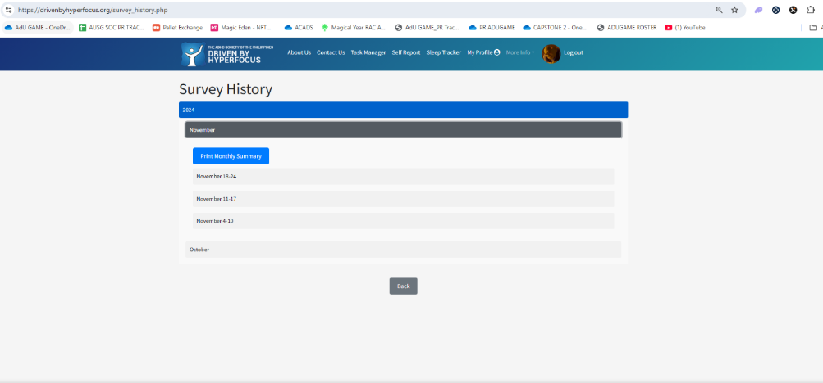

1. After clicking the “Print Monthly Summary” Button it will give you a digital copy of the results of your self-report

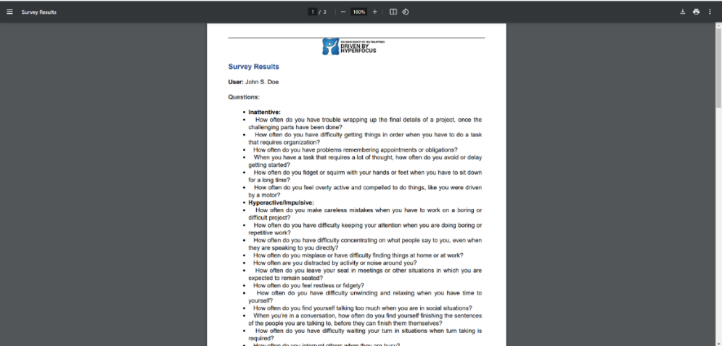

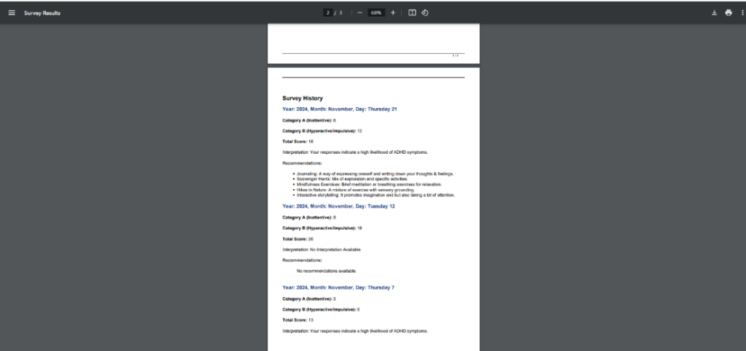

1. Click the download or print button to save a copy of the results in soft copy and in hard copy



1. **How to use the Sleep Tracker**

**Steps:**

1. Navigate to the Sleep Tracker Page
2. In the Table, Green Rows are dates that the user has a record, red are dates that the user does not. There are also graphs here that show a summary of your sleep data,

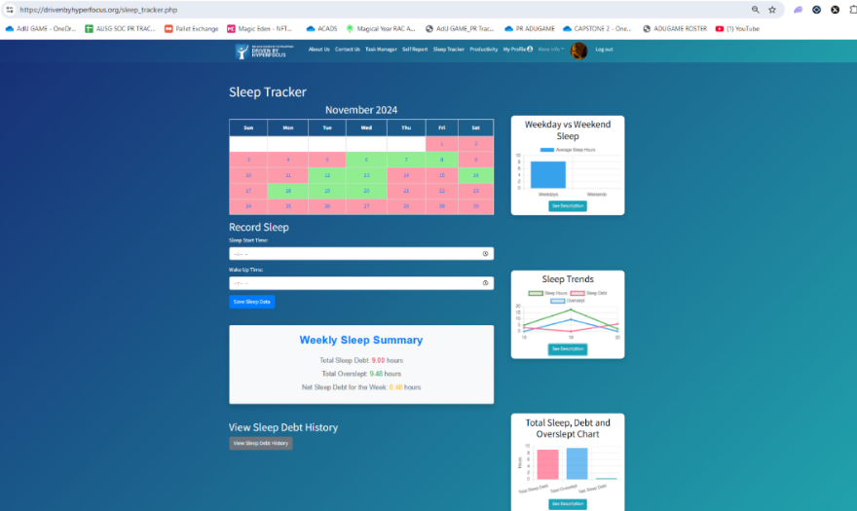

1. Weekday vs Weekend Sleep: This chart compares your average sleep hours on weekdays versus weekends during the current week. It helps illustrate any differences in your sleep patterns.

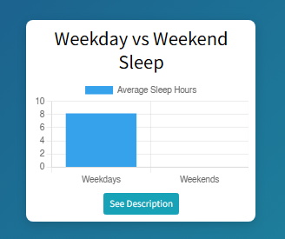

1. Sleep Trends: This line chart shows your daily sleep hours, sleep debt, and overslept hours for the current week. It provides a visual representation of your sleep patterns over time.

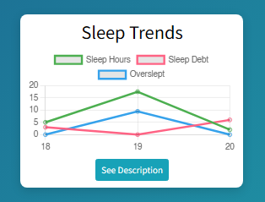

1. Total Sleep, Debt and Overslept: This bar chart summarizes your total sleep debt, total overslept hours, and the net sleep debt for the current week. It provides a quick overview of your overall sleep health.
2. Select Sleep Start Time: Input here the time that you slept for the day

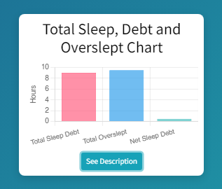

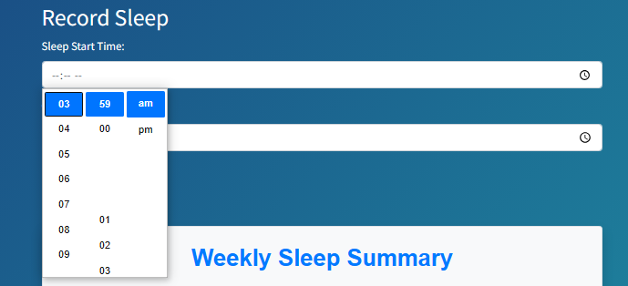

1. Select Wake Up Time: Input here the time that you have awoken.

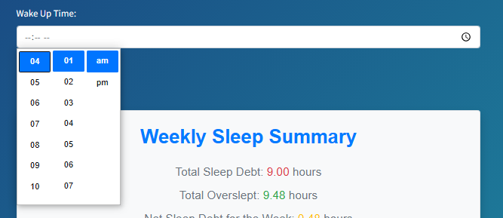

1. Click the “Save Sleep Data” in order to submit it to the Sleep Tracker

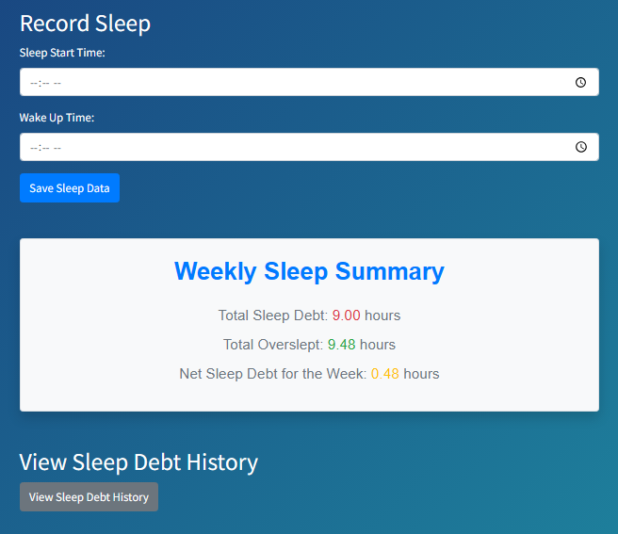

1. Once you have submitted, you can check your current and previous records inside the Sleep Tracker, by clicking the “View Sleep Debt History” button

1. View your Sleep Data here, in here you will see your overslept and your sleep debt which is the hours of sleep missing in your Week

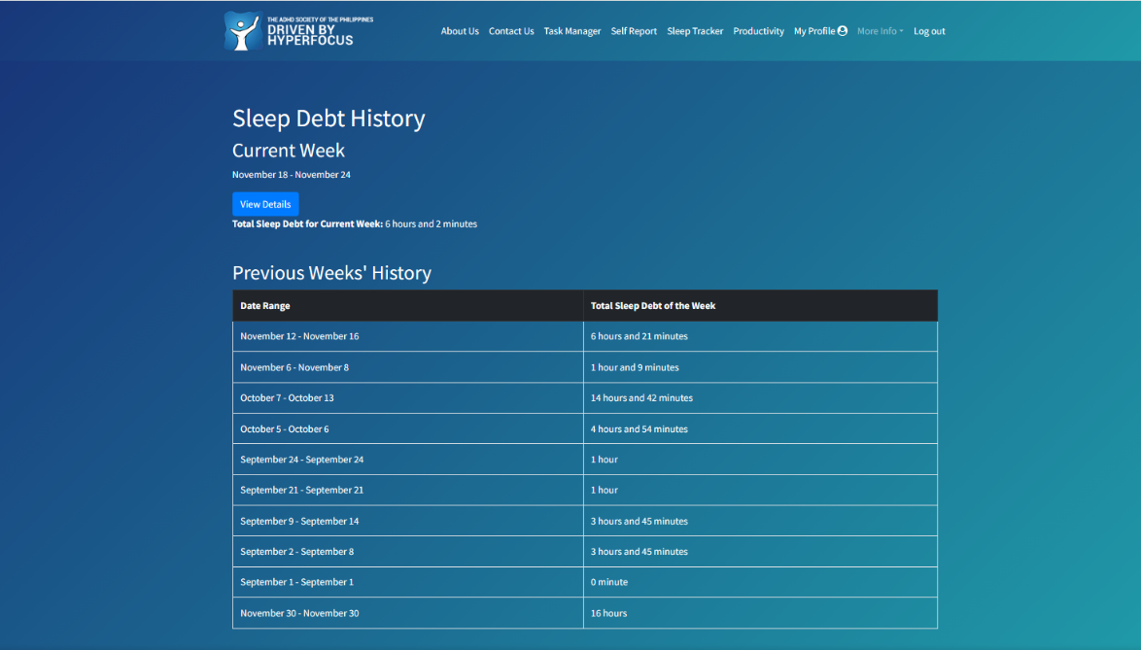

1. Click the “View Details” Button to check your Sleep Debt Details for each day of the week that you have inputted sleep data

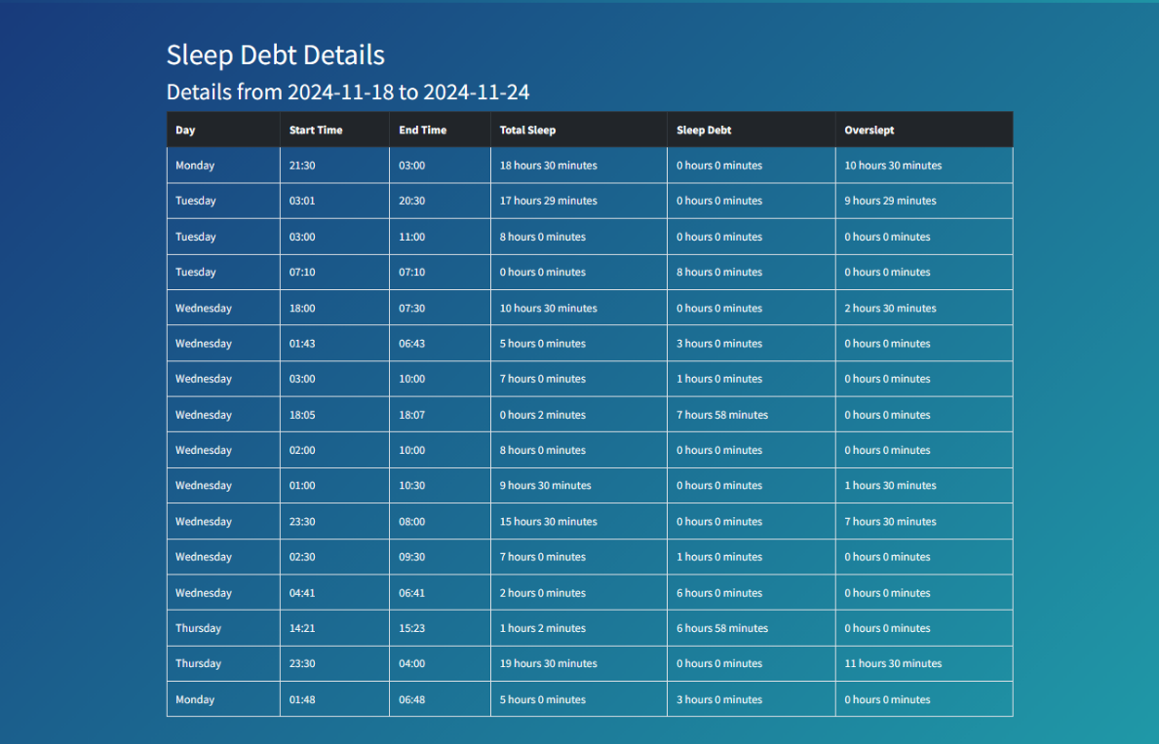

**G. How to use the Progress Tracker**

**Steps:**

1. Navigate to the Progress Tracker Page

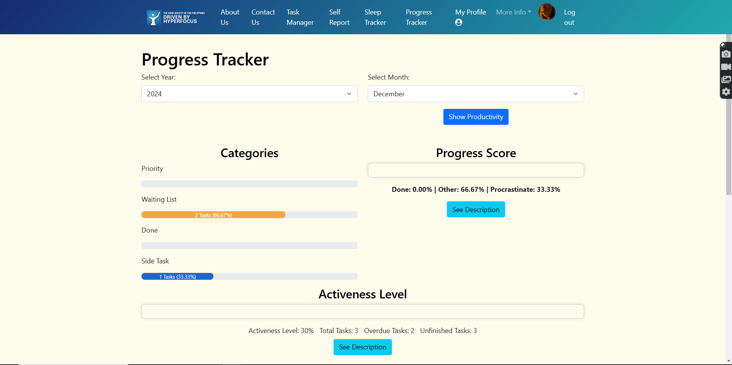

1. Select the year you want to view your progress

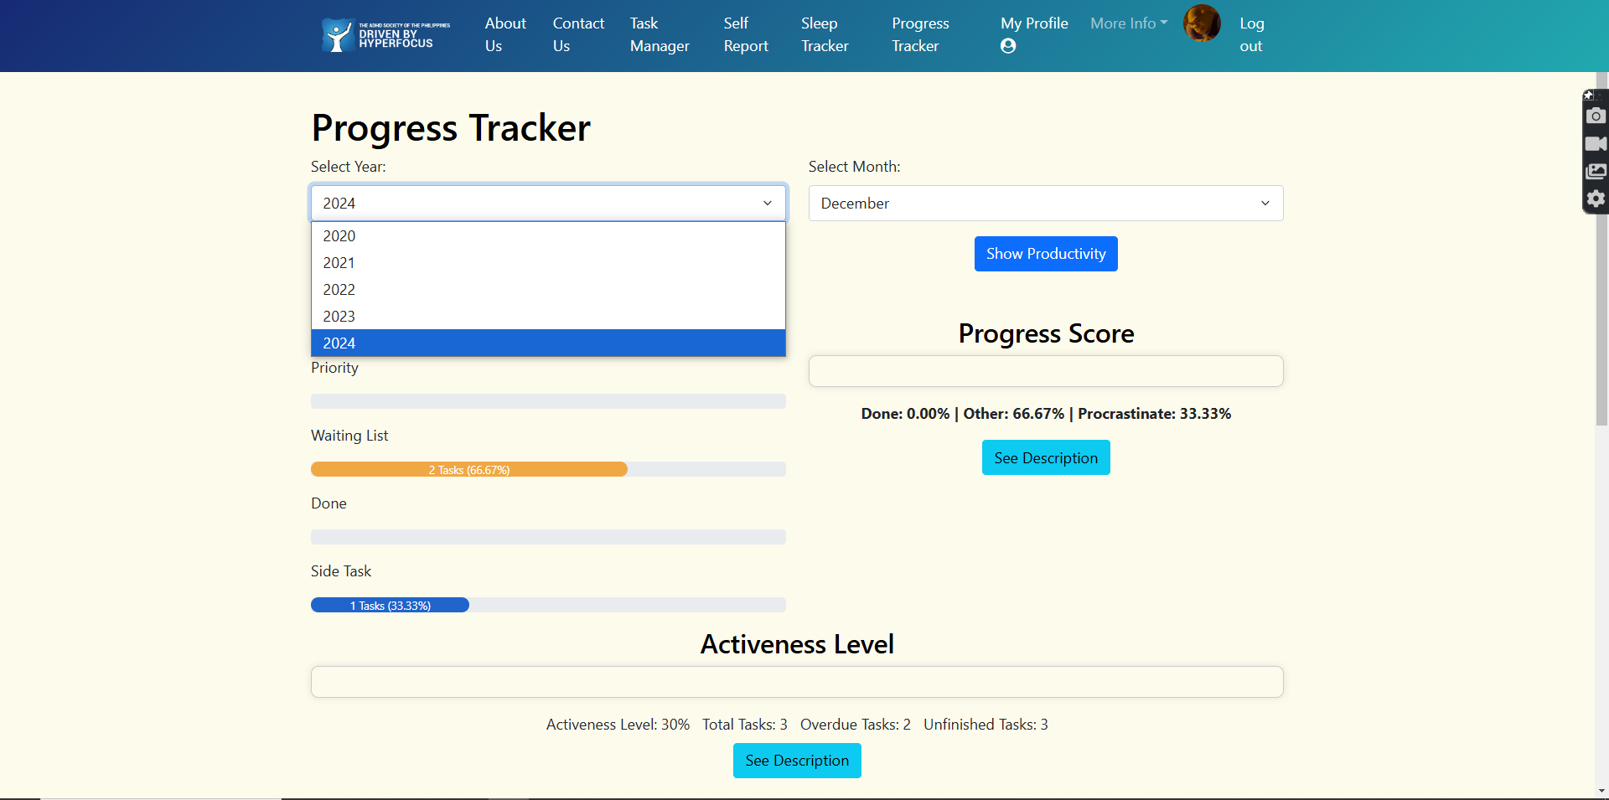

1. Select the Month then click the “Show Productivity” Button



1. After selecting the year and the month it will now give you the data analytics of your progress for that period

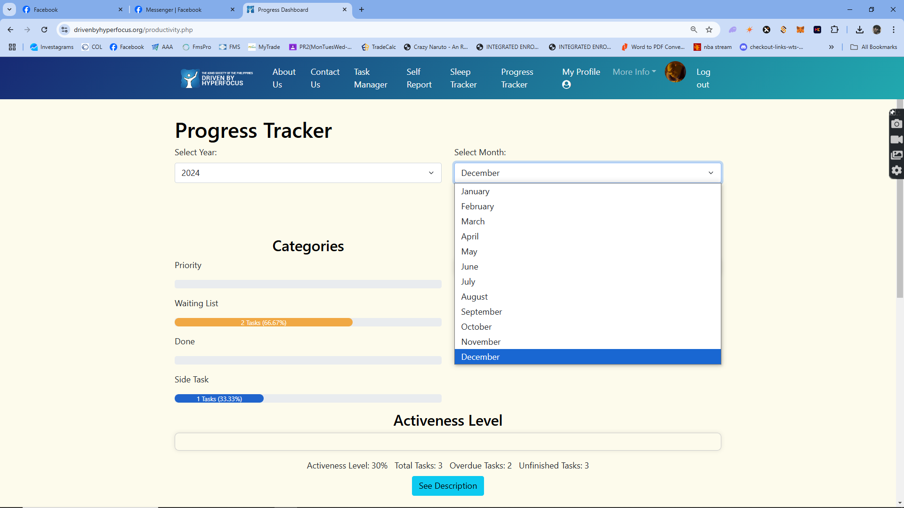

1. Progress Chart: This chart shows your task completion percentage for the month.

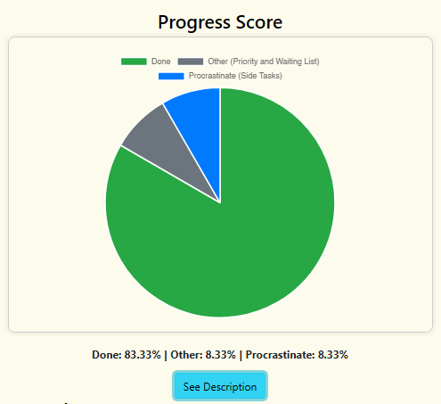

1. Activeness Level: This chart displays your overall activeness level based on completed and overdue tasks.

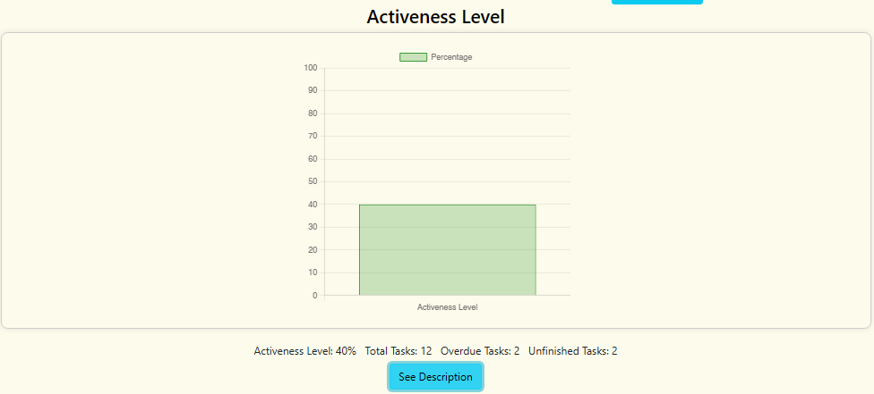

1. Sleep Tracker Analytics: in this section it shows the data analytics gathered from the Sleep Tracker
2. Weekday Vs Weekend Chart: This chart compares your average sleep hours on weekdays versus weekends per month.
3. Sleep Trends Chart: This chart shows the trend of your daily sleep hours, sleep debt, and overslept hours.

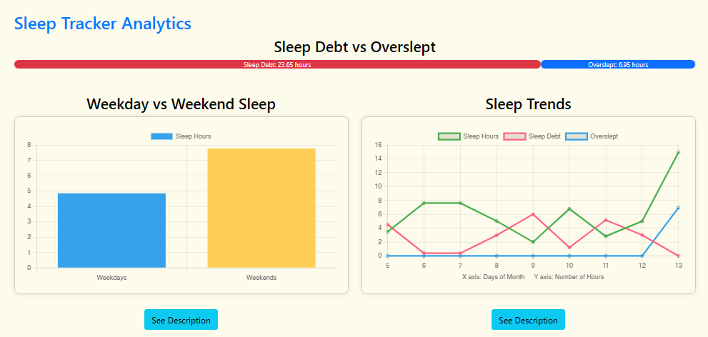

**H. How to manage your User Profile**

**Steps:**

1. Navigate to the “My Profile” Page
2. Click the “Choose File” Button to change your profile picture
3. You can update your credentials here by inputting it inside the textboxes provided
4. If you want to change your password, you need to type your old password first as proof that you are the owner of the account
5. Click the “Update Profile” button to save your changes

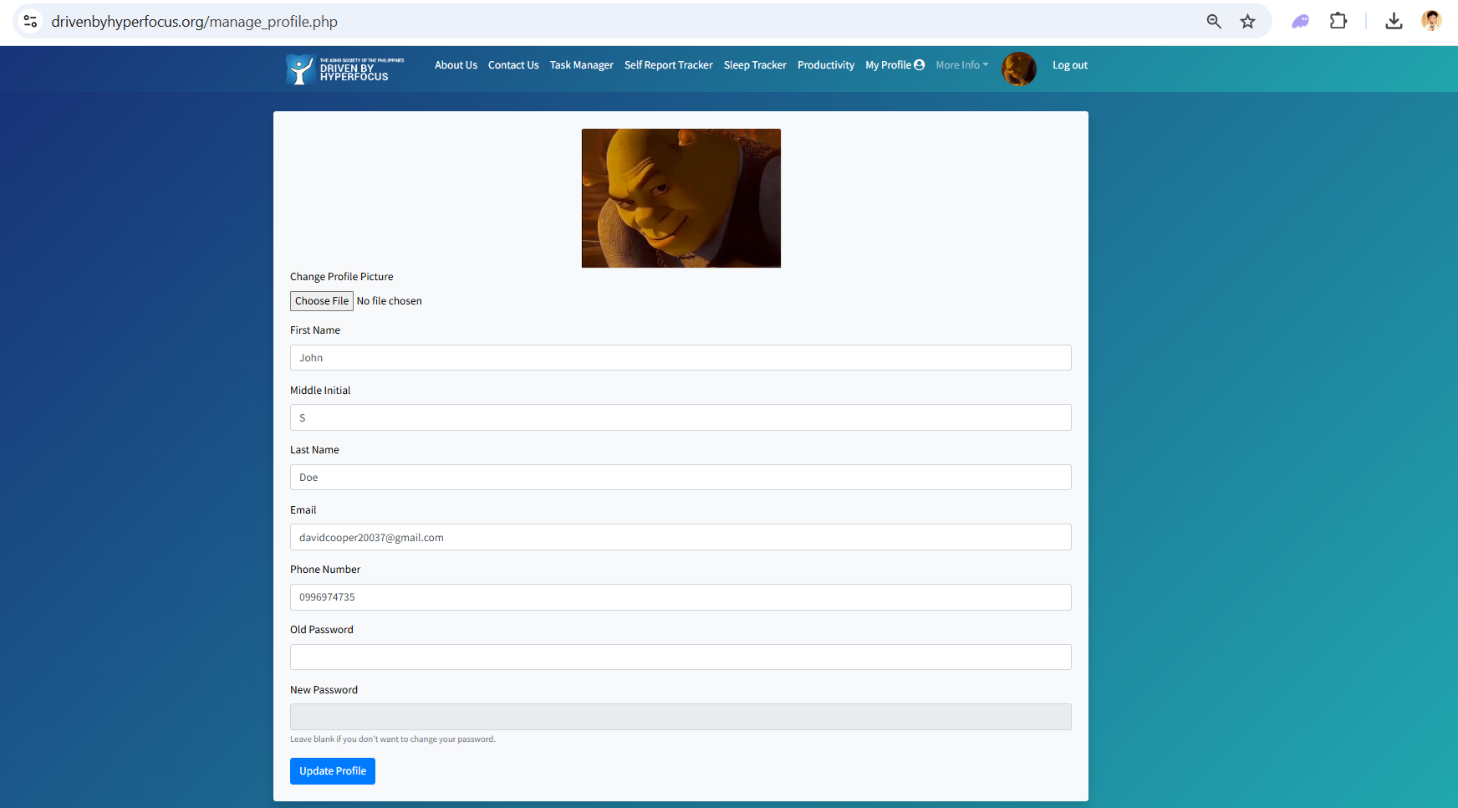

**I. Health Professional Dashboard**

**Steps:**

1. Navigate to the Log-In Page and select “Login as Health Professional”

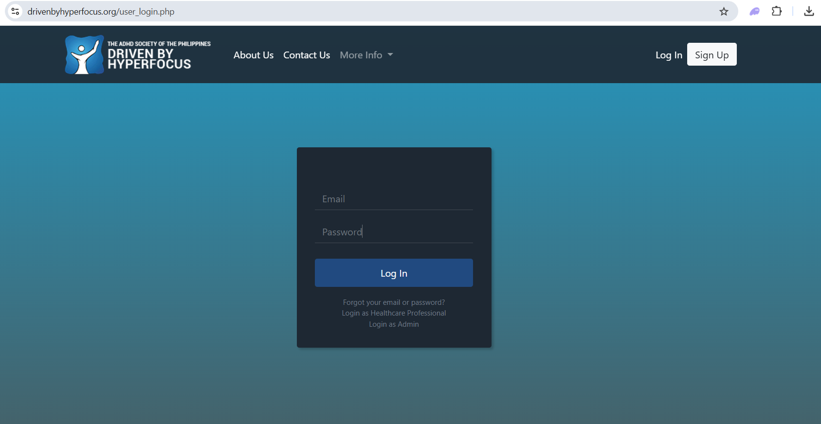

1. If you are a Health Professional, you will log in here

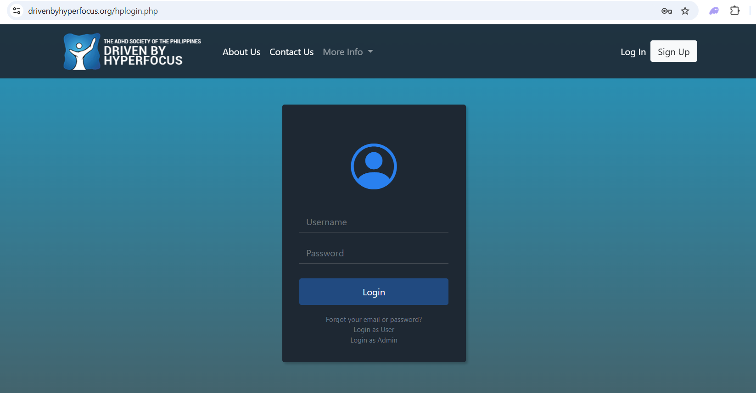

1. After logging in as a Health Professional, you will now see the list of patients and their productivity data in the website

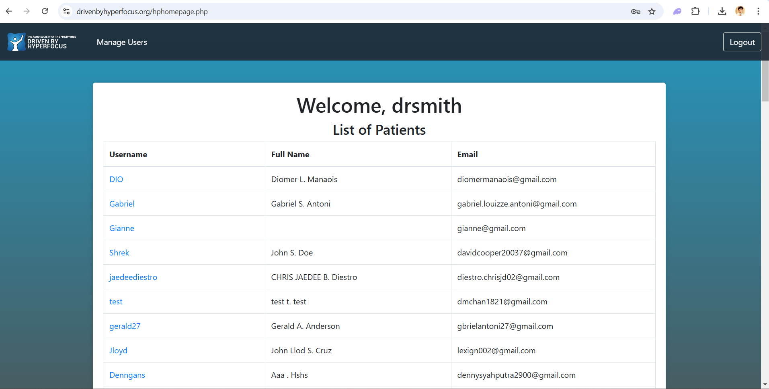

1. Select the user that you want to view Progress Data
2. You will now be redirected to the Progress Page which contains the data of that user

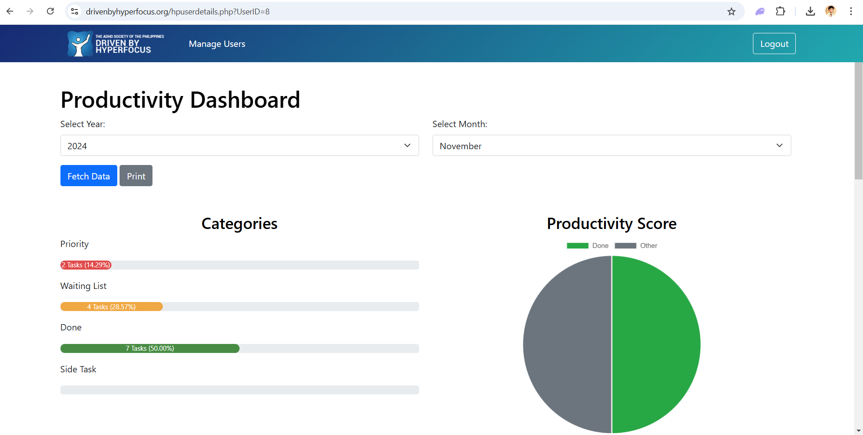

**J. How to manage Web Contents**

**Steps:**

1. Navigate to the Log-In Page and select “Login as Admin”
2. Input your Admin Credentials and click the “Login” button

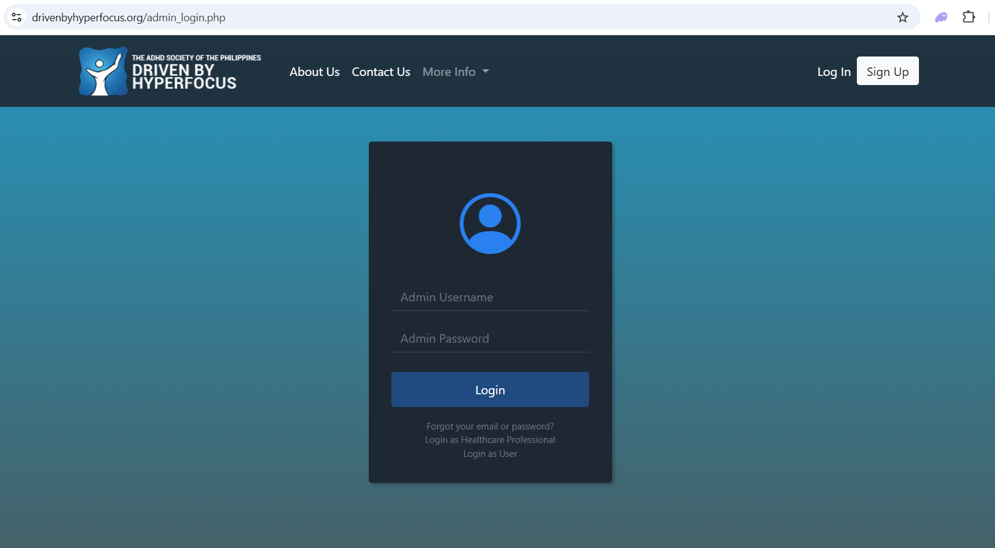

1. You will now be redirected to the Admin Dashboard
2. Click “Web Contents”

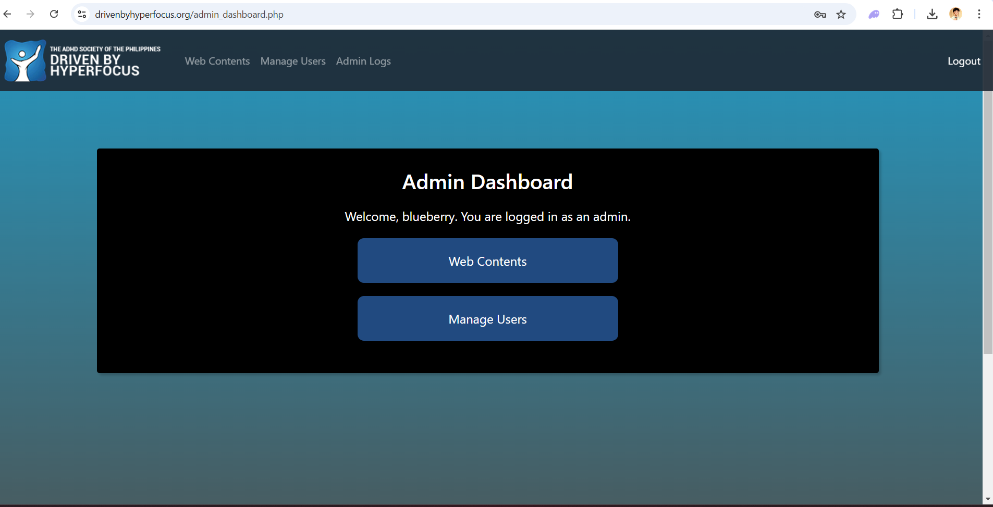

1. After clicking you will be redirected to the Web Contents page which will contain the images that are displaying in the website
2. You can change the image and description by clicking the ‘View Description” Button

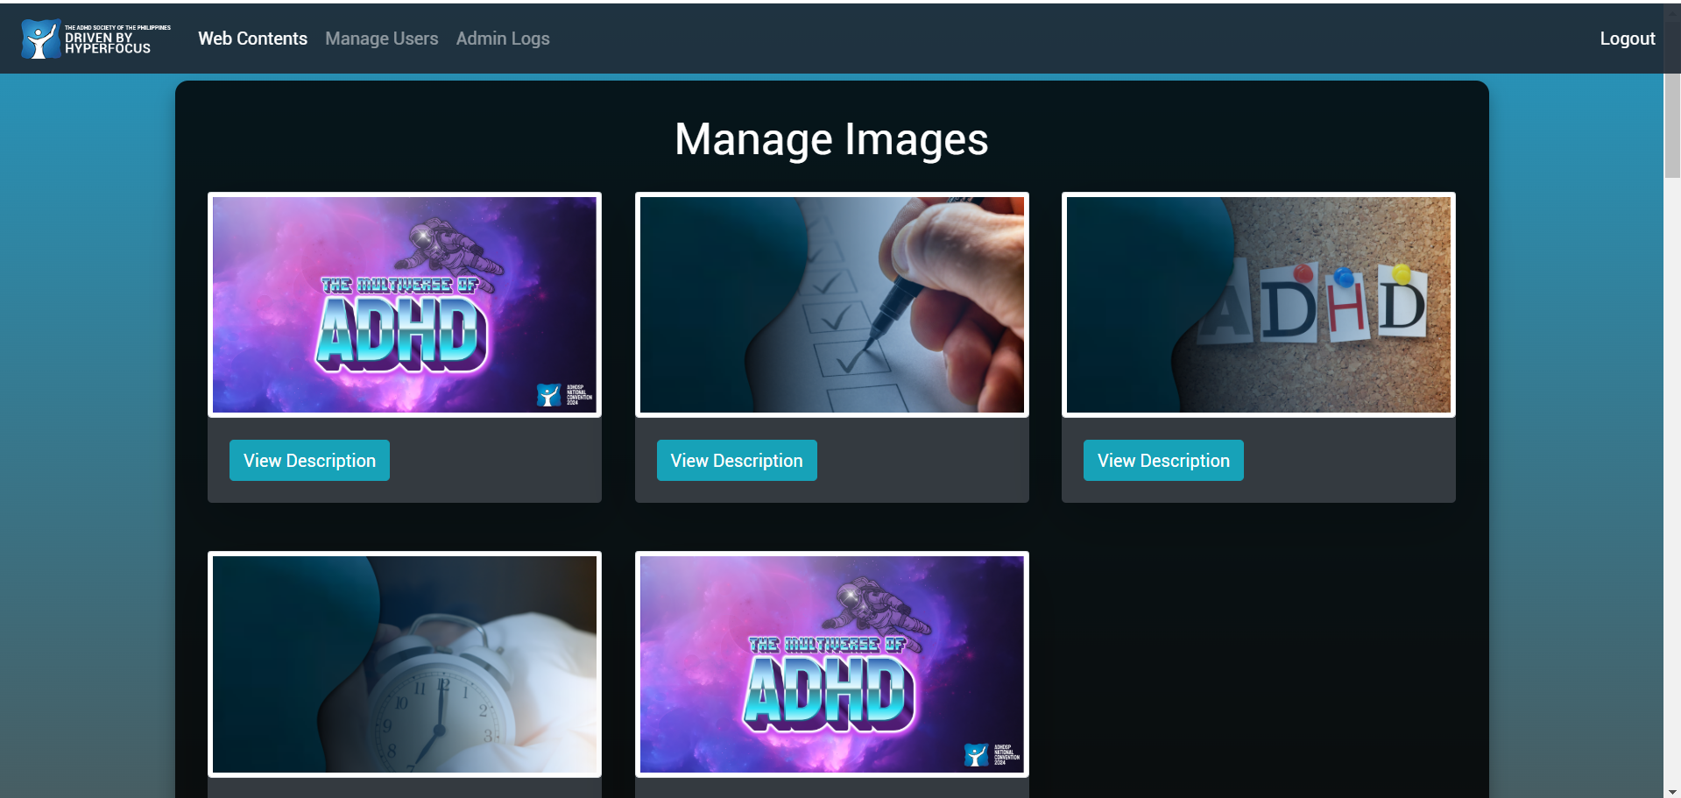

1. This will be the prompt when you click View Description Button
2. Click the Choose File to change the image being displayed
3. Click the textbox so that you can edit any information you want to update or change
4. After you have put the new image or new information, click the “Save Changes” button to save your changes or you can click the Close/X button if you don’t want your changes to be saved

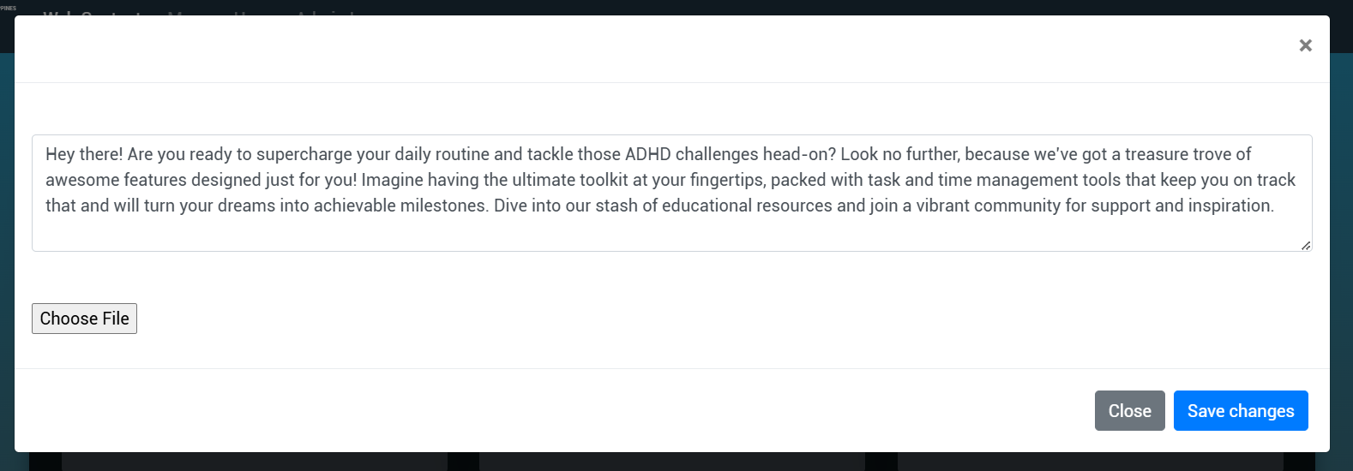

1. The “Save Changes” button will ask you if you are sure of the changes after clicking it

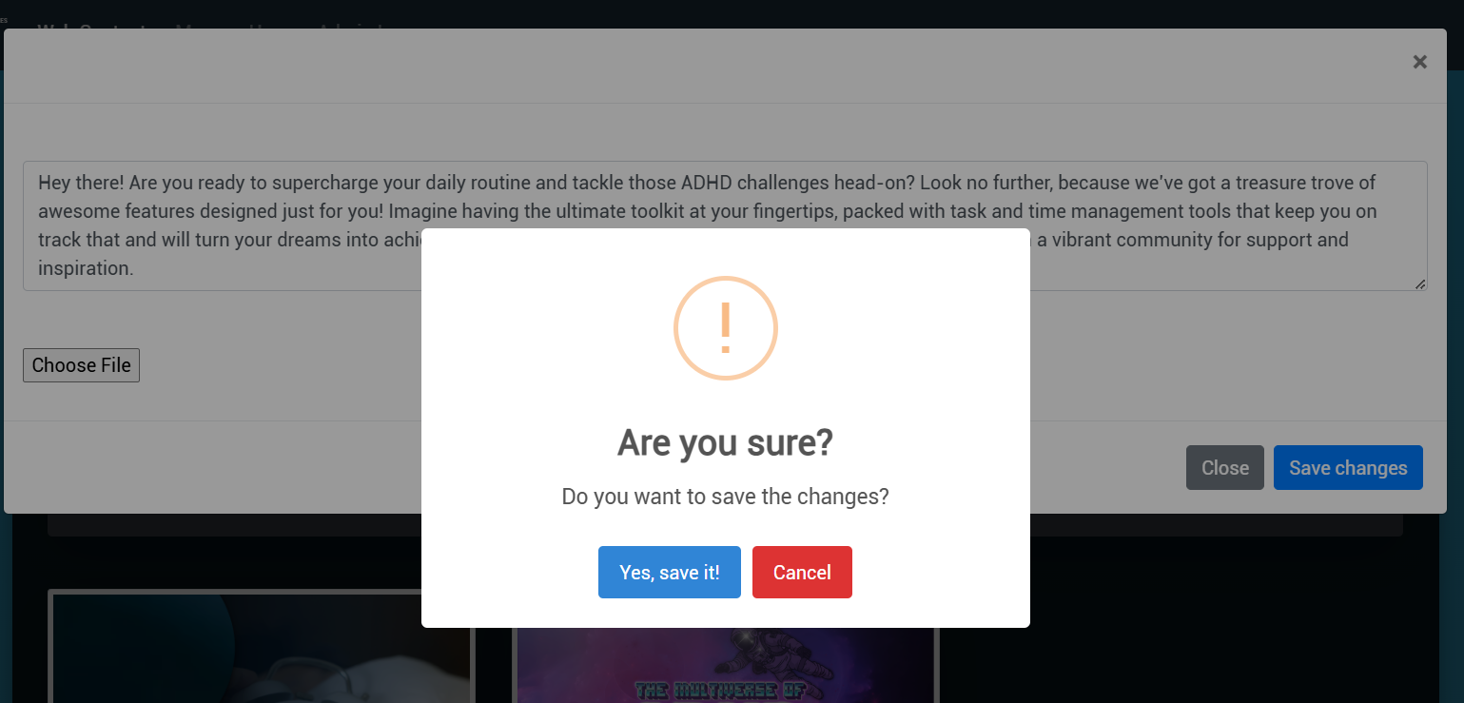

1. You can also change the interpretation of the Self Report here. Note: Only change the interpretation if a Health Professional advice you to update it

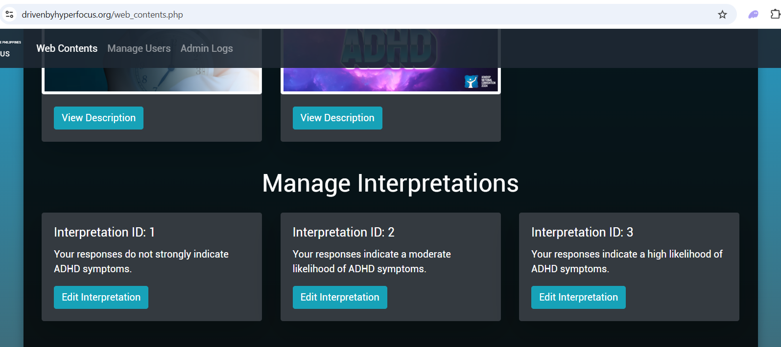

1. The same goes with the Manage Survey Questions, only change the question if given an advice by a Health Professional within the organization.

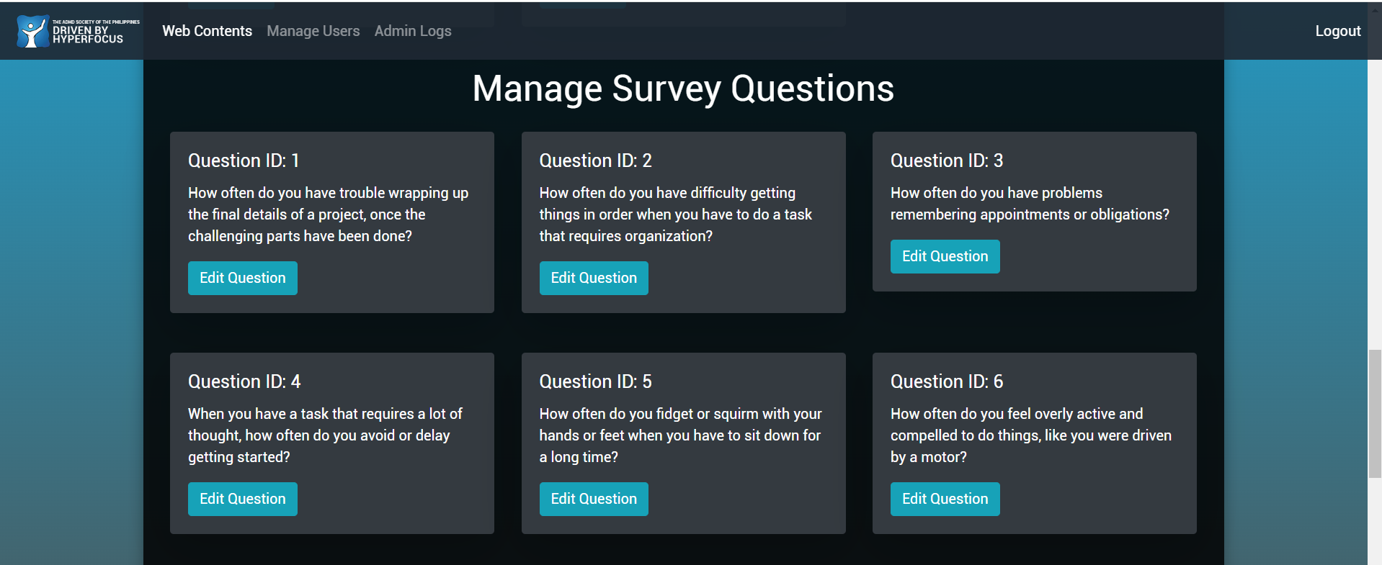

**K. How to manage User Accounts**

**Steps:**

1. If you are logged in as an Admin, navigate to the Manage Users Page by clicking the “Manage Users” button

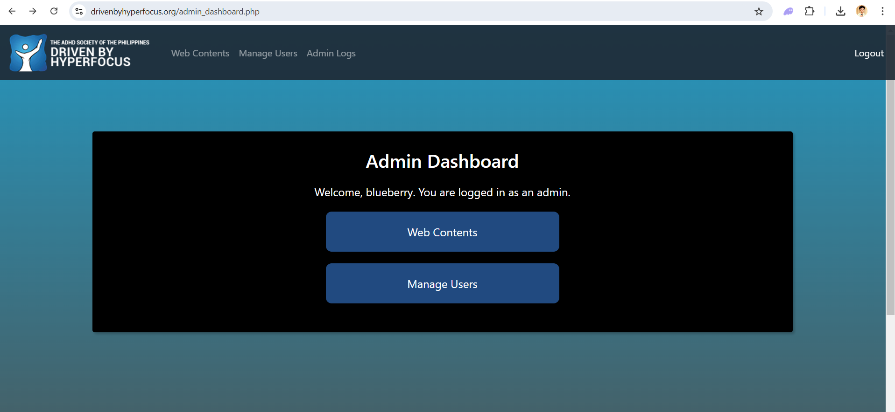

1. You will now be redirected to the Manage Users Page

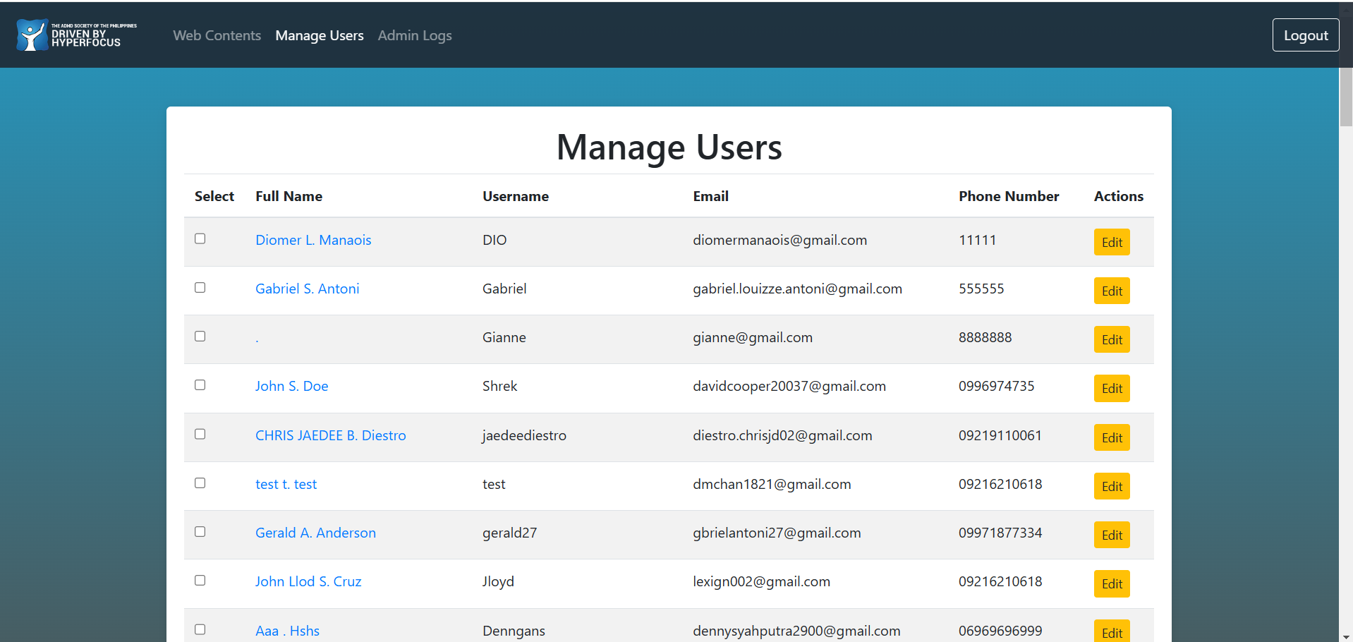

1. If you want to edit the details of the user then click the “Edit” button
2. This is the page where you can change the details of your user except his/her password
3. Click the “Update User” button to save changes

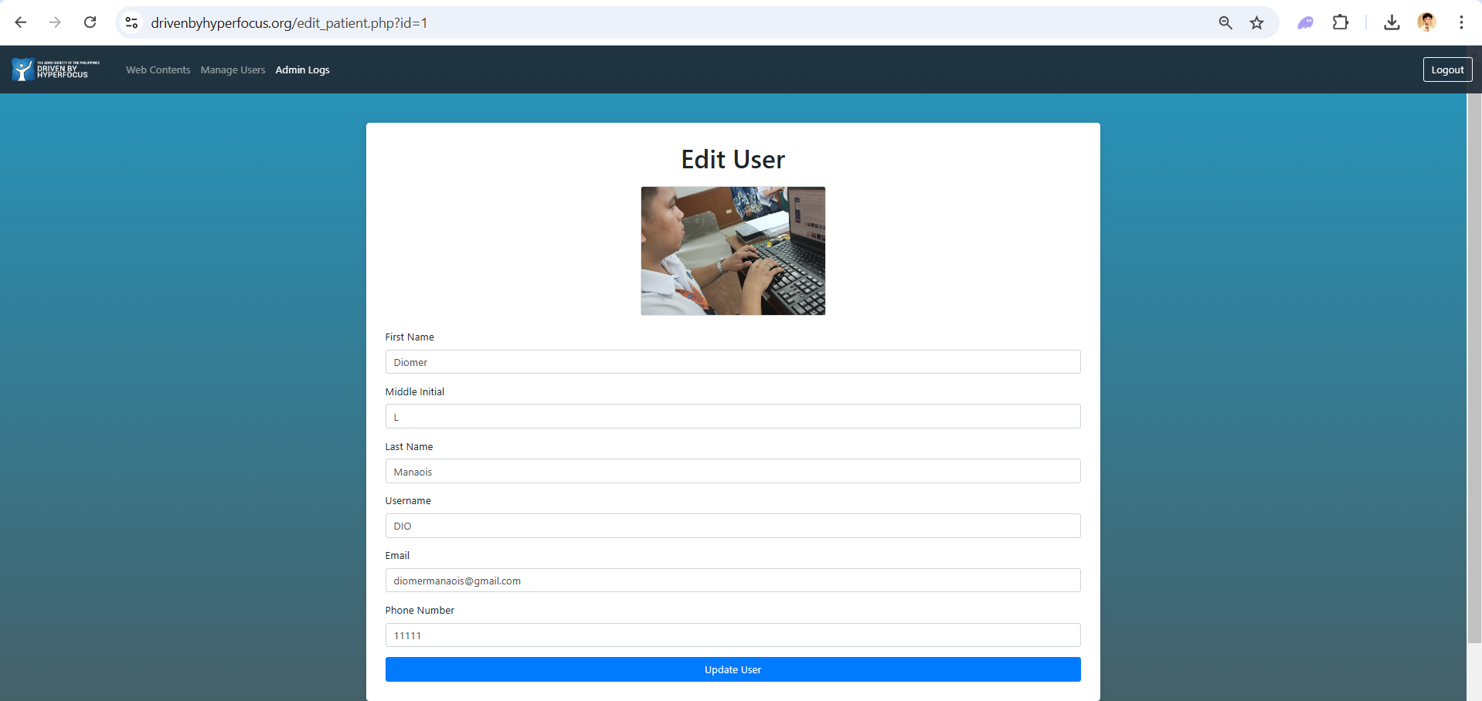

1. If you want to delete a user click the small box then proceed to the “Remove Selected Users” button, you can also delete multiple users by selecting multiple boxes before clicking the “Remove Selected Users” button

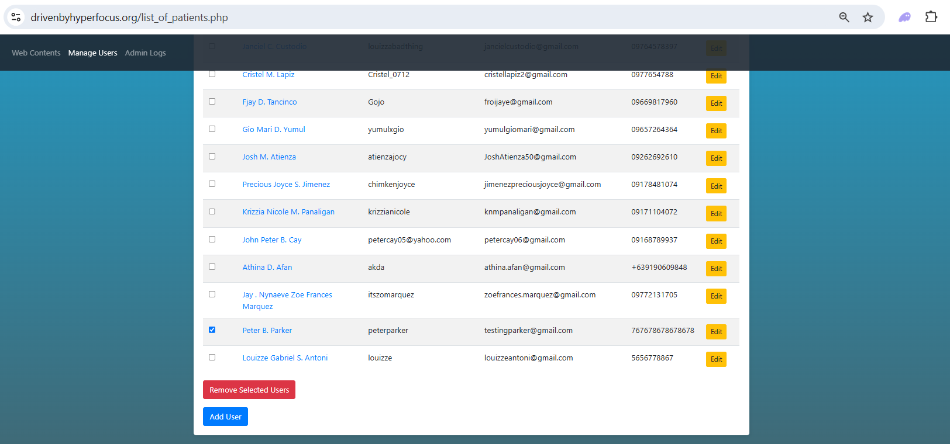

1. This will be prompted once an account has been deleted



1. If you want to create an account for the user, you need to navigate to the Manage Users page then click the “Add User” button at the bottom

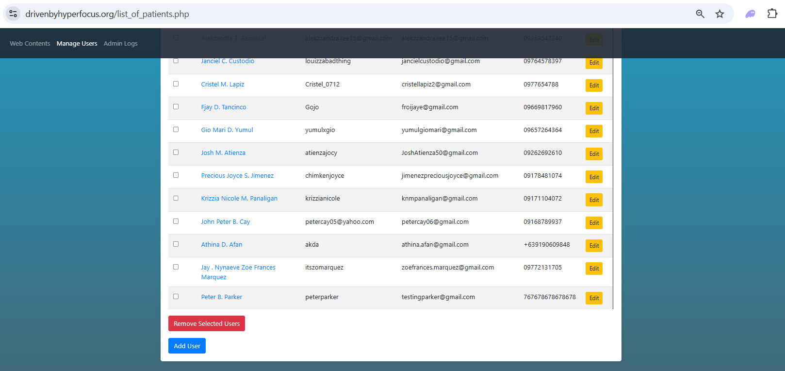

1. Click the button and you will be redirected in the create account page.

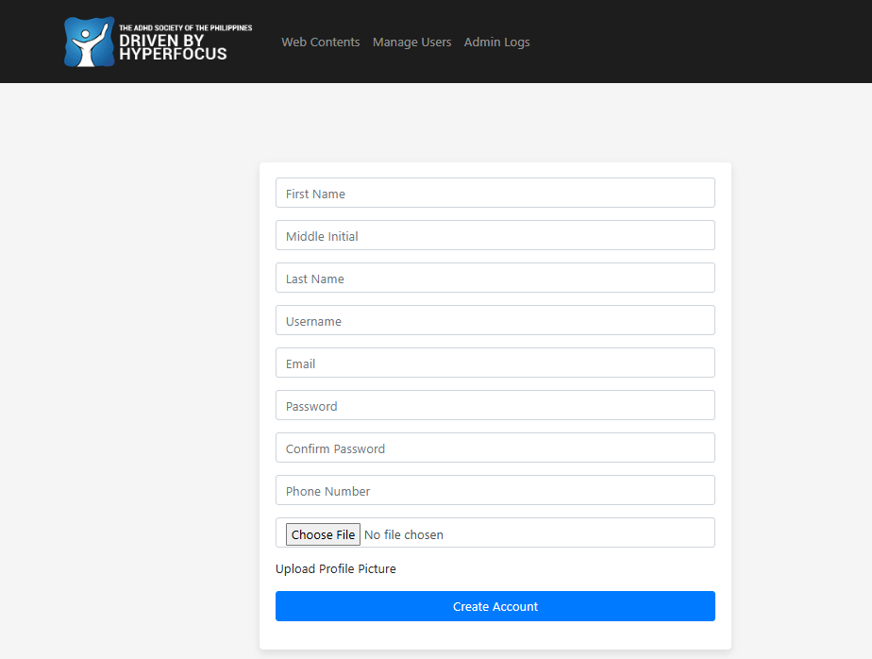

1. Create the account for the user here
2. After inputting all the credentials, click the “Create Account” button to save the account for the user

**L. How to manage Admin Logs**

**Steps:**

1. If you are logged in as an Admin, navigate to the Admin Logs Page by clicking the “Admin Logs” navigation at the header



1. You will be redirected to the Admin Logs page where you will be able to see the Admin Logs which contains changes being made in the website
2. This section provides a report of who made the changes, what changes were made, and when was it changed

